RSM 2 RAR (Amphib) – BIO
WARRANT OFFICER CLASS ONE CHARLES ALLAN
Warrant Officer Class One Charles Allan enlisted in the Army Reserve in 1998, serving in the 4th/3rd Battalion, The Royal New South Wales Regiment before transferring to the Australian Regular Army and being posted to the 3rd Battalion (Parachute), The Royal Australian Regiment in 2003. His experience includes postings to the School of Infantry, Sydney University Regiment and the 2nd/17th Battalion, The Royal New South Wales Regiment.
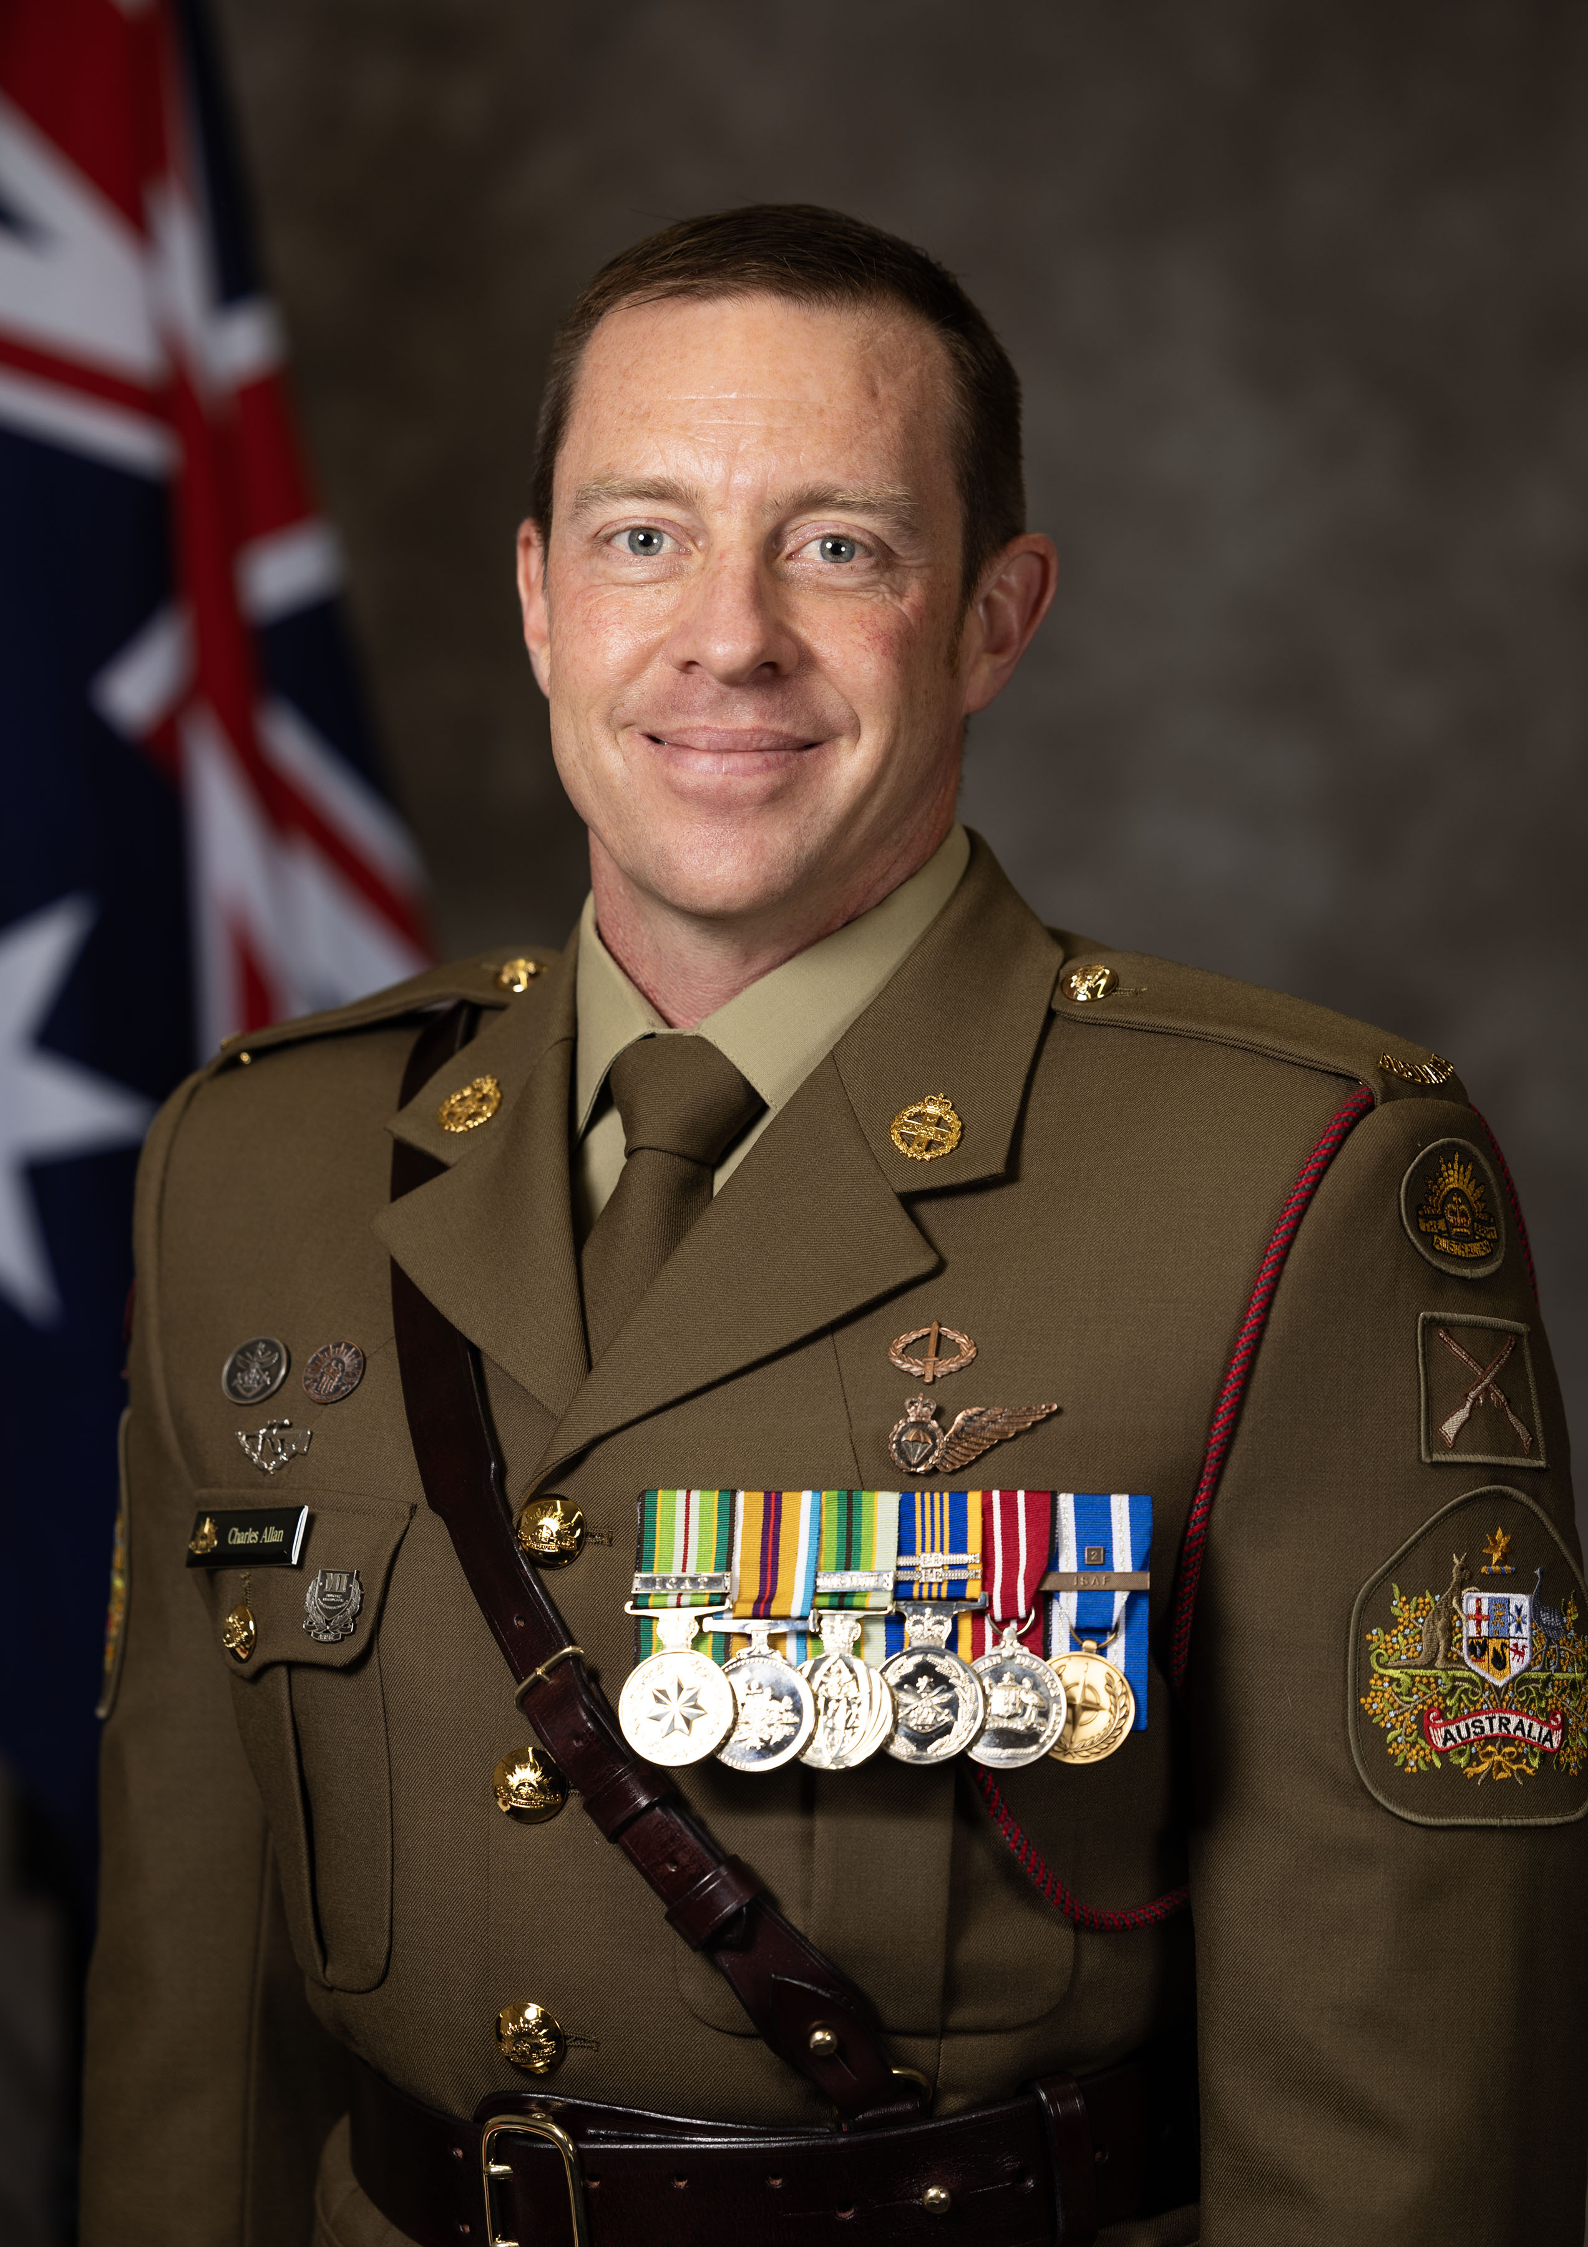
He has held sergeant major appointments in the 2nd Battalion (Amphibious), The Royal Australian Regiment and at the Royal Military College - Duntroon. In 2024, Warrant Officer Allan was appointed as Regimental Sergeant Major of the 4th/3rd Battalion, The Royal New South Wales Regiment, and in 2026 he returned to the 2nd Battalion as its senior soldier.
As well as participating in numerous training and engagement activities with Australia’s regional partners, as a junior leader he served in the United Kingdom on exchange with 42 Commando, Royal Marines, gaining exposure to world best-practice in amphibious operations. He has deployed overseas to Timor Leste on Operation ASTUTE in 2007, to Afghanistan on Operation SLIPPER in 2008 and 2012, and on Operation SAVILLE as the Embarked Forces Sergeant Major in HMAS Canberra during freedom of navigation operations in the South China Sea in 2020. In addition to campaign and service medals commensurate with his service, Warrant Officer Allan was awarded a silver ADF Commendation by the Commander of the 1st Division for his service as a section commander in Timor Leste in 2007, and was presented with a Soldier’s Medallion for Exemplary Service as an instructor at the School of Infantry in 2009. In 2022, he was selected by the Deputy Chief of Army to represent Army in the ‘Games Ready’ collaborative mentorship program with the Australian Institute of Sport, preparing elite Australian athletes for the 2024 Olympics in Paris.
When not spending time with his partner Dominique (an Air Force officer who is also Commanding Officer of No 27 [City of Townsville] Squadron) and children James (11), Sophie (9), Emily (2) and Nicholas (9 months), Warrant Officer Allan is finalising his study towards a Bachelor of International Studies at the University of New England. He enjoys keeping his mind and body active by swimming, weightlifting, rock-climbing and reading, and tries not to embarrass himself with his new hobby of stand-up paddleboarding.

