ROLL OF HONOUR – 2/401173 LCPL Edmund “Sonny” George BOURKE
07th Jun 1953
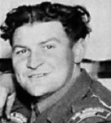

2/401173 LCPL E.G BOURKE
(25 Mar 1927 – 07 Jun 1953: Aged 26yrs)

Service Details
Edmund was born in Langley Vale NSW on 25 Mar 1927; his hometown was Singleton NSW. He enlisted in the Australian Army on 25 Jun 1950 and served in Korea with 1 RAR (11 Jun 1952 – 21 Mar 1953) then joined C Coy 2 RAR on 22 Mar 1953.
On the night of 6/7 Jun 1953, LCpl Bourke was a member of a fighting patrol which had as its onjective the Mound, a feature forward of Pt159. When moving into position the patrol was ambushed by an enemy force later estimated to be thirty strong. LCpl Bourke was forward scout when the clash occurred and was caught in the crossfire of at least three enemy automatics. Although wounded he opened fire on the enemy, thus repulsing them and enabling the remainder of the patrol to take up a defensive position. Then still under fire he went to the assistance of a wounded comrade and helped him back.
After leaving the wounded man within the perimeter LCpl Bourke, although knowing full well there was still enemy within the vicinity, moved out to recover the weapon dropped by his comrade. Whilst he was out the enemy again attacked the patrol. After this second clash LCpl Bourke was not seen again.
LCpl Bourke displayed keen devotion to duty throughout this action. By engaging the enemy single handed he enabled the patrol to reorganise and by the assistance he rendered to his comrade undoubtedly saved his life.
LCPl Bourke was posthumously mentioned in Dispatches.
Edmund, aged 26, was presumed killed on 7 Jun 1953, last seen near the feature, Hill 159 (The Mound), GR 1444 1855 Map: Majon Ni 1:50,000, his body was never recovered and is therefore regarded as missing, presumed Killed in Action and has No known grave - "Known Only Unto God".

Unit: 1st Battalion, The Royal Australian Regiment – 11 Nov 1952 - 21 Mar 1953 (73 days)
2nd Battalion, The Royal Australian Regiment – 12 Mar - 07 Jun 1953 (209 days)
Fate: Presumed KIA, Korea
Cause of Death: Unknown
Memorial Details: United Nations Memorial Cemetery, Busan, Korea, the Australian War Memorial, Canberra ACT, 2nd Battalion Royal Australian Regiment Memorial, Lavarack Army Barracks Townsville QLD and RAR National Memorial Walk, Enoggera QLD.

Note - LCPL Bourke’s body was never recovered and is therefore regarded as missing, presumed killed in action.

2RAR lost 10 killed, and 57 were wounded and 3 members were missing. One of these PTE Fred Speed was eventually returned from prisoner of war camps, on the signing of the Truce. The others PTE E G Bourke and PTE Son Joong Ok, a KATCOM, were presumed dead. ....

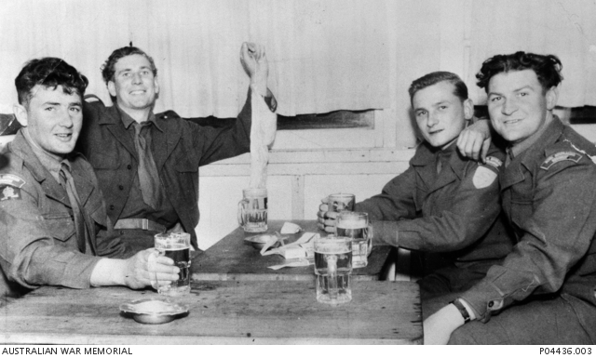

‘Lest we forget’

