66th Battalion – Roll of Honour

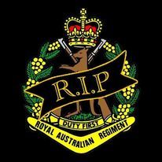

SX38810 PTE Samuel Edley EVANS
SX33581 CPL Leonard Ronald LISHMUND
SX26369 PTE Kenneth PARKEN
QX55791 PTE Neville Leo VOLLING
WX23289 PTE Henry Alan ROWBOTTAM

‘Lest we forget’

ROLL OF HONOUR – SX 38810 Pte Samuel Edley EVANS
19th December 1945

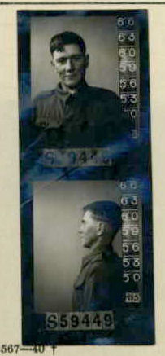

SX38810 PTE S.E EVANS
(01 Aug 1922 – 19 Dec 1945: Aged 23 yrs)

Service Details

Pte Evans was born in Peterborough, South Australia on 01st Aug 1922. Prior to his service, Samuel worked as a Labourer before enlisting on the 09 Jun 1942 at Henley Beach in South Australia aged 19 and was given the Army number S59449, he was later transferred to the AIF, completing his Oath of Enlistment on 05 Jul 1945 and received the service number SX 38810.
Pte Evans was posted to units as a labourer (25 Employment Company) before he was Taken on Strength (TOS) from 1 HQ Aust Army to 17 CRE Works on 26 Oct 1945. He embarked on the Kamibula on the 12 Nov 1945 for Moratai disembarking on 17 Nov 1945. Pte Evans was stated missing at sea on the 19 Dec 1945 from an aircraft accident. Pte Evans emplaned at Moratai on 19 Dec 1945 for medical evacuation to Darwin. The plane was lost at sea between Ambon and Darwin.
Pte Evans was classified Missing after an Aircraft evacuation flight from Moratai that crashed (No35 Squadron Dakota aircraft A65-83) over the Arafura Sea on 19 December 1945, aged 23 years. Pte Evans at the time of being reported missing was travelling between Ambon and Darwin with 25 other passengers and crew when the Aircraft he was travelling in went down at sea. The cause of death is Accidental (Aircraft accident). Pte Evans was officially presumed deceased on 15 Aug 1946 with the date of death being 19 December 1945. His remains have never been recovered.
No. 35 Squadron Operations Record Book A50 Entry dated 21 December 1945.
In terms of lives lost, the disappearance of A65-83 with twenty five lives is one of the worst accidents in the history of the RAAF. No trace of the crew or passengers has been found despite an extensive search lasting 17 days.
Records of Pte Evans service indicate his last posting location being with 17th Commander Royal Engineers Works (17CRE Works) on 26 Oct 1945, and embarked on the Kanibula on the 12 Nov 1945 for Moratai, there is no identified paperwork indicating the member served with the 66th Bn apart from his official certificate of death which was written by the 66th Aust Inf Bn AIF after the members death. Passenger flight details of the ill-fated flight has Pte Evans rank as Sapper.
Pte Evans Cemetery/Memorial sight can be found at:
- Ambon Memorial, Ambon, Maluku, Indonesia (column 6),
- Australian War Memorial Commemorative Area Canberra, Australia (Panel 71, Supplementary Panel 2).
- World War II Honour Roll, National Memorial of SA, North Terrace, Adelaide.
- National Memorial Walk, Brisbane (Memorial plaque)
Pte Evans honours and awards:
- 1939/45 Star
- Pacific Star
- Defence Medal
- War Medal
- ASM
Pte Evans was the Son of Edley Horald Joseph and Sarah Jane Evans of Peterborough, South Australia, and husband of Joyce Reta Evans, of Torrensville, South Australia.
https://pacificwrecks.com/aircraft/c-47/A65-83.html
Unit: 66th Battalion, Australian Infantry, 2nd AIF.
Fate: Died at sea (between Ambon and Darwin), 19 December 1945.
Cause of Death: Accidental (Aircraft accident)

‘Lest we forget’

ROLL OF HONOUR – SX 33581 CPL Leonard Ronald LISHMUND
19th December 1945
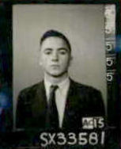

SX33581 CPL LR LISHMUND
(23 Jan 1926 – 19 Dec 1945: aged 19 yrs)

Service Details
Leonard Ronald Lishmund was born in Kingscote, South Australia on 23 January 1926. Prior to his service Leonard worked as a junior assistant (PMG) before enlisting on 24 April 1944 in Wayville, South Australia. He enlisted as a Pte with the service number SX3358.
On 29 Nov 1945 was admitted to 2/9 General Hospital, Moratai, and on 19 Dec 1945, Leonard was medically evacuation by plane which was lost at sea travelling between Ambon and Darwin. Leonard, age 19, and 24 other passengers and crew were classified “Missing” after their Aircraft from No 35 Sqn, a Dakota A65-83 (VHCIZ) on an evacuation flight from Moratai crashed over the Arafura Sea on 19 December 1945.
They were officially presumed deceased on 15 Aug 1946 with the date of death being 19 December 1945, “Died at sea (between Ambon and Darwin), Accidental (Aircraft accident)” Leonard’s remains have never been recovered, and he has No known grave - "Known Unto God" and is commemorated on Column 6 Ambon Memorial, Ambon, Maluku, Indonesia, Panel 71, Commemorative Area, Australian War Memorial, Canberra, ACT, Australia. WWII Honour Roll, National War Memorial of SA, North Terrace, Adelaide SA.

Corporal Lishmund was the son of Frederick Clifford and Ada Mary Lishmund and he is survived by his sister Doreen Lishmund, of North Adelaide.

Flight Details Log:
Signal Received to the effect that Squadron aircraft VH-CLZ is overdue on flight from Ambon to Darwin. Crew comprises Flying Officer F. Robinson (Captain), Flight Lieutenant N.J. Hazle (Co-Pilot), Pilot Officer G. Connell (Wireless Operator Air Gunner) and Sergeant P. Bodley (Navigator). There are also 21 passengers on board.
https://www.findagrave.com/memorial/21405773/leonard-ronald-lishmund
https://pacificwrecks.com/aircraft/c-47/A65-83.html

No. 35 Squadron Operations Record Book:
A50 Entry dated 20 December 1945:
Received advice from D.T.M. (Directorate of Transport and Movements) Melbourne, that Naval Authorities at Darwin had received message “All Alive”. Bearings were obtained on signal but searches were negative.
A50 Entry dated 21 December 1945:
In terms of lives lost, the disappearance of A65-83 with twenty five lives is one of the worst accidents in the history of the RAAF. No trace of the crew or passengers has been found despite an extensive search lasting 17 days.

Unit: 66th Battalion, Australian Infantry, 2nd AIF.
Fate: Died at sea (between Ambon and Darwin), 19 December 1945
Cause of Death: Accidental (Aircraft accident)
Memorial Details: Column 6 Ambon Memorial, Ambon, Maluku, Indonesia. Panel 71, Commemorative Area, Australian War Memorial, Canberra, ACT, Australia. WWII Honour Roll, National War Memorial of SA, North Terrace, Adelaide, Australia.

‘Lest we forget’

ROLL OF HONOUR – SX 26369 PTE Kenneth PARKEN
14th August 1946
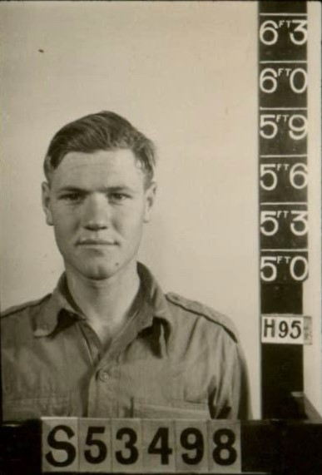

SX26369 PTE K PARKEN
(21 Sep 1923 – 14 Aug 1946: aged 22 yrs)

Private Kenneth Parken was born in South Australia on 21 Sep 1923 and grew up in Gawler, South Australia. Kenneth was Mechanics Asst prior to enlisting enlisted on 29 Dec 1941 (S53498) serving with the 108 A/Tank Regt and called up for full time duty on 10 Mar 1942 (SX26369) serving with 24 Aust Inf Bde (1944) and on 23 Feb 1946 marched in to 66th Aust Inf Bn in Kure, Japan.
Kenneth passed away on 14 Aug 1946, aged 22 years, by accidental drowning near Nîgata, Japan and his body was never recovered due to the swirling currents of the inland sea.
Unit: 66th Battalion, Australian Infantry, 2nd AIF.
Fate: Died Accidently (drowning) near Nigata, Japan 14 Aug 1946
Cause of Death: Drowned
Memorial Details: Panel 71, Commemorative Area, Australian War Memorial, Canberra, ACT, Australia. Adelaide WW2 Wall of Remembrance, Singapore Memorial Kranji War Cemetery column 133.
From 66 Bn War Dairy:

‘Lest we forget’
ROLL OF HONOUR – QX 55791 PTE Neville Leo VOLLING
01st May 1946
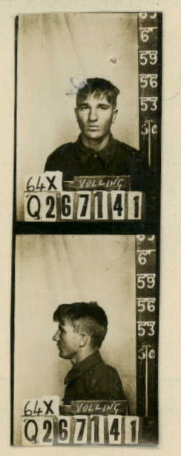

QX55791 PTE N.L VOLLING
(03 Mar 1924 – 01 May 1946: aged 22 yrs)

Private Neville Leo Volling was born in Longreach, QLD on 03 Mar 1924 to Alexander Volling and Julia Rose (Gillett) Volling and was a Station Hand prior to enlisting on 15 Oct 1942 at Selwyn, Qld (Q267141).

He transferred to the AIF 19 May 1943 and posted to 2/12 Fd Regt in Lae, New Guinea on 4 Feb 1944, then transferred to 34th Inf Bde on 25 Oct 1945 and posted to HQ Coy 66 Aust Inf Bn in Kure, Japan.
Neville died of injuries (rupture of liver) sustained in a road accident near Saka, Japan on 1 May 1946, age 22.
Unit: 66th Battalion, Australian Infantry, 2nd AIF.
Fate: Road Accident, Saka, Japan, 01 May 1946
Cause of Death: Sustained Injuries from vehicle accident
Memorial Details: Yokohama War Cemetery, Yokohama, Kanto, Japan – Plot Aust.Sec.E.C.4. Panel 71, Commemorative Area, Australian War Memorial, Canberra, ACT.

From 66 Bn War Dairy:
‘Lest we forget’
ROLL OF HONOUR – WX 23289 PTE Henry Alan ROWBOTTAM
27th May 1946

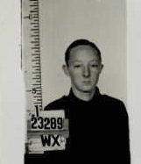

WX23289 PTE H.A ROWBOTTAM
(11 May 1927 – 27 May 1946: aged 19 yrs)

Private Henry Alan Rowbottam was born in Dalwallinu, WA on 11 May 1927, the son of Harry Walter and Eileen Marion Rowbottam. Henry was a Storeman prior to enlisting as a General Reinforcement in the AMF on 22 May 1945 at Karrakatta WA. After training in Australia Henry arrived in Kure, Japan on 26 April 1946 posted to 66th Aust Inf Bn.

On 27 May 1946 In Hachihonmatsu, Japan, Henry, age 19, died from a 303 bullet wound to the abdomen from an Accidental discharge whilst on duty. (There was no misconduct, but evidence exists of negligence). Henry’s Pl attended his funeral, with members of the Hachihonmatsu detachment his pall bearers.

He was the first soldier to be buried in the ground of the temporary British War Cemetery and is now buried in the Yokohama War Cemetery Yokohama, Yokohama-shi, Kanagawa, Japan – Plot Aust. Sec. E. C. 3 and commemorated on Panel 71, Commemorative Area, Australian War Memorial, Canberra, ACT and the Subiaco Fallen Soldiers Memorial, Subiaco WA

Unit: 66th Battalion, Australian Infantry, 2nd AIF.
Fate: Died accidently in Hachihonmatsu, 27 May 1946
Cause of Death: Accidental discharge whilst on duty
Memorial Details: Panel 71, Commemorative Area, Australian War Memorial, Canberra, ACT.

From 66 Bn War Dairy:

INSPECTOR ROWBOTTOM’S LOSS
SON KILLED IN JAPAN
Inspector Rowbottam, in charge of the South-West police and stationed in Bunbury, received a telegram on June 30 from the Minister for the Army advising him that his son Pte Henry Alan Rowbottam (19) had been killed as a result of an accident.
Henry Rowbottam, who will be well remembered in Bunbury, where he was employed at Donaldson's Garage, was a member of the Australian Occupation Forces in Japan when the
tragedy occurred. Beyond the bare announcement of his son’s death, Inspector Rowbottem has so far received no information in regard to the unfortunate occurrence.
Inspector Rowbottam, during the period he has been stationed .in Bunbury, has won wide popularity as a police officer, and all sections of the community will hear of his loss with very great regret, and extend to him a full measure of sympathy.
Henry Rowbottam was in Bunbury on leave last February before being drafted to duty in Japan. Two-other sons returned safely after serving their country with the fighting forces.
South Western Times (Bunbury, WA Thu 6 Jun 1946

‘Lest we forget’

ROLL OF HONOUR – 66th BATTALION: Summary

Number | Rank | Int | Given Names | Surname | Comments | Age | DOB | DOD | Coy, Platoon
16th October, 1945 - 66 Australian Infantry Battalion (2nd AIF then Interim Army then Australian Regular Army)
Morotai (Between Ambon and Darwin)
S59449  SX38810 | PTE | SE | Samuel Edley | EVANS | Emplaned from Moratai No.35 Sqn RAAF Dakota A65-83 (VHCIZ), which went missing on a medevac flight between Ambon and Darwin | 23 | 01 Aug 1922 | 19 Dec 1945
SX33581 | CPL | LR | Leonard Ronald | LISHMUND | Emplaned from Moratai No.35 Sqn RAAF Dakota A65-83 (VHCIZ), which went missing on a medevac flight between Ambon and Darwin | 19 | 23 Jan 1926 | 19 Dec 1945
Japan
SX26369 | PTE | K | Kenneth | PARKEN | Died Accidentally (Drowning) near Nigata | 22 | 21 Sep 1923 | 14 Aug 1946 | Battalion Band Member
WX23289 | PTE | HA | Henry Alan | ROWBOTTAM | Died Accidentally (Accidental Discharge whilst on Duty) in Hachihonmatsu | 19 | 11 May 1927 | 27 May 1946
QX55791 | PTE | NL | Neville Leo | VOLLING | Died Accidently  Died of Injuries from vehicle accident near Saka | 22 | 03 Mar 1924 | 01 May 1946 | HQ Coy

MEMORIALS
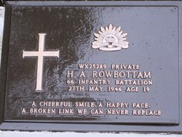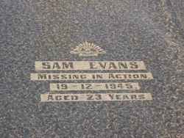
PTE H.A ROWBOTTAM PTE S.E EVANS
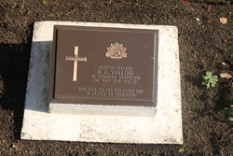
PTE N.L VOLLING

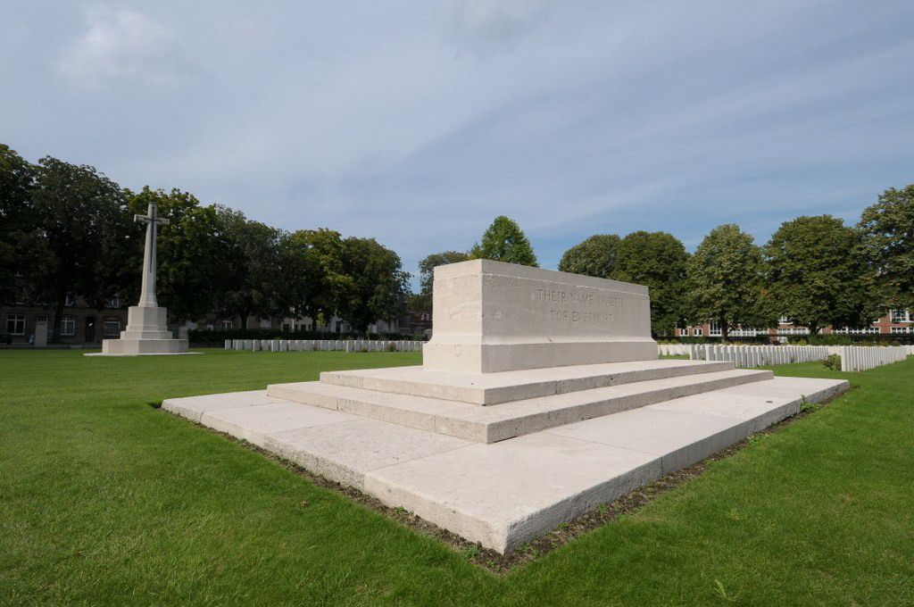
Yokohama War Cemetery Yokohama, Yokohama-shi, Kanagawa, Japan – Plot Aust. Sec. E. C. 3 and commemorated on Panel 71, Commemorative Area,

