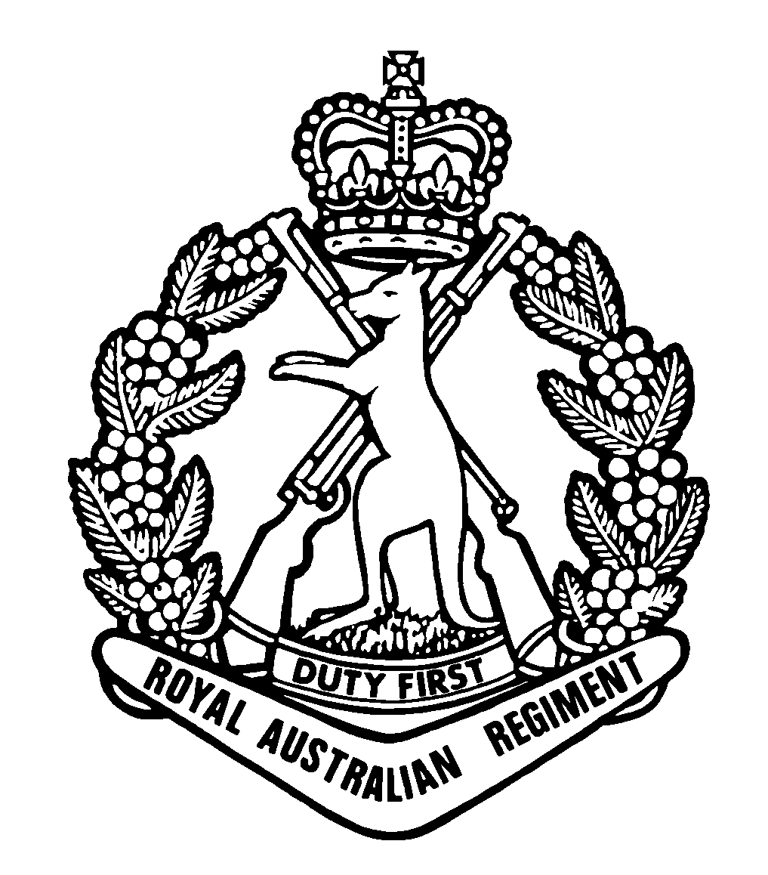

2nd Battalion
The Royal Australian Regiment

A Unit History
This booklet does not attempt to re-write the history of the 2nd Battalion, The Royal Australian Regiment (2 RAR) but aims to give an insight to the history and traditions earned by the service of those who have gone before.

66th Australian Infantry Battalion

(16 Oct 1945 – 22 Nov 1948)

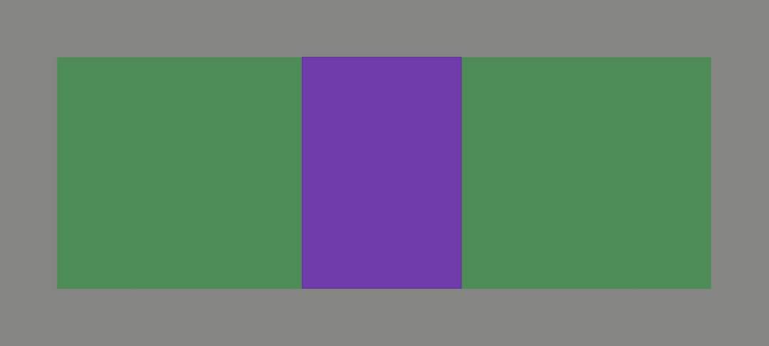

South-West Pacific
1945

Background.

In May 1945 when the Japanese were nearing the point when defeat was inevitable, the Australian Government decided that a force would be raised of volunteers from the Infantry Divisions then in operations against the enemy as part of the Occupation Forces in Japan.

War Cabinet informed Britain that Australia wanted to take part in the occupation of Japan and offered a Brigade group, a wing of RAAF Mustang Fighters, two carriers and two destroyers of the RAN. The Australian offer was accepted and would form a component in a larger British Commonwealth Occupation Force (BCOF) which was to include Indian and New Zealand Armed Forces as well as British and Australian Army, Navy and Airforce contributions to assist with the demilitarisation of Japan.

Origins.

The origins of the 66th Australian Infantry Battalion (66th Bn) lie in the decision made by the Australian Government to raise a force for occupation duties in Japan at the end of the Second World War. The 34th Australian Infantry Brigade was raised in October 1945 from the Second Australian Imperial Force (2nd AIF) personnel then serving in the Southwest Pacific Area.

The 34th Australian Brigade included the 65th Bn (ex-members of 7th Australian Division), 66th Bn (ex-members of 9th Australian Division), 67th Bn (ex-members of 5th and 6th Division), a Field Battery RAA, and Engineer Field Squadron, 1st Armoured Car Squadron, and a Field Ambulance.

66th Australian Infantry Battalion.

The 66th Bn was an infantry force raised from volunteers principally from men of the 9th Australian Division, 2nd AIF for service with the BCOF in Japan. Lt Col G.E. Colvin DSO and Bar, ED, was appointed to command this new Battalion. Lt Col Colvin was a soldier of Middle East fame from the 2/13 Infantry Battalion who took over command during the Battle of El Alamein, for his deeds, he was awarded the Distinguished Service Order (DSO).

The 66th Bn was officially formed on 16th October 1945 in Labuan, then in British North Borneo, before joining the 34th Australian Infantry Brigade stationed on the island of Morotai, Netherlands East Indies in November 1945.

The Battalion consisted of a Bn HQ, HQ Company and four Rifle Companies. In those days HQ Company embraced what later became Admin and Support Companies, with 1PL being the Signals platoon, 2PL Mortars, 3PL MMG, 4PL A Tank, 5PL Pioneers, 6PL QM and Transport with a total strength of about 250 personnel. The effective strength of the unit increased rapidly to over 500 by the end of October with personnel arriving from all parts of Western Borneo. Rifle platoons were numbered from 7 through 18.

There were no restrictions on the number of volunteers from AIF units and therefore a commander had a wide choice and could select whom he wished provided he kept within his establishment.

The early formative days were very rugged to say the least and in Oct 1945, when members of 66 Bn assembled in Labuan no one wanted them, they were in everyone’s way. The 9 Div was preparing to go home and with one object in mind – to get going as soon as possible.

LTCOL G. Colvin CMG, DSO, ED (66th Bn Original Commander)

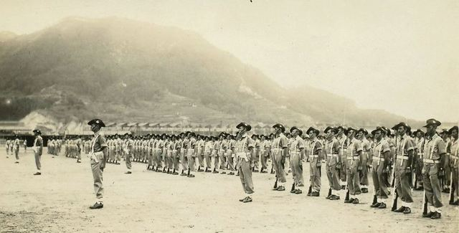

66th Australian Infantry Battalion on parade in Japan – end of WW2

Little was known of forward planning. What was to be their role? Where were they to land in Japan, or by what means they were to get there and more importantly when?

Life at Morotai consisted of organising, equipping, drilling, briefings and a vigorous training and fitness campaign. Due to the uncertainty in information about departure dates for Japan there was some dissatisfaction and ‘unsoldierly’ incidents occurred.

Morotai Incident

Morotai was in the sweltering tropics whilst at the same time it was snowing in Japan only a few days journey away. The troops were anxious to get there and get on with the job, but it was to be many weeks before they saw Japan in about mid – February 1946.

Troops were becoming frustrated, and despite all the promises made by visiting politicians they were demanding answers to their questions. Where were their new uniforms that had been promised? When would they embark for Japan? If not, when could they take some leave? What about pay and conditions and the promises made at the time of enlistment were some of the questions being thrown around.

Things hadn’t been going to well with Japforce, which was the name given to the Australian contingent on its way to take part in the Occupation. When we’d left Bougainville we’d been told that we would stage very briefly on Morotai and then head off for Japan. As it turned out, the army was up to its old tricks. Nothing happened for weeks, and inevitably the rumours began to fly…

But worst of all was the insult of having to wait around for MacArthur to make up his mind whether we’d even be allowed to join the occupation – or so someone said. “What?’ roared indignant groups at the boozer, night after night. ‘That yank poofter? Tell the Aussies whether or not they can go to Japan? Bloody hell!’ It would have been so easy to bring the whole boiling back to the normal bubbling simmer of army discontent and suspicion, if only the Brass had been able to trust the troops with the facts….

T.A.G. Hungerford (A Knockabout with a Slouch Hat)

One Saturday afternoon and in their own time, the troops organised their own Brigade parade complete with bands, public address system and spokesmen. The parade was well organised without officers and senior NCOs. To ensure that their demands were listened to the spokesmen for the parade insisted that he wasn’t going to be fronting up for any screaming rabble. It was going to be an orderly parade – better than orderly, the very best they could put on. They were to be marched onto the crash-strip by their own unit NCO’s and formed up in a three-sided square facing the Brigadier’s tent. It was all series business in which, if things went wrong, whole truckloads of shit would hit the fan – and they’d all be standing directly under it.

I suppose mutiny in the army is a bit like VD – you can’t have just a little of it and then walk away from it. And by the time I got onto that parade ground, I’d have had it, good and proper.

T.A.G. Hungerford

With the coconut palms holding up a cloudless blue sky over a world cool and sunny with the promise of another perfect Morotai day motions were set in place for the parade to begin. It was an impressive sight and sobering one. There was some three thousand men on that parade that day, all brown boots, and khaki drill.

The spokesmen addressed the parade then went in search of the Brigadiers administration tent to hand over the list of grievances. Brigadier Nimmo was absent in Australia – and the fact that this was not known to the men under him was good enough evidence of the breakdown in communications the force laboured under. Instead, the spokesmen paraded in front of the Colonel in charge and handed over a note written on a forlorn sheet of Red Shield writing paper requesting answers to a long list of questions.

He barely glanced at it before he looked up again. He fixed me with those cold eyes and stared at me in silence for what seemed like a week.

‘You know Sergeant,’ he said eventually, ‘you can be shot for this.’ He spoke in a pleasant conversational tone which left me in no doubt at all that he would like to press the trigger.

T.A.G. Hungerford

The Commander consented to address the parade and answered most of their queries with information received from HQ in Melbourne only about one hour prior to the parade thanks in part to the frantic conferences and cables passed back to Army HQ for last minute information. The Colonel was cold, unbending but reasonable. The men were still, silent, and soldierly. The Colonel made no promise, but he made no threat. He finished and handed the parade back over to the Sergeant and walked away to his own quarters. No frills, no fuss.

The soldiers were complimented on their dress and bearing and for conducting the parade in their own time in such an orderly manner and because the soldiers appeared to like Bn parades in their time they spent the remainder of the afternoon at Bn drill. The troops took this in good spirit and consoled themselves with the updated information they had been given.

SOUTHERN JAPAN

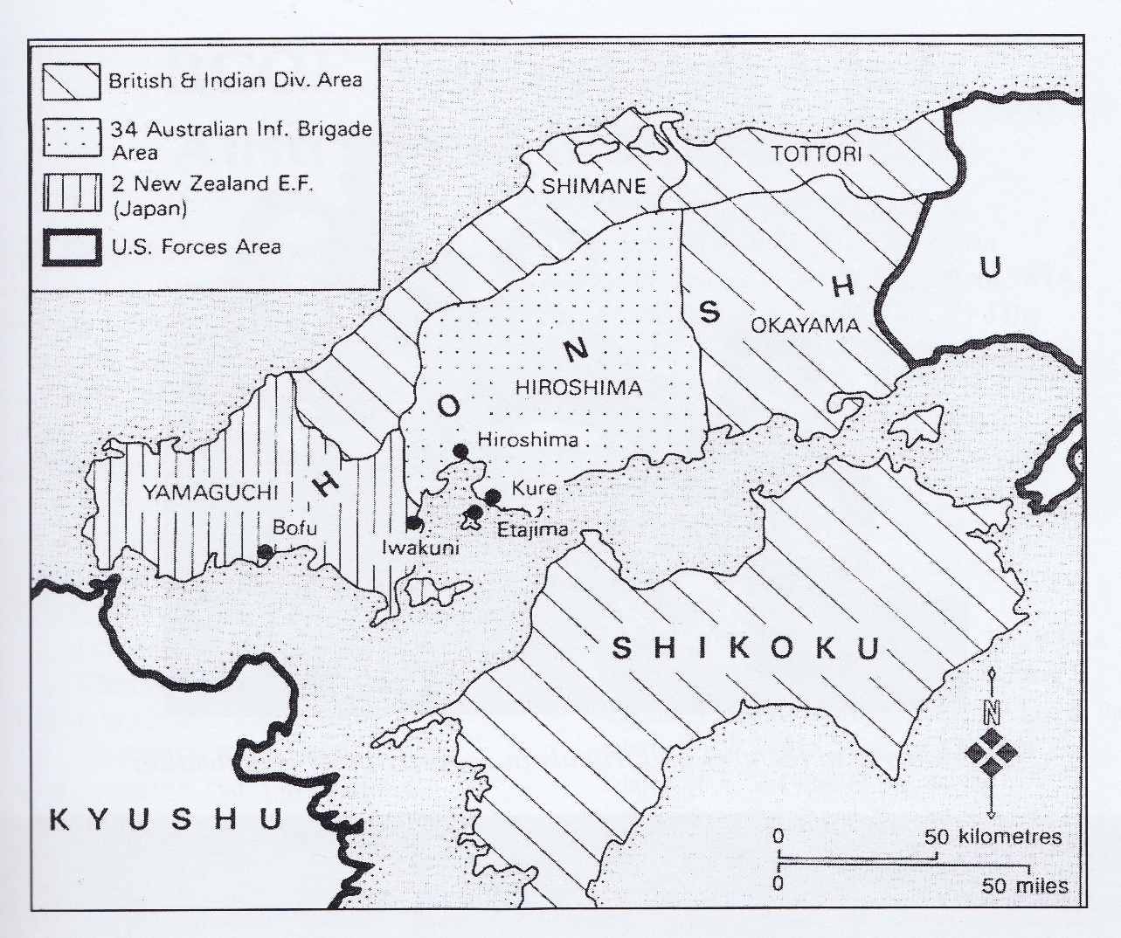
BCOF areas of responsibility

Japan (BCOF)
1946 – 1948

After concentrating on the island of Morotai, the Battalion participated in the occupation of Japan as part of the 34th Australian Infantry Brigade from February 1946 to December 1948. The policy for British Commonwealth participation in the occupation of Japan, as laid down by the Joint Chiefs of Staff in Australia was briefly:

- To represent worthily the British Commonwealth.
- To maintain and enhance British Commonwealth prestige and influence in the eyes of the Japanese and of our Allies; and
- To illustrate to, and impress on, the Japanese people, as far as may be possible, the democratic way and purpose in life.

The Battalion, throughout the remainder of 1946 and up to their departure in late 1948, carried out this policy with dignity, forbearance, and courage.

The primary objective of BCOF was to enforce the terms of the unconditional surrender that had ended the war the previous September. BCOF was required to maintain military control and to supervise the demilitarisation and disposal of the remnants of Japan’s war-making capacity.

The 66th Bn sailed from Morotai, and arrived in Kure, Japan around 21st February 1946 aboard two less than luxurious Liberty ships, the SS Stamford Victory and the Pachaug Victory. They then moved immediately to 34th Australian Infantry Brigade concentration area camp at Kaitaichi on the Inland Sea between the previous Japanese Naval Base at Kure and the atom bombed city of Hiroshima.

Kure in mid-February the weather was freezing, with the troops to be billeted in draughty barracks at Kaitaichi. The barracks had no windows, no heating and practically no lighting. It was a very bad beginning, but with typical Australian resourcefulness and scrouging they were soon comfortable and being fairly well fed.

“Sailing into Kure was quite an experience. The shoreline was lined with sunken battleships with only the top deck and superstructure above the waterline. The massive shipyard docks were filled with destroyed submarines of all types as well as other types of naval craft.

Our barracks were single story wooden structures built on reclaimed land. They had been storehouses. The climatic change for troops who only a few months earlier had been campaigning in the tropics to a Japanese winter was traumatic even though the southern areas of Japan have relatively mild winters.

Barracks heating was a case of improvisation. Diesel fuel proved the best system when it was ignited in 44-gallon drums using a drip method with heat being forced through flues to the center of the hut. Our uniforms were the old winter service dress which had not altered since World War 1, and the only concession to the climate was the issue of motorcycle DR gloves, hardly suitable for good rifle drill.”

Lt G.J. Lucas, MC (66th Bn original)

The 66th Bn was stationed at Kure (once the largest naval base in Japan) and later stationed in the prefecture of Hiroshima, which was divided into three areas of unit responsibility. The 65th Bn guarded the eastern area, the 66th Bn the central region and the 67th Bn, the western areas. During this time, the Battalion was temporarily garrisoned at Tokyo and Ebisu, as part of its occupation duties.

For the soldiers on the ground there was a sense of apprehension. The Japanese had been a feared and dedicated former foe with a fierce loyalty to their Emperor, but now all the Australian soldiers found was burned buildings, general chaos and widespread misery.

Throughout the remainder of 1946, and up to December 1948, 66th Bn carried out Occupation Force duties in Japan. The duties of the Battalion in Japan included many arduous and unpleasant tasks such as Barracks improvement, orientation, familiarization, security patrols, repatriation of Japanese POWs, picqueting of trains and the removal of ammunition dumps. Among the more pleasant ones were such activities as tours of guard duty in Tokyo at the Imperial Palace. The CO 66 Bn noted that for the “first 20 months of their occupational role they (units) were completely involved in operations with very little time spent in garrison duties. Training was confined to specialists in disposals and intelligence”.

Main tasks conducted for the 66th Bn involved guarding BCOF headquarters on the island of Eta Jima, finding a midget submarine base (at Kanokawa) on the island, along with extensive ammunition dumps and weapons. They also patrolled areas where it was suspected the 'back market' was rife, with, on occasion, the battalion rotating with the others to do guard duties at the Imperial Palace in Tokyo. They also established an NCO school at Hachihonmatsu and conducted range practices and courses at Haramura.

One of the Battalion’s responsibilities was the disposal of ammunition from Hachihonmatsu storage area, some 20 miles north of Hiro. In all some 8000 tons of ammunition including some rapidly deteriorating mustard gas bombs were removed, taken by train and then onto lighters and dumped of the continental shelf. Despite some hairy moments, no casualties occurred.

The first birthday celebrations for the battalion were at Hiro on 16th October 1946, with plans for the day including an Officers v Sergeants football match followed by a dinner. The football match was attended by all Battalion members quite voluntarily as most wanted to see blood spilt. There was also no shortage of food nor liquor with the local Asahi brewery on the outskirts of Hiroshima. The troops reckoned its non-destruction by the atom bomb was indeed an “Act of God”.

“Sport played an important part of our lives with each platoon fielding a rugby league team. The games were played on a decomposed granite field with not one blade of grass, so high tackles were the order of the day. Old sock tops covered the knees and mittens for the hands. Despite this protection a lot of 66 Bn skin and blood was left on that ground.

In 1948 Lt Col MacArthur the new CO had several train loads of soil brought from Haramura training area to cover the field, grass was planted and thus after two years we had a proper sports field.
Lt G.J. Lucas, MC (66th Bn original)

By late 1946 Australian dependents started to arrive, those members with dependents were housed in newly built dwellings at Nijimura, an old airfield close by the Battalion lines.

In early 1947 many of the originals left for Australia and discharge, with others who had opted for a military career taking some leave in Australia. Training periods increased at Hiro with the introduction in June 1947 of the new CO, Lt Col M.H McArthur who assumed command of the Battalion, and was succeeded in August 1948 by Lt Col S.C. Graham MC, who brought the unit home to Australia.

In September 1948 it was announced the Battalion would be withdrawn from BCOF and would return to Australia. An advance party departed in September 1948, with transfers to the 67th Bn beginning, both the 65th and 66th departed Japan on 7th December, aboard HMAS Kanimbla.

On the 23rd of November 1948 the 66th Bn was renamed the 2nd Battalion, The Australian Regiment (2 AR), and with the winding down of their duties in Japan the 2nd Battalion returned to Australia in December to take up a part of the 1st Independent Brigade Group at Puckapunyal, Victoria.

As an entity 66th Australian Infantry Battalion had a short history, but many hundreds of first-class soldiers of all ranks passed through it. It was a good and happy unit!

Personnel who served in Japan received no formal recognition by way of a medal or service clasp, which contributed to a feeling of disaffection and lack of appreciation on the part of many who had served. This was later remedied in 1995 to a small extant through the award of the Australian Service Medal 1945-1975 to those veterans who served between 1945 and 1952.

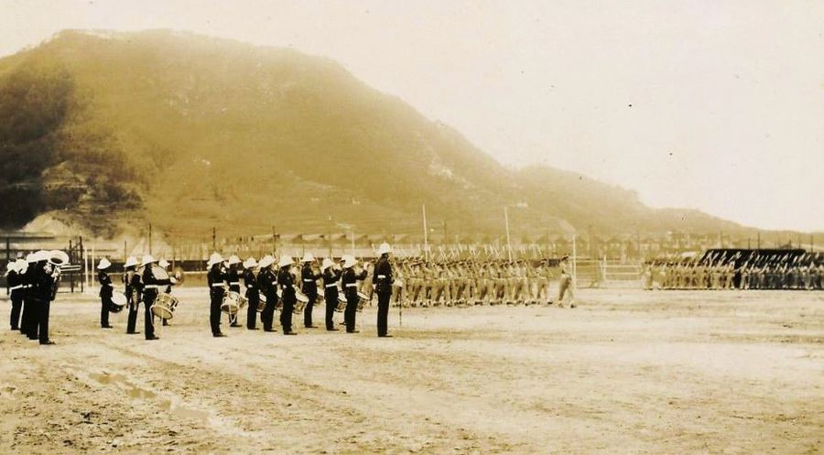

66th Australian Battalion Band – The 66th Battalion was stationed at Hiro Naval Arsenal, at Kure in the Hiroshima Prefecture of Japan.

Area of Operations.

Tokuyama – This city, positioned with Nagasaki to its west and Hiroshima due east, was a very important area for the Japanese Naval-Command, because of the local production of high-density oil, used for the maintenance/running of sub-marines the infamous (Kaiten), or ‘midget sub-marine’. It was in fact a highly secretive project based on the island of Otsushima nearby. After the war, the mini base was found by the 66th Bn (Jenko Force), and a large number of midget subs, and poison-gas on Eta-Jima and Otsushima Islands.

The ‘Kaitan’ Island of Otsushima – Is a windswept cold grey place, with only a few houses and a small population living there. Now days a small gauge railway line is visible at the shore, tunnels ran deep into the hills. A museum to commemorate the ‘valiant dead’ lies along a steep track that is both enduring and fascinating to bear witness to.

Personal Experiences

MUTINY AT MOROTAI – A Reflection

(Wally Mills, MBE)

Wal Mills MBE first joined the Army at the beginning of 1942 when he was 15, and after initial training he was posted to the 10th Advanced Ordnance Depot in Papua. His age was discovered, and he was sent home to Australia and discharged. He joined the AIF later in 1942, to serve with 2/12 Calvary Commando till his posting to 66th Australian Infantry Battalion, through to its name change to 2RAR. He served as a CSM with 3RAR in Korea, then as RSM 1 Reinforcement Holding Unit in Japan, returning as RSM of 2RAR in 1954. From then till 1958 he remained with 2RAR including its first tour in Malaya.

Was it Mutiny? Was it a Jack up? Was it a Brigade Parade without Officers and Senior NCO’s? Or was it a political blunder on a large scale?

As an original member of 66th Australian Infantry Battalion I will relate to you the details of an event which happened over 50 years ago seen through the eyes of a young soldier.

Whilst at Morotai the force was subjected to a monotonous daily routine of drilling and ceremonial parades all in the extreme heat, the guarding of Japanese POWs and attendance as guards at war crime trials. Conditions were very poor and generally troops were most dissatisfied because at this stage many members of the Australian forces were being sent home on discharge. The dissatisfaction arose from lack of communication to the troops regarding the date of departure for Japan. Complete boredom was the result of this uncertainty.

As a Lcpl and then soon after being made a Cpl I could see that discontent and low morale was rife. I approached the RSM, Wilfred Seymore, who then in turn the CO of 66th Bn, Lt Col George Colvin whether we could have a corporals’ mess to alleviate the monotony and raise morale. To my knowledge this was the first-time permission was granted for a corporals’ mess to be established within a Battalion. The mess was given a marquee and tables. Tennis tables were made available, 2 kerosene refrigerators were supplied, and a bar was established. This was a great asset as morale improved and comradeship, which would not otherwise have occurred, emerged within the new Battalion.

Unlike any other situation, the mess in the final stages became the central point for the 34th Brigade Organisation Committee, consisting of corporals, to organise the jack-up details of which I will now describe.

On the night of Thursday, 10th January 1946, a delegation from the corporals’ mess came to the sergeants’ mess seeking the advice of both myself (who was past president of the corporals’ mess, promoted to L/SGT on 5th Jan 1946) and SSGT Sam Condon as we were both held in high regard. We proceeded to the corporals’ mess where I addressed them first, advising them strongly against taking such as action. SSGT Sam Condon reinforced my advice.

We then left the corporal’s mess. Waiting outside and having listened to what we had said with great intent, were the CO and the RSM. They walked towards us and stated that the only thing that saved the two of us was the fact that we were advising the corporals with sincerity against the stupid action they were contemplating. Our advice to the corporals went unheeded.

On the morning of 11th Jan 1946, LTCOL Colvin had already called a battalion parade, but this was disobeyed with the exception of B Company who were on Regimental duties and hence unable to join in except for a few of their members. The rest of the 66th Bn assembled in column groups by companies. Without any order being given or heard they marched off regimentally dressed with band playing onto the Brigade parade ground which was the airstrip at Moratai adjoining the camp surrounds.

They formed up with the rest of the 34th Brigade group watched by Officers and Senior NCOs who to a man did not participate except, to the best of my knowledge, for an engineer sergeant. He was to be the spokesman for the brigade group for their demands. He had arranged a dais, loudspeakers and hailers. It was a magnificent parade and the demands put forward were:

-A definite date for the Brigade’s departure for Japan, or

-Return of all troops to Australia.

Brig Northcote who was the Brigade Commander had returned to Australia on leave, and LTCOL Colvin was acting in his capacity. The spokesman called on LTCOL Colvin to address the parade. Initially he refused, but on learning that the whole 34th Brigade was on parade, regimentally dressed, and waiting him, he then reluctantly did so with the proviso that he would leave the dais if there were any catcalls or interjections.

It was reported that signals were sent from Moratai to Australia that night. As a result of that signal a return signal was sent from Australia to 34th Brigade HQ that the service of all personnel would begin as from the 1st January 1946.

The action of the troops certainly stirred the politicians. The then Minister for the Army, and Deputy Prime Minister, Frank Forde, arrived on the 22nd Jan 1946 by flying boat from Australia in response to the protest march of the 11th January. He addressed a packed audience of troops in the outer Brigade cinema. He was dressed in hat, khaki, felt, fur without badge, a green safari suit and brown boots-new and unpolished – with gaiters.

For the first 5 to 10 minutes, he was subjected to catcalls and interjection, but being a good politician managed to calm the troops down and had them on side. He was able to inform them that ships would be diverted to Moratai to take them to Japan within the next 4-6 weeks. He withered under the terrific heat of Moratai and asked more than once “how do you boys stand the severe heat up here?” he received the obvious answer, “we just have to; there’s no place to go to!”

Mixing informally with the troops he made it known he sympathised with their cause. Later that day he rejoined his flying boat and returned to Australia hopefully to a cooler climate in Canberra both weatherwise and politically.

The 66th Bn finally embarked on the Liberty ship “Pancho Victory” on 17th Feb 1946 arriving in Japan on 23rd Feb.

As a result of the Corporals’ being involved in the parade of the 11th Jan, the Corporals’ mess was demolished on the 12th Jan, never to be raised again.

EXPERIENCING THE AFTERMATH OF ATOMIC EXPLOSION
(Brian Evans, 1946-1947, BCOF 66 Australian Infantry Brigade, Japan)

Brian Evans spent 20 months in Japan with BCOF, returning to Australia in November 1947. He was discharged one month later at the age of 20.

Brian Evans was 18 when he joined the AIF in May 1945 so was a bit late to take part in the fighting. Instead, he volunteered for the British Commonwealth Occupation Force (BCOF) and found himself sailing aboard HMAS Duntroon with other volunteers in March 1946.

The trip proved to be an adventure in itself with a number of incidents occurring which delayed the ship. The trip lasted almost four weeks, at least a week longer than normal, thanks to a typhoon, sickness, and damage by a tug and a tidal wave. With 1400 reinforcements for BCOF on board, the Duntroon had to make an 850 km mercy dash to Guam after a Digger became dangerously ill following a cerebral haemorrhage. On arrival at Guam, the ill soldier was admitted to the US Army Hospital.

Meanwhile, all shipping had been ordered to leave Port Apra to dodge a typhoon that was sweeping towards Guam. The ship was by now very short on drinking water, and it was strictly rationed for the next three days as the Duntroon headed away from the typhoon. The ship then returned to Guam where it took on water and was about to sail when an American tug stove in a porthole on her weather deck. An hour later a tidal wave warning was broadcast, and all ships were again ordered to leave port.

The Duntroon was forced to stay behind for repairs and lifebelts were donned by all on board while they sheltered below decks. The tidal wave didn't eventuate and after eight hours things were back to normal. After repairs were completed, she set out once more for Japan. Two days later one of the crew collapsed at the wheel with heart trouble but eventually Duntroon reached Japan.

The Australian contingent of the BCOF consisted of three battalions 65/66/67, 34 Brigade HQ, Australian Service Corps and other Army support groups plus the RAAF. Brian Evans recalls that on arrival in Japan he was stationed in barracks at a town called Kaitaichi and later moved to new barracks at Hiro within the Hiroshima Prefecture.

"Hiro was approximately 10 miles from Hiroshima so naturally, when we were allowed leave we visited the devastated city," Brian said. "It showed the vast effects of the atom bomb which had been dropped six months earlier. We saw many of the scarred and maimed victims who were still living in temporary shelters."

Thanks to his experience as an artist on a Sydney newspaper, Brian was seconded to his battalion's intelligence section, which allowed him greater freedom of movement.
"It also afforded me interesting and varied experiences in the many tasks required in those early years of the occupation," he said. "One of these consisted of traversing some of the main dirt roads, tracks and bridges to ascertain the suitability for truck or jeep transport within our responsibility.

"I also accompanied some infantry patrols, at that time rifles and side arms were carried, in case of possible hostilities. However, to my knowledge no serious incidents occurred." The patrols were necessary to locate and report stocks of ammunition and explosives as part of the disarmament program. "In one of the huge and extensive man-made tunnels honeycombing the nearby mountains, we found stores of huge torpedoes," Brian recalled. "Items located in the tunnels were indicated on our area maps back at the battalion intelligence office as targets for future demolition. The information was forwarded to the Australian bomb disposal unit to locate and destroy. I have reason to believe that some of these soldiers were killed carrying out this task."

On one of the patrols Brian and his colleagues found a number of miniature submarines similar to the ones which entered Sydney Harbour in 1942. Many of the mountain tunnels were set up as hidden mini factories producing materials for war, he said.

The occupation authorities decreed that girls sold into prostitution by poor farming families were to be freed of their bonds. "Teams of soldiers in all areas made raids on brothels, together with interpreters who informed the girls of their rights," Brian recalled. "However, many knowing no other way of making a living, didn't bother to accept their newfound freedom." Another interesting job was to observe the first democratic elections decreed by Macarthur's military government.

"Giving women the right to vote, we were alerted to stop any intimidation, especially by communist groups, corrupt officials and Japanese police who were greatly feared as 'thought police' during the war," Brian added.

"The elections throughout Japan consisted of local, state and federal, covered a five-week period. The group under my responsibility (I was only a 19-year-old private) consisted of two Australian boat drivers, one sergeant interpreter and four Japanese crew for the boats. "We had two boats: one steam, one diesel which were previously Japanese owned and had been commandeered by the army. Being on detachment from the battalion, we lived for the five weeks in a small hotel in a fishing village called Kinoe. We used one boat to patrol the three islands in the inland sea of the coastal naval port of Kure, which was located in my area.

"In order to be self-sufficient, the second boat was necessary to bring our food supplies as well as to deliver reports of apparent success of compulsory voting. During our stay, we developed a good relationship with the hotel staff on Kinoe. They were mostly women, apart from the elderly owner."

On one occasion they transported several of the women over to another island so they could attend a festival on one of their special days. Living in Japan was very restrictive for the average serviceman "We lived among the civilian populace but had a non-fraternisation rule. We were discouraged by the military police of the three allied forces, American, English, and Australian.

"Because of this rule I was fortunate to have the opportunity to share, on numerous occasions, in the everyday life of the Japanese. On one occasion, several of the personnel from our section were invited to attend the wedding of one of our Japanese interpreters.

"In our battalion we had three soldiers who had been prisoners of war of the Japanese and had worked on the Burma-Thailand railway. One of these men, who was a great mate, practiced non-fraternisation with the Japanese. The other two, being typical knock-about Aussies, merged in with the other troops."

Towards the end of 1946, the battalion went on a tour of duty to Tokyo where they were involved in the changing of the guard at the Imperial Palace.

"During my tour of duty in Tokyo, I attended, as a spectator, the war trials where General Tojo, the leading Japanese General during the war, was on trial. He was later executed.

"To smarten the appearance of our drab Second World War uniforms on ceremonial parades, it was decreed we should whiten our webbing. This consisted of gaiters, belt, scabbard, rifle sling and shoulder straps, which up till then had been a dull kaki.
On one of our patrols large quantities of bleach were found so we proceeded to bleach our webbing. We had not allowed for the effect of the bleach on the stitching.

Fortunately, it was on a practice parade, when the order to present arms was given, that the snappy activity involved caused much of the webbing to fall apart.
"In order to resolve this problem, blocks of soluble whitener, known as Blanco, were supplied. However, when any equipment slapping manoeuvre was carried out, a great cloud of white dust emanated from the parading battalion of 500 'blancoed' troops."

3914 (ex-VX946994, VX221330) Leonard Harold William 'Billy' Andrew.

(AWM – Collection)

Andrew enlisted in the Second AIF on 11 April 1944, soon after his 18th birthday. He served in the Pacific Theatre before being posted to Japan with 66th Australian Infantry Battalion as part of the British Commonwealth Occupation Force after the Second World War. In Japan, the then Sergeant (Sgt) L H Andrew was a member of the Provost Combined Rugby League Team. The team went on to become the British Commonwealth Occupation Force (BCOF) premiers in April 1950.

Andrew also met his wife, Tomiko, in Japan, who is represented in the photo by the doll. Tomiko was born in Hiroshima and was there the day it was bombed. She was feeling sick that day and didn’t go to work, which saved her life. She lost her father, three sisters and one brother in the blast. She and her mother were inside the house and had all their clothes burned off and their hair singed. Her father was fixing the roof at the time of the bombing and was too badly burned to survive. Her family borrowed some petrol from soldiers and cremated the father’s body. She looked for her sisters for several days but did not find any trace of them. Despite the anti-fraternizing policy between the occupying forces and the locals, they began to date. In 1952, Andrew was sent to Korea, with the Australian Ancillary Unit as a Warrant Officer Class 1. He returned to Japan on leave to marry Tomiko and then returned to Korea to complete service until 1953. After an extensive application process, Tomiko was cleared to immigrate to Australia only due to the recent relaxation of the 'White Australia Policy' in 1952. Arriving in Australia together, Tomiko was warmly welcomed by Andrew's large family, and they were married with children, for 41 years until her death in 2007.

Andrew also saw service in Papua New Guinea after joining the Royal Australian Corps of Military Police and commissioned to lieutenant in the mid-1960s. Andrew completed his career with the rank of Major as Deputy Assistant Provost Marshall, 3rd Military District. He was discharged on 1st April 1981 at the age of 55, after 37 years of service.

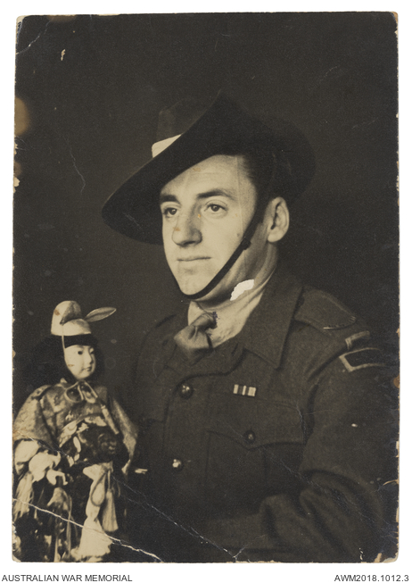

TIMELINE OF EVENTS

66th Australian Infantry Battalion.

Bn was raised from elements of 1 Corp Troops, 9th Australian Infantry Division (AIF) at Tarakan-Labuan.

1945

11 Oct 1945 - Volunteers for the 66th Australian Infantry Battalion (BCOF) (34th Australian Infantry Brigade.) were selected at a temporary Camp at Tembau Beach, Labuan.

26 Oct 1945 - The Bn was formed with an effective strength of eight (8) Officers and two hundred (200) Other ranks...personnel were from the 25th Australian Infantry Brigade. Tarakan troops (volunteers) arrived later.

02 Nov 1945 - Unit strength reached six hundred (600) all ranks.

03 Nov 1945 - Bn embarked on LST 408 and 324 for Moratai.

08 Nov 1945 - Work began on Camp which was to be flanked on the West by 67th Bn, and on the East by the 65th Bn.

14 Nov 1945 - Bn Band played at its first Parade.

Nov 1945 - NCO courses were conducted by RSM, WO1 W. Seymour to bring NCO strength up to Bn requirements. Course continued into December.

1946

Feb 1946 - Unit strength, 27 Officers and 553 Other Ranks. Unit with other 34 Brigade Bn’s were initially based at Kaitaichi. Duties in brief were to assist in disarming and de-militarising Japanese servicepersons including other nationalities who served with Japan at war. To place a military control on the Prefectures under their immediate control as contained in the SCAP Directives.

Mar 1946 - Patrolling and deployment of A, B and C Companies under command of Major R.G. Jenkinson (Jenko Force) for six weeks to guard various tunnels, in Kure and Kure Wharf. On many occasions "Jenko Force" was asked to put on "shows of strength" to the Japanese.

21 Mar 1946 - A patrol under Lt D.R. McLeod were deployed to the railway station at Kure. Armed and in "battle order", with rifles with fixed bayonets, Owen sub-machine guns, and light machine guns, all with charged magazines, they leapt from their transport and secured and searched the buildings. After ten minutes they returned to their vehicles and moved on to the marketplace, where a similar demonstration was put on. The demonstrations did not appear to impress the Japanese they simply looked on with little expression.

Apr 1946 – The Bn Companies were now scattered - with elements at Kaitaichi, Hiro, Hachihonmatsu and Tokyo, and Eta Jima. Companies were rotated through patrolling and guard duties on Eta Jima, with C & D Companies deployed there until April. Their tasks were to guard Head Quarters BCOF area and the extensive Japanese weapons and ammunition dumps on the Island, and later assisted in the disposal, of which many thousands of cases were dumped at sea. A platoon was also required to occupy and guard ammunition dumps at Hachihonmatsu, Kawakami and Yonemitsu. First platoon for this duty was 7 Platoon, A Company commanded by Lt J.W. King.

25 Apr 1946 - The Bn with other Australian Units participated in Anzac Day Remembrance service and parade.

02 May 1946 - Patrols were required in Saijo to disperse crowds of Koreans who had taken advantage of their "free" status and were demonstrating against any form of Japanese authority.

02 May 1946 - The Bn provided B Company for Guard duty in Tokyo. The Company with other Companies of the Brigade went into training at Kaitaichi where the Composite Btn were preparing for their stint as the first BCOF troops to undertake Garrison Guard duties at Ebisu camp, Tokyo.

04 May 1946 - The C in C (BCOF) Lt General J. Northcott CBE DSO, visited the camp where the Composite Bn was training to inspect their progress.

06 May 1946 - also saw elements of the battalion at Saijo monitoring the flow of Koreans being repatriated to Korea, and the demobilising of Japanese servicemen passing through Saijo.

07 May 1946 - Composite Bn arrived in Tokyo and marched to Ebisu Camp from Ebisu Station.

07 May 1946 - Under command of Lt H.M. Fox (ex POW) troops handled the disposal of 508 tonnes of mustard gas and lewisite gas, 267 tonnes of explosives and destruction of ammunition at Haramura. Lt Fox commanded 12 Pl of B Company.

08 May 1946 - Under the command of Lt R.H. Marson DSO (OC 65 Bn) the Composite Bn made up of 34th Brigade troops were the first Australian troops to march through the Streets of Tokyo. In all 680 servicemen under Lt Colonel Marson marched via Main Station to Hybia Park via the main entrance to the Imperial Palace, where the parade was inspected by US General Bradford.

11 May 1946 – A Company (65 Bn) were accompanied by the Brass Band of 66th Bn for a ceremony of changing of the Guard on the Imperial Palace Plaza, with the United States 2nd Cava1ry Brigade Guard. Private Hallett (65 Bn) was the first Australian guard to mount guard in front of the Imperial Palace.

14 May 1946 - The Prime Minister of Australia, Mr Ben Chifley with the C in C (BCOF) visited the Garrison Bn at Ebisu Camp, Tokyo, to inspect the Bn.

20 May 1946 - All leave cancelled for Composite Guard Bn due to "mass demonstrations by Japanese communist elements - later in the day all troops stood down.

24 May 1946 - Troops were marshalled for the "Empire Day" parade through Tokyo. Order of March:
- Band of the Cameron Highlanders,
- Royal Navy and Royal Australian Navy,
- Royal Marine detachment,
- Kumanon Band,
- AIF. (A company - 65th Bn and B Company 66th Bn),
- New Zealand detachments,
- 2/5th Royal Ghurkha Regiment,
- 1st Punjab Regiment,
- Madras Rifles,
- New Zealand Band,
- Royal Air Force,
- Royal Australian Air Force,
- Royal New Zealand Air Force,
- Royal Indian Air Force.

C Company (67 Bn) provided a guard of honour for the Commander in Chief, (BCOF) Lt General Northcott and other Allied dignitaries. The route of the march was 2 miles long, via the Imperial Plaza to the Streets of Tokyo. The "general salute" was played by the AIF Band. Parade was inspected by the C in C (BCOF) following which an investiture was made when Lt Colonel D.R. Jackson received the DSO.

01 Jun 1946 – B Coy (66 Bn) relieved A Company (65 Bn) on Palace Guard.

08 Jun 1946 – 66th Bn Band moves to Tokyo Central Station to entrain for Kaitaichi Base.

11 June 1946 - The Bn with others in the Brigade help supervise Japanese elections.

Jul 1946 - Bn area of responsibility now included 60 Islands to patrol. Their area was approximately 2000 square kilometres in the centre of Hiroshima Prefecture.

10 July 1946 - The main body of the Bn moved from Kaitaichi to a Camp a short distance away to North Camp at Hiro. The barracks had previously been part of a Japanese arsenal and accommodation for workers.

21 Sep 1946 - B Company under command of Captain A.P.A. Denness raided the town of Kinoe and the shipping in its harbour. The raid was in response for smuggling.

Nov 1946 - Bn strength: 30 Officers and 885 Other Ranks.

Dec 1946 - Replacements from Australia allowed others in the Bn to be discharged or go home on leave. Battalion prepares to undertake Garrison duties in Tokyo.

1947

05 Jan 1947 - Main body of the 66th Bn Garrison Guard arrives at Ebisu Camp. The Bn had in support a detachment from lst Armoured Car Squadron and, BCAIR - a total strength of 750 all ranks. The Bn was organised into five Companies, 1,2,3,4 Guard Coys and Administration Coy. 4 Coy consisted of Armoured Car Squadron and BCAIR detachments. Lt Colonel G. Colvin commanded the Garrison Bn with Major C.F. McKenzie MC as 2IC. Major C. Ives was in command of lst Armoured Car Squadron & BCAIR. Adjutant of the Bn was Captain I.A. Geddes and other Coy commanders were, Captain C. Downs, Captain K. Turbayne, Captain R. Garland MC, and Captain R. Waddy. Guard duties commenced.

26 Jan 1947 - 2 Company mounted Guard on Plaza. During the afternoon an exhibition of Rugby Union match was played at Nile Kinnick Stadium between 66 Bn and 2 Battalion Royal Welch Fusiliers. The latter won 9-0.

28 Jan 1947 - Lt Colone1 M.H. McArthur marched in to take command from Lt Colonel G. Colvin DSO, ED.

02 Feb 1947 - 1 & 2 Companies plus detachment 34 Brigade and Admin Company marched out to Hiro.

1948

03 May 1948 - Main body of 66 Bn arrived at Ebisu Camp.

10 May 1948 - A Warning Order was issued by 2 United States Cavalry Brigade that a state of emergency would exist from 0730 hrs. 0630 hrs this Order was rescinded.

25 May 1948 - Formal hand over of Guard duties in Tokyo (BCOF) on the Imperial Plaza. 66th Old Guard commanded by Lt Heath. 66 Bn depart Ebisu for Base.

Aug 1948 - Bn command changed hands. Lt Colonel S. Graham MC took command.

06 Sep 1948 - The main body of 66 Bn under the command of Major R.S. Garland MC arrived at Ebisu Garrison Camp to take up Guard duties.

07 Sep 1948 - Official handover by 67th Bn, old Guard to 66th Bn new Guard on the Imperial Palace Plaza. Lt R.W. Hone commanded the Guard and the Guard commander; Captain A.W. Power inspected the guard, the combined Band of 34th Australian infantry Brigade provided music.

14 Sep 1948 - Warning Order received from Bricosat to prepare the Guard for the arrival of General Sir Thomas Blamey at Haneda Airfield on 16th and a Guard of Honour for the C in C Lt General HCH Robertson 0830 hrs. Due to bad weather the Honour Guard was cancelled.

17 Sep 1948 - Guard of Honour for General Sir Thomas Blamey at Haneda Airfield. Guard consisted of a detachment of General D. MacArthurs Honour Guard, detachment of 66th Australian Infantry Battalion GHQ Band, one (1) troop of United States Field Battery. Guard commanded by Captain Hodges, (US Honour Gd Gmdr) Captain A.W. Power, Lt R.W. Hone and Lt G.J. Geary being subordinate commands. The standard of battalion drill was good.

20 Sep 1948 - The Commanding Officer of 66th Bn, Lt Colonel Graham, MC marched in from Hiro base.

28 Sep 1948 - Bn strength, 22 Officers and 208 Other Ranks.

15 Oct 1948 - Formal handing over the Guard to 67th Bn. 66 Bn detachment departed to Hiro Base.

Nov 1948 - The Bn with other battalions of 34th Australian Infantry Brigade held the last Brigade Parade through Hiro and the city of Kure.

23 Nov 1948 - The Battalion became (redesignated) 2 Battalion.

07 Dec 1948 - Battalion sailed for Australia ending its BCOF duties.

CUSTOMS & TRADITIONS

66th Battalion - Colour Patch

Colour patches disappeared after WWII with the introduction of the formation patches and regimental and Coro flashes. The original colours stem from standard Infantry Battalion Colours in the Brigade from the 1st AIF. In late 1948 the Bn was directed to cease wearing colour patches and to replace them with woven titles bearing the Roman numerals LXVI in gold on a maroon ground.

66th Battalion – Regimental Badge

The design is crossed rifles with superimposed truncated cross, bearing the figures 66, and surmounted by a crown. The whole is surrounded by a laurel wreath. Beneath is a scroll containing the words Australian Infantry Battalion.

The crossed rifles are the traditional symbol of an Infantry Battalion. The truncated cross is the shape of the colour patch of the famous 9th Aust Div from which the unit was originally formed in Oct 1945. The crown symbolizes Australia’s membership of the British Commonwealth of Nations.

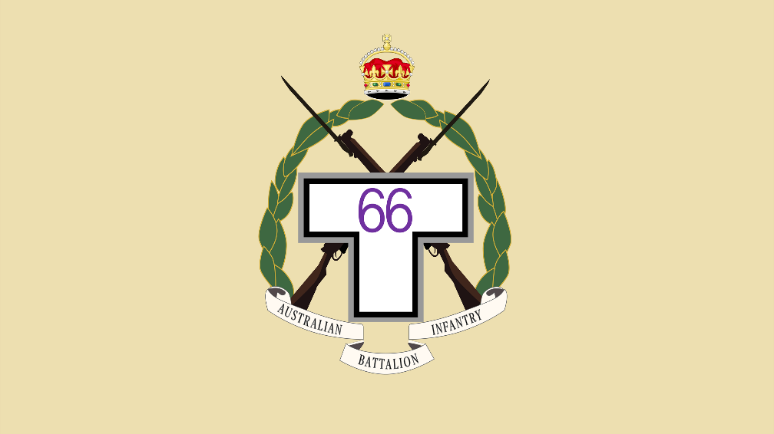

66th Battalion – Regimental March

In June 1947 the CO approached the Bandmaster, then Sgt Jack Silk to put Ringo (the Apple Song) to Brass Band Music. This was organised through decree, and MacArthur wanted the tune as the Bn March. From then on, Ringo became the ‘unofficial’ Regimental March until the departure of 2RAR to Korea in 1953. It became the official Battalion March in 1955 for the Presentation of the Colours.

The Apple Song – RINGO

I put my lips to the red apple,

And gaze silently at the blue sky.

The apple says nothing,

But I understand how she feels.

What a lovely apple, how lovely she is.

She’s a good girl, a kind girl,

And lovely, just like the apple.

If someone speaks well of her,

She gives a little sneeze.

What a lovely apple, how lovely she is.

When I whisper a morning greeting,

To my darling apple, or a farewell at night,

She bows her head slightly, without a word,

But her dreamy look says, “See you tomorrow”.

What a lovely apple, how lovely she is.

Let’s sing the apple song,

It’s more fun if two of us sing,

And merrier still if we all sing together.

Let’s tell how the apple feels,

What a lovely apple, how lovely she is.

66th Battalion – Band

The band of the 66 Bn in Japan normally wore service dress or khaki drill with white webbing, and sometimes with a white pith helmet. At times it wore a blue uniform which was the pre-war dress uniform of the Royal Australian Artillery.

COMMAND POSITIONS

66th Battalion - Command Positions
The following table provides details of 66th Battalion’s Commanding Officers and Regimental Sergeant Majors:

Commanding Officers:
16 Oct 1945 – 05 Jun 1947 LTCOL G.E. Colvin, DSO and bar, ED
05 Jun 1947 – 24 May 1948 LTCOL M.H. McArthur
24 May 1948 – 12 Aug 1948 MAJ S.C.F.G. McKenzie
12 Aug 1948 – 10 Jan 1949 LTCOL S.C. Graham, MC

Regimental Sergeant Majors:
Oct 1945 – Mar 1946 WO1 W. Seymour
Mar 1946 – Dec 1946 WO1 C. Carne
Dec 1946 – Dec 1947 WO1 J. Holland

ROLL OF HONOUR

66th Battalion – Roll of Honour

SX38810 PTE Samuel Edley EVANS
SX33581 CPL Leonard Ronald LISHMUND
SX26369 PTE Kenneth PARKEN
QX55791 PTE Neville Leo ` VOLLING
WX23289 PTE Henry Alan ROWBOTTAM

‘Lest we forget’

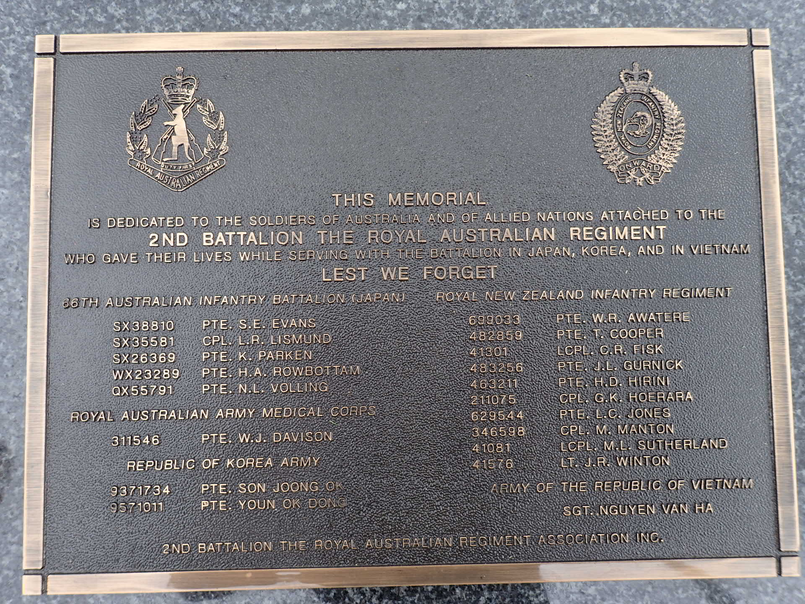
2 RAR Association dedicated Plaque laid at the National Memorial Walk

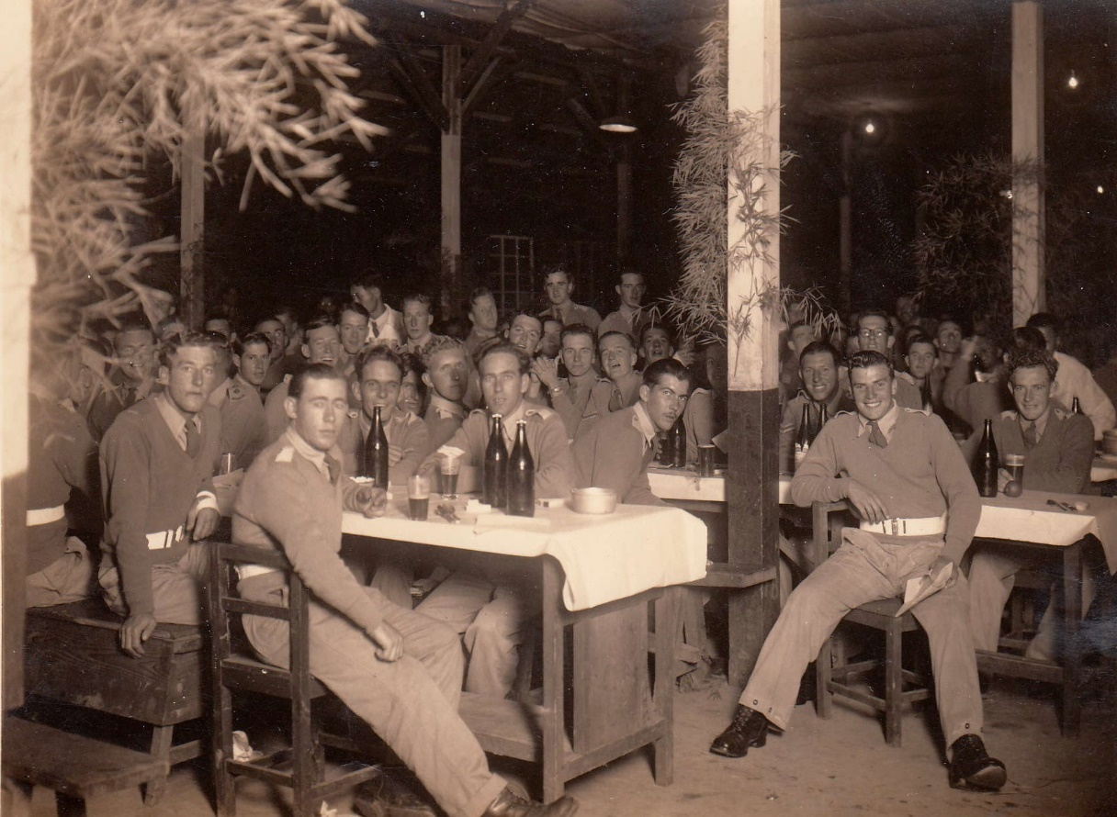
66th Bn members enjoying a well-earned drink.

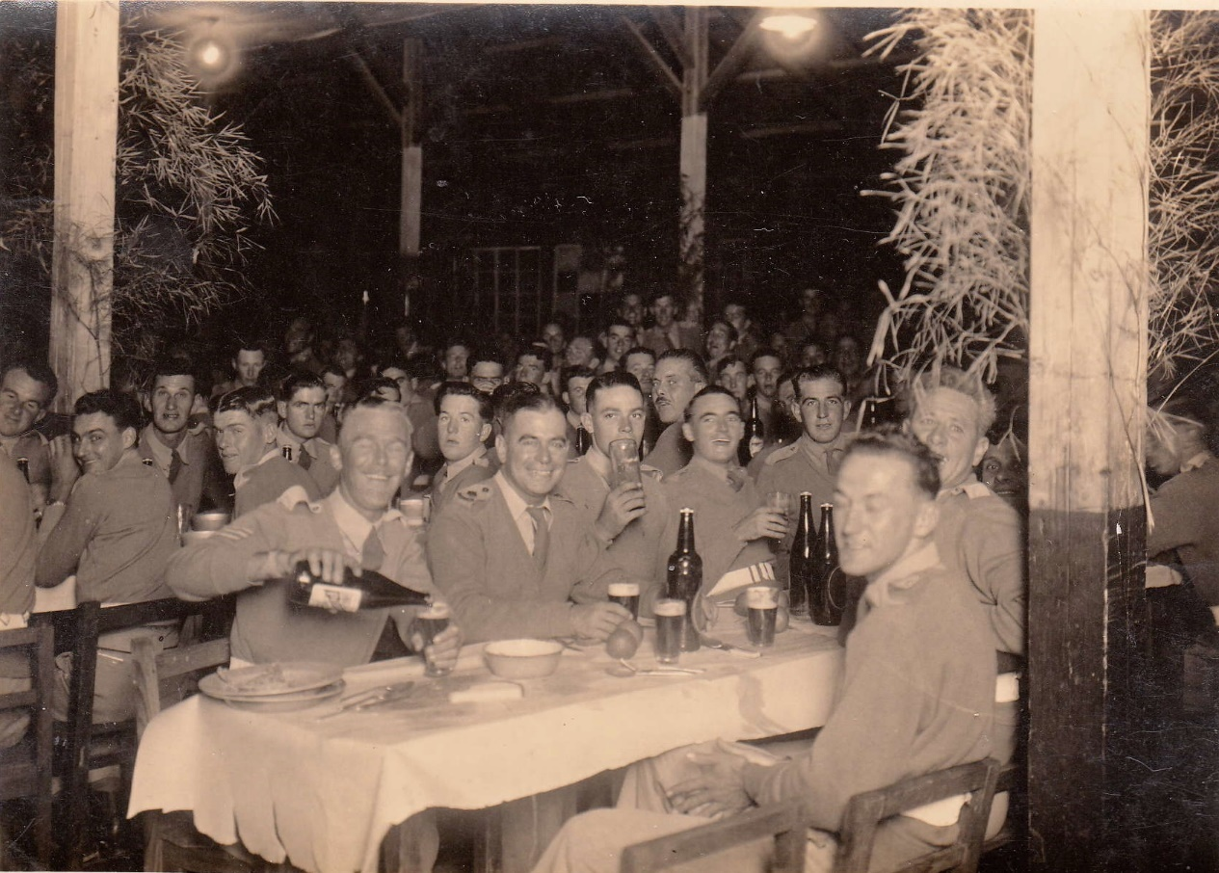
66th Bn function

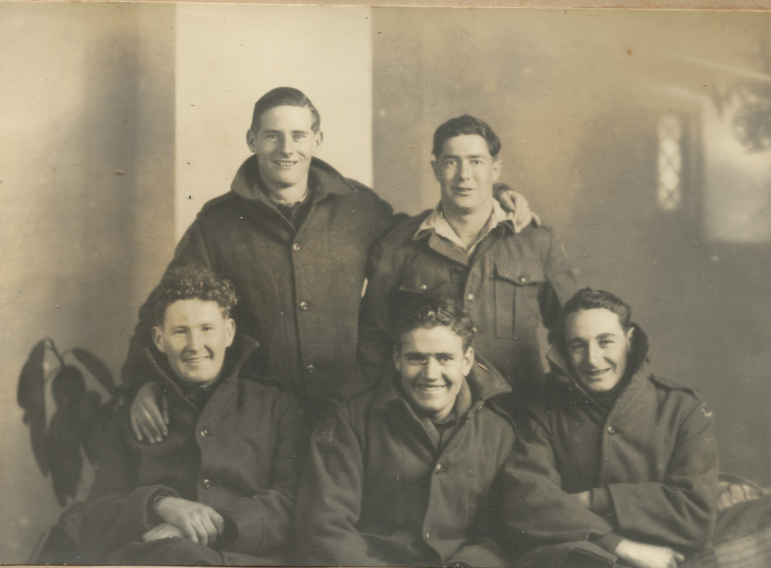
66th Bn members fitted out in new cold weather clothing.

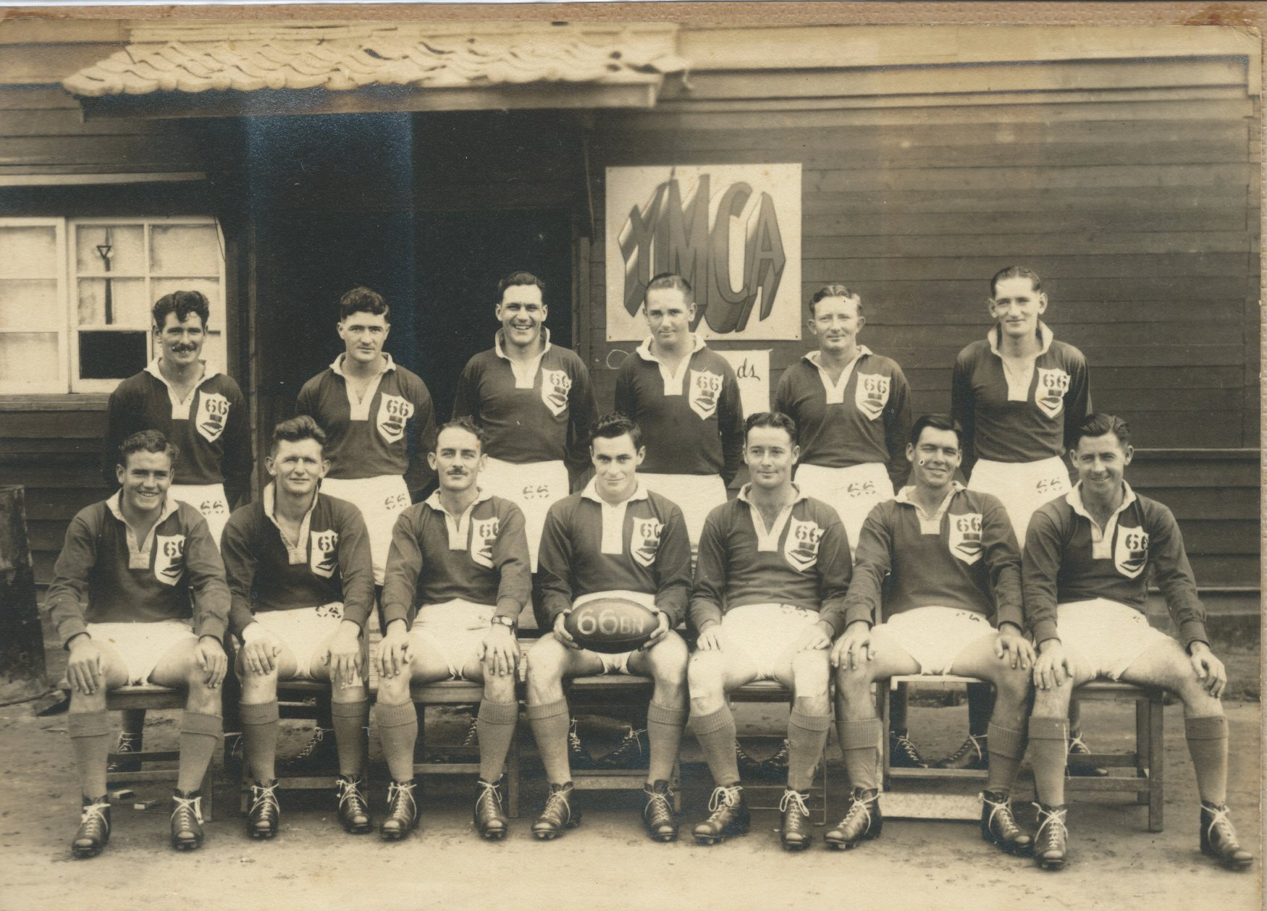
League photo left to right – Backrow - Jones, Eyre, Harvy-Lister, Entwistle, Elliot, Silk,
Front-row – Priestly, Aspinal, Gorman, Murdoch, Moore, Smith, Flanery

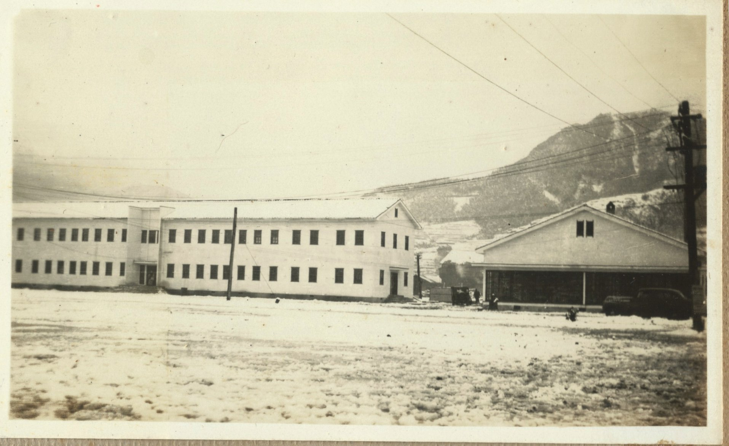
66th Battalion – Officer’s Mess Hut

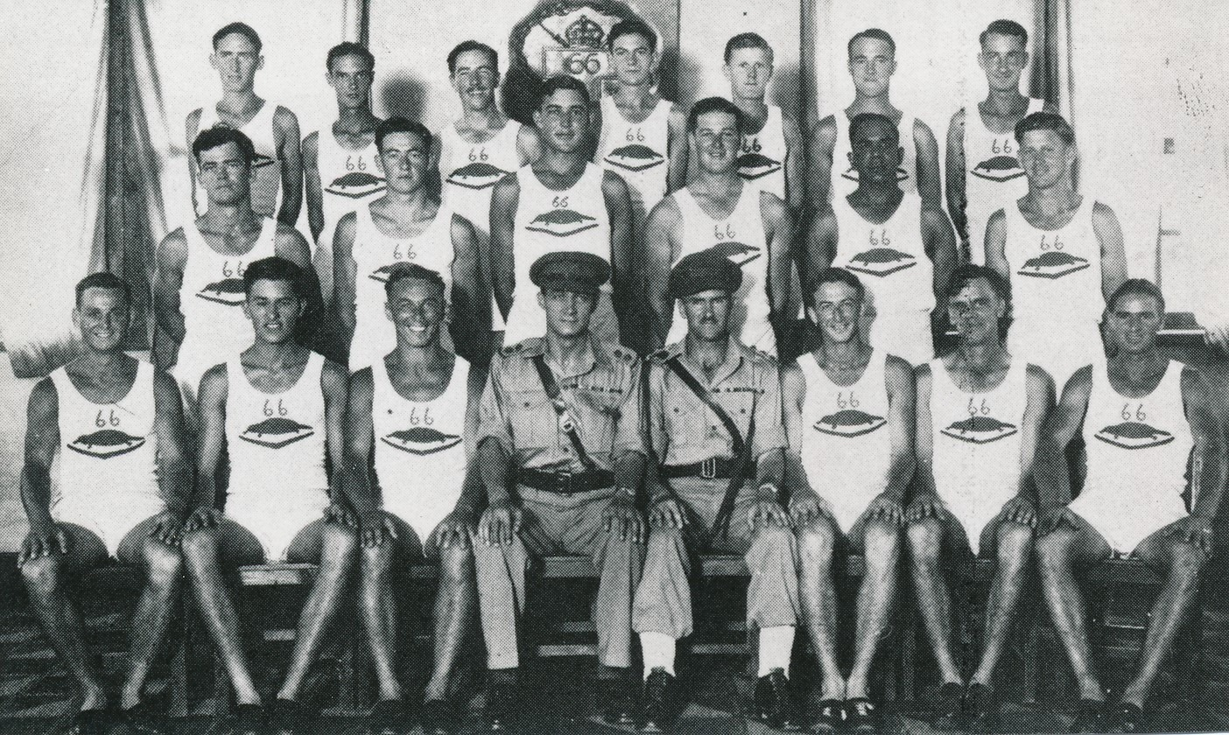
66th Battalion Athletics team

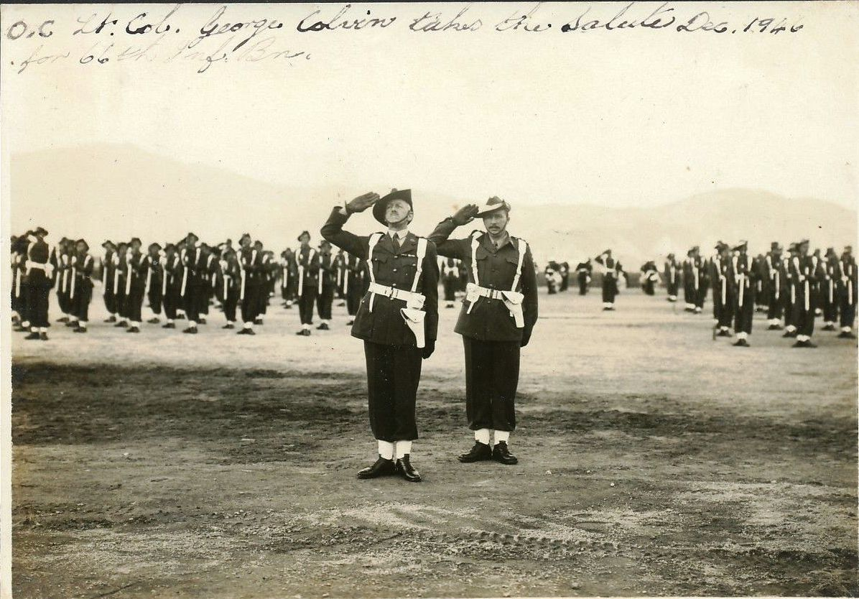
CO of 66th Bn 1946 LTCOL G. Colvin, DSO and Bar, ED takes the salute on parade.
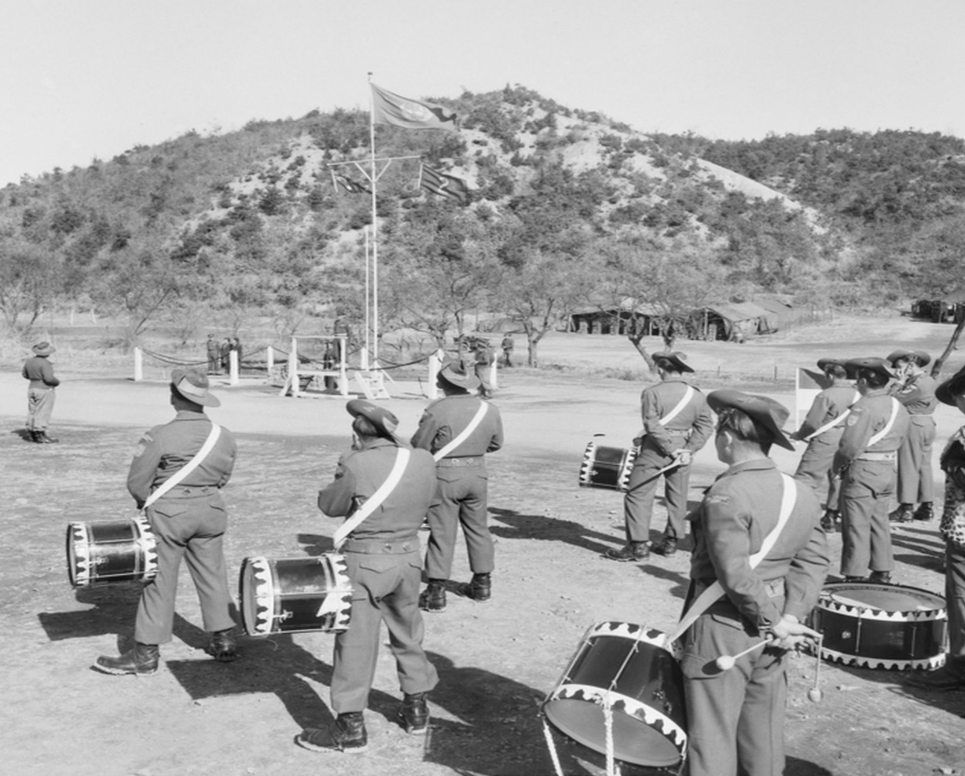
The new unit colours – 2AR

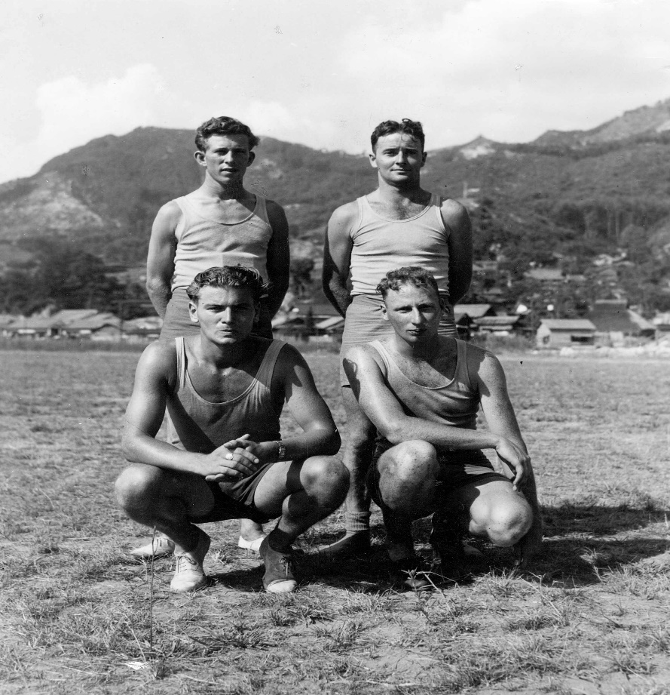
Sporting events in Japan.

66th Battalion – Roll of Honour

ROLL OF HONOUR – SX 38810 Pte Samuel Edley EVANS
19th December 1945

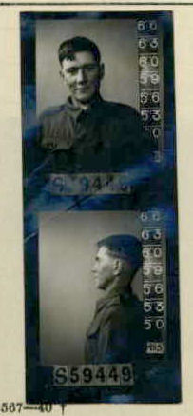

SX38810 PTE S. EVANS
(01 Aug 1922 – 19 Dec 1945: Aged 23 yrs)

Service Details

Pte Evans was born in Peterborough, South Australia on 01st Aug 1922. Prior to his service, Samuel worked as a Labourer before enlisting on the 09 Jun 1942 at Henley Beach in South Australia aged 19 and was given the Army number S59449, he was later transferred to the AIF, completing his Oath of Enlistment on 05 Jul 1945 and received the service number SX 38810.
Pte Evans was posted to units as a labourer (25 Employment Company) before he was Taken on Strength (TOS) from 1 HQ Aust Army to 17 CRE Works on 26 Oct 1945. He embarked on the Kamibula on the 12 Nov 1945 for Moratai and was stated missing at sea on the 19 Dec 1945 from an aircraft accident. Pte Evans emplaned at Moratai on 19 Dec 1945 for medical evacuation to Darwin. The plane was lost at sea between Ambon and Darwin.
Pte Evans was classified Missing after an Aircraft evacuation flight from Moratai that crashed (No35 Squadron Dakota aircraft A65-83) over the Arafura Sea on 19 December 1945, aged 23 years. Pte Evans at the time of being reported missing was travelling between Ambon and Darwin with 25 other passengers and crew when the Aircraft he was travelling in went down at sea. The cause of death is Accidental (Aircraft accident). Pte Evans was officially presumed deceased on 15 Aug 1946 with the date of death being 19 December 1945. His remains have never been recovered.
No. 35 Squadron Operations Record Book A50 Entry dated 21 December 1945.
In terms of lives lost, the disappearance of A65-83 with twenty five lives is one of the worst accidents in the history of the RAAF. No trace of the crew or passengers has been found despite an extensive search lasting 17 days.
Records of Pte Evans service indicate his last posting location being with 17th Commander Royal Engineers Works (17CRE Works) on 26 Oct 1945, and embarked on the Kanibula on the 12 Nov 1945 for Moratai, there is no identified paperwork indicating the member served with the 66th Bn apart from his official certificate of death which was written by the 66th Aust Inf Bn AIF after the members death. Passenger flight details of the ill-fated flight has Pte Evans rank as Sapper.
Pte Evans Cemetery/Memorial sight can be found at:
- Ambon Memorial, Ambon, Maluku, Indonesia (column 6),
- Australian War Memorial Commemorative Area Canberra, Australia (Panel 71, Supplementary Panel 2).
- World War II Honour Roll, National Memorial of SA, North Terrace, Adelaide.
- National Memorial Walk, Brisbane (Memorial plaque)
Pte Evans honours and awards:
- 1939/45 Star
- Pacific Star
- Defence Medal
- War Medal
- ASM
Pte Evans was the Son of Edley Horald Joseph and Sarah Jane Evans of Peterborough, South Australia, and husband of Joyce Reta Evans, of Torrensville, South Australia.
https://pacificwrecks.com/aircraft/c-47/A65-83.html
Unit: 66th Battalion, Australian Infantry, 2nd AIF.
Fate: Died at sea (between Ambon and Darwin), 19 December 1945.
Cause of Death: Accidental (Aircraft accident)

‘Lest we forget’

ROLL OF HONOUR – SX 33581 CPL Leonard Ronald LISHMUND
19th December 1945
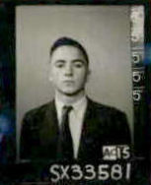

SX33581 CPL LR LISHMUND
(23 Jan 1926 – 19 Dec 1945: aged 19 yrs)

Service Details
Leonard Ronald Lishmund was born in Kingscote, South Australia on 23 January 1926. Prior to his service Leonard worked as a junior assistant (PMG) before enlisting on 24 April 1944 in Wayville, South Australia. He enlisted as a Pte with the service number SX3358 and moved through the ranks to Corporal prior to his passing.
Corporal Lishmund was the son of Frederick Clifford and Ada Mary Lishmund and he is survived by his sister Doreen Lishmund, of North Adelaide.
Corporal Lishmund emplaned from Moratai on No.35 Sqn RAAF Dakota A65-83 (VHCIZ), which went missing on a medivac flight between Ambon and Darwin on 19 Dec 1945 over the Arafura Sea.
Corporal Lishmund body has never been recovered.
Flight Details Log:
Signal Received to the effect that Squadron aircraft VH-CLZ is overdue on flight from Ambon to Darwin. Crew comprises Flying Officer F. Robinson (Captain), Flight Lieutenant N.J. Hazle (Co-Pilot), Pilot Officer G. Connell (Wireless Operator Air Gunner) and Sergeant P. Bodley (Navigator). There are also 21 passengers on board.
https://www.findagrave.com/memorial/21405773/leonard-ronald-lishmund
https://pacificwrecks.com/aircraft/c-47/A65-83.html

No. 35 Squadron Operations Record Book:
A50 Entry dated 20 December 1945:
Received advice from D.T.M. (Directorate of Transport and Movements) Melbourne, that Naval Authorities at Darwin had received message “All Alive”. Bearings were obtained on signal but searches were negative.
A50 Entry dated 21 December 1945:
In terms of lives lost, the disappearance of A65-83 with twenty five lives is one of the worst accidents in the history of the RAAF. No trace of the crew or passengers has been found despite an extensive search lasting 17 days.

Unit: 66th Battalion, Australian Infantry, 2nd AIF.
Fate: Died at sea (between Ambon and Darwin), 19 December 1945
Cause of Death: Accidental (Aircraft accident)
Memorial Details: Column 6 Ambon Memorial, Ambon, Maluku, Indonesia. Panel 71, Commemorative Area, Australian War Memorial, Canberra, ACT, Australia. WWII Honour Roll, National War Memorial of SA, North Terrace, Adelaide, Australia.

‘Lest we forget’

ROLL OF HONOUR – SX 26369 PTE Kenneth PARKEN
14th August 1946
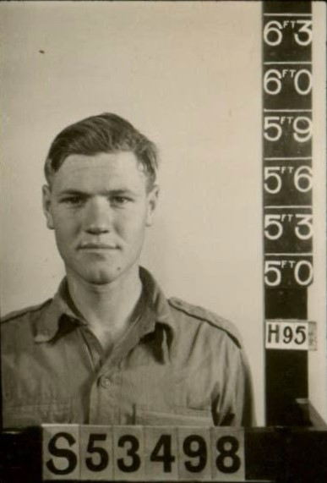

SX26369 PTE K PARKEN
(21 Sep 1923 – 14 Aug 1946: aged 22 yrs)

Private Kenneth Parken was born in South Australia on 21 Sep 1923 and grew up in Gawler, South Australia. Pte Parken enlisted on 14 Oct 1942, in Field, South Australia and was given the service number SX26369 (S53498)
Private Parken passed away on 14 Aug 1946 by accidental drowning near Nigata, Japan and his body was never recovered due to the swirling currents of the inland sea.

Unit: 66th Battalion, Australian Infantry, 2nd AIF.
Fate: Died Accidently (drowning) near Nigata, Japan 14 Aug 1946
Cause of Death: Drowned
Memorial Details: Panel 71, Commemorative Area, Australian War Memorial, Canberra, ACT, Australia. Adelaide WW2 Wall of Remembrance, Singapore Memorial Kranji War Cemetery column 133.
From 66 Bn War Dairy:
‘Lest we forget’
ROLL OF HONOUR – QX 55791 PTE Neville Leo VOLLING
01st May 1946
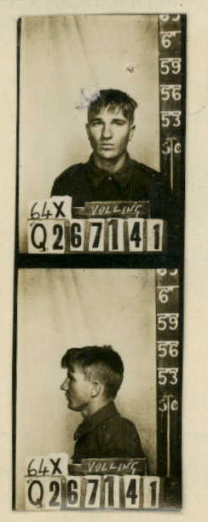

QX55791 PTE N.L VOLLING
(03 Mar 1924 – 01 May 1946: aged 22 yrs)

Private Neville Leo Volling was born in Longreach, QLD on 03 Mar 1924. Pte Volling enlisted on 19 May 1943, Selwyn, Queensland and was given the Service number QX55791 (Q267141).
Pte Volling was the son of Alexander and Julie Rose Volling and passed away due to injuries sustained in a vehicle accident near Saka in Japan.
Unit: 66th Battalion, Australian Infantry, 2nd AIF.
Fate: Road Accident, Saka, Japan, 01 May 1946
Cause of Death: Sustained Injuries from vehicle accident
Memorial Details: Yokohama War Cemetery, Yokohama, Kanto, Japan – Plot Aust.Sec.E.C.4. Panel 71, Commemorative Area, Australian War Memorial, Canberra, ACT.

From 66 Bn War Dairy:

‘Lest we forget’
ROLL OF HONOUR – WX 23289 PTE Henry Alan ROWBOTTAM
27th May 1946
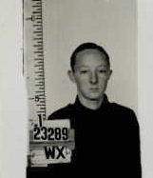

WX23289 PTE H.A ROWBOTTAM
(11 May 1927 – 27 May 1946: aged 19 yrs)

Private Henry Alan Rowbottam was born in Dalwallinu, WA on 11 May 1927. Pte Rowbottam enlisted on 22 May 1945, Bunbury , WA and was given the Service number WX23289
Pte Rowbottam was the son of Harry Rowbottam and passed away due to injuries sustained from an Accidental discharge whilst on duty.
Unit: 66th Battalion, Australian Infantry, 2nd AIF.
Fate: Died accidently in Hachihonmatsu, 27 May 1946
Cause of Death: Accidental discharge whilst on duty
Memorial Details: Panel 71, Commemorative Area, Australian War Memorial, Canberra, ACT.

From 66 Bn War Dairy:

‘Lest we forget’
ROLL OF HONOUR – 66th BATTALION: Summary

Number | Rank | Int | Given Names | Surname | Comments | Age | DOB | DOD | Coy, Platoon
16th October, 1945 - 66 Australian Infantry Battalion (2nd AIF then Interim Army then Australian Regular Army)
Morotai (Between Ambon and Darwin)
S59449  SX38810 | PTE | SE | Samuel Edley | EVANS | Emplaned from Moratai No.35 Sqn RAAF Dakota A65-83 (VHCIZ), which went missing on a medevac flight between Ambon and Darwin | 23 | 01 Aug 1922 | 19 Dec 1945
SX33581 | CPL | LR | Leonard Ronald | LISHMUND | Emplaned from Moratai No.35 Sqn RAAF Dakota A65-83 (VHCIZ), which went missing on a medevac flight between Ambon and Darwin | 19 | 23 Jan 1926 | 19 Dec 1945
Japan
SX26369 | PTE | K | Kenneth | PARKEN | Died Accidentally (Drowning) near Nigata | 22 | 21 Sep 1923 | 14 Aug 1946 | Battalion Band Member
WX23289 | PTE | HA | Henry Alan | ROWBOTTAM | Died Accidentally (Accidental Discharge whilst on Duty) in Hachihonmatsu | 19 | 11 May 1927 | 27 May 1946
QX55791 | PTE | NL | Neville Leo | VOLLING | Died Accidently  Died of Injuries from vehicle accident near Saka | 22 | 03 Mar 1924 | 01 May 1946 | HQ Coy

Nominal Roll of the 66th Battalion – as of 16 Oct 1945 (TBC)

NX 12217 GE COLVIN, DSO LTCOL QX 23800 AH PIGRAM SGT
SX 9461 OH ISAKSSON, MC MAJ QX 42491 ED PIKE SGT
WX 5369 CFG MCKENZIE, MC MAJ SX 12917 WE POLKINGHORNE SGT
NX 70852 WM BENNETT CAPT NX 32160 HJ PRICE SGT
NX 34747 GL CARTER CAPT QX 22204 GP SAYEG SGT
VX 39719 RG CRONK CAPT QX 20112 GC SHERATON SGT
WX 8667 APA DENNESS CAPT NX 31103 RS SMITH SGT
NX 31543 CF DOWNES CAPT SX 10474 HC SPURLING SGT
NX 200861 GM FISHER CAPT SX 21692 RA THOMAS SGT
NX 67530 GC HOGAN CAPT NX 12844 EM TOSI SGT
QX 6274 RG JENKINSON CAPT NX 16214 EM WILLIAMS SGT
NX 204019 EG LAVER CAPT WX 18412 AG WOODCOCK SGT
QX 16128 KG TURBAYNE CAPT NX 149052 L ASPINALL CPL
VX 146393 JD ANDREW LT VX 80346 AS BATCHELOR CPL
NX 122171 D BARNES LT QX 52342 EW BENSTEAD CPL
TX 16384 RG DEEGAN LT QX 37023 PA BERTRAND CPL
QX 1720 HM DOUGLAS LT SX 13181 SJ BOLITHO CPL
NX 138185 M EDDY LT NX 83086 GW BOWRER CPL
NX 12465 IA GEDDES LT NX 125888 EE BOYD CPL
QX 27192 FAM GORMAN LT SX 8753 LA BRAENLER CPL
NX 49125 WH GRANT LT NX 132880 KN BROWN CPL
NX 131543 RE HADDY LT WX 25878 WJ BUDDEN CPL
VX 100050 WP JOHNSTONE LT NX 163300 DC BYRNE CPL
SX 3336 R JOSE LT NX 84130 WG CALVERT CPL
NX 108586 GN JUSTICE LT VX 51426 SJ CARLILE CPL
VX 38601 JW KING LT NX 46833 RF CARSENS CPL
VX 54741 EW MARSHALL LT NX 66259 JF CHAPLIN CPL
NX 196229 WN MCDONALD LT VX 111726 JH CHESTNUT CPL
WX 7303 ED RULE LT NX 50083 RW CURTIN CPL
NX 120650 HR WHIBLEY LT VX 91611 AF DALTON CPL
NX 7855 R WILSON LT SX 12729 J DAVIDSON CPL
WX 16929 GC WILSON LT NX 81250 W FLANAGAN CPL
NX 144208 WF SEYMORE WO1 QX 52624 JR FRASER CPL
SX 38242 IR COTTON WO2(T) NX 44221 RE GAIN CPL
VX 28034 CW CARNE WO2 VX 146967 GH GIBBINS CPL
WX 26701 OC CHAPMAN WO2 WX 5578 AT GRAFFIN CPL
NX 33820 WA DAHL WO2 NX 41178 SC HAHN CPL
NX 18260 RK EASTER WO2 NX 53591 MA HEMPEL CPL
WX 25539 F ELSTON WO2 QX 38222 CW HING CPL
NX 28065 KH KITCHING WO2 WX 33032 EG HODGSON CPL
NX 35162 MN MCVICAR WO2 NX 145058 PG HORE CPL
WX 41033 GW EAST SSGT NX 18890 AR JURY CPL
SX 7127 RA GEORGE SSGT NX 180615 S KELEN CPL
NX 57279 BT SCANLON SSGT SX 13388 CL KING CPL
NX 43250 AJ BAIRD SGT VX 58149 SJ KING CPL
NX 103883 OL BATES SGT SX 33581 LR LISHMUND CPL (DECEASED)
NX 25124 CAD BIRRELL SGT VX 79619 S LOVEL CPL
WX 35340 AJ BRAIN SGT NX 20088 JL MAHER CPL
WX 36836 EG BROWN SGT WX 25146 JP MEEKS CPL
NX 35987 G BRYANT SGT NX 176559 W MILLS CPL
SX 31840 DL BURZACOTT SGT SX 12950 BE MILTON CPL
QX 201154 SR CONDON SGT VX 76306 LC MITCHELL CPL
WX 37425 W CONNELLY SGT VX 50855 KW MURPHY CPL
QX 77387 FD COOPER SGT NX 16195 JBP O’SULLIVAN CPL
NX 140422 JH DENT SGT VX 47875 JH OLDHAM CPL
DX 802 JW EACOTT SGT VX 113416 RL ORR CPL
NX 162993 RJ EDWARDS SGT VX 470 LE PARRY CPL
SX 11110 HN FREEBAIRN SGT NX 91429 EJ PENNY CPL
SX 13253 JN HAY SGT VX 110777 CD PROSS CPL
NX 135256 OP HAYMAN SGT NX 168447 GA SMART CPL
WX 5342 JC HENDERSON SGT VX 30781 RA STEWART CPL
NX 148370 CG KERR SGT VX 105191 RA STILLMAN CPL
QX 15359 CW LEES SGT SX 13262 JD SULLIVAN CPL
VX 91635 VR MARSHALL SGT SX 13618 MA TODD CPL
TX 14965 GE MCGINNESS SGT VX 140981 RO TRUDGEON CPL
WX 14042 HA MENNER SGT SX 11779 JL TUCKER CPL
SX 16605 HJ MUNRO SGT NX 101516 AM VALE CPL
NX 96346 RF O’GRADY SGT NX 99486 NW VANE CPL
NX 13900 MJ WEARY CPL WX 26196 AD BORRELLO PTE
WX 16870 KB WHITFIELD CPL VX 93296 CR BOSTON PTE
WX 39289 WILLIAMS CPL NX 179018 M BOSWELL PTE
QX 60699 JH WOOLACOTT CPL NX 171292 AJ BOSWELL PTE
VX 73284 EJ YAXLEY CPL NX 162150 RA BOTH PTE
NX 147091 HJ CAMPBELL LCPL NX 190798 RM BOURKE PTE
WX 11323 JRM CASSIDY LCPL NX 202723 WF BOURKE PTE
SX 15056 VM GROVES LCPL TX 5663 K BOWEN PTE
NX 191692 PJ ADAIR PTE SX 18898 S BOWN PTE
QX 24282 VS ADAMS PTE SX 29211 MK BOYLAN PTE
NX 161922 WJ AIRD PTE NX 40103 VR BRADBERY PTE
VX 61914 E ALDRED PTE VX 146584 J BRADLEY PTE
NX 175007 CJ ALEXANDER PTE NX 167446 AK BRADY PTE
NX 202003 RJ ALLAN PTE QX 58686 PJ BRANDENBURG PTE
VX 82195 RP ALLEN PTE VX 93359 L BREACHER PTE
NX 175052 MA ALLISTER PTE NX 155774 BA BREED PTE
NX 203515 RW AMBROSE PTE NX 178178 NL BRIGHT PTE
NX 116170 EJ AMPS PTE SX 33560 TJ BRISCOE PTE
VX 102939 LF ANDERSON PTE NX 135211 RB BROTHERSON PTE
NX 96528 RD ANDERSON PTE WX 30924 KW BROWN PTE
QX 25030 H ANDERSON PTE SX 35217 RW BROWN PTE
QX 59022 MW ANDERSON PTE SX 33669 AV BROWNE PTE
NX 125174 AR ANDREW PTE NX 72334 C BRYANT PTE
VX 94694 LH ANDREW PTE QX 44046 EA BRYDE PTE
QX 44057 RA ANEAR PTE SX 14965 CJ BUBNER PTE
NX 132978 RF ANTONE PTE VX 79203 RJ BUGGE PTE
VX 141053 RC ARNOLD PTE QX 45181 FV BUNN PTE
SX 18716 F ARTHUR PTE NX 10436 GW BUNYAN PTE
SX 18683 WM ASTHON PTE VX 69860 AJ BURGESS PTE
VX 92068 K ASHWORTH PTE VX 66132 OV BURNHAM PTE
VX 101774 WA AUSTIN PTE NX 203731 WN BURNS PTE
WX 17243 JH AVERY PTE NX 192401 CA BUSHELL PTE
VX 118002 HD AYLMER PTE SX 24968 CK CAMERON PTE
DX 726 LR BACON PTE NX 180199 R CAMERON PTE
SX 33148 HD BAILEY PTE QX 49040 WJ CAMERON PTE
VX 83724 AB BAKER PTE WX 21756 CL CAMERON PTE
NX 43183 RT BALDWIN PTE SX 28907 RJ CAMILLERI PTE
VX 94847 IM BARCHAM PTE VX 84501 GW CAMPBELL PTE
VX 132418 RT BARNES PTE SX 28907 JT CAMPBELL PTE
TX 16393 CM BARNES PTE WX 31335 CR CAMPBELL PTE
SX 33156 DR BARNES PTE VX 128626 G CAMPESATO PTE
QX 23008 R BARNHAM PTE VX 140822 CA CAMPLIN PTE
NX 154437 LA BARRETT PTE VX 92182 JL CARLAN PTE
VX 42567 CT BEATTY PTE QX 39990 PJ CARMODY PTE
NX 113981 JO BECKINSLADE PTE NX 130074 KW CARPENTER PTE
NX 127514 H BEER PTE NX 79732 AJ CARROLL PTE
QX 63917 J BELL PTE NX 170523 DM CARROLL PTE
VX 145755 TA BELL PTE NX 167263 LA CARTER PTE
WX 33430 J BELL PTE NX 44356 AJ CAVANAGH PTE
VX 61083 C BELVILLE PTE QX 36109 PH CAVE PTE
VX 101015 RB BENDER PTE QX 50760 RE CHADWICK PTE
VX 93213 RP BERRY PTE VX 94310 RL CHALMERS PTE
QX 58501 L BESSINGTON PTE NX 9996 BK CHAPMAN PTE
VX 94488 GG BETHERAS PTE NX 135971 MJ CHARLTON PTE
NX 118360 E BETTS PTE NX 134253 EH CHASTY PTE
WX 22860 AK BIDSTRUP PTE NX 174026 CHEETHAM PTE
NX 122990 NW BIFFIN PTE QX 20148 GJ CHEETHAM PTE
NX 73723 TS BILLETT PTE NX 66246 RL CHESHER PTE
NX 142362 SR BIRCH PTE NX 162187 J CHRISTOPHER PTE
NX 177731 JS BIRD PTE WX 29552 KB CHURCH PTE
VX 146012 CE BLACK PTE NX 96939 DP CHUTE PTE
NX 177800 CR BLANCH PTE NX 162526 AJ CLARK PTE
QX 55144 NC BLENEY PTE QX 27501 WT CLARKE PTE
NX 177650 RC BLOOM PTE TX 9217 BN CLARKE PTE
VX 71622 CJ BOAG PTE VX 124564 FJ CLARKE PTE
VX 79461 RK BOHLING PTE QX 46661 RL CLITHROE PTE
NX 174170 NR BOLIN PTE QX 57186 T CODY PTE
SX 24203 CJ BOND PTE VX 93005 HB COE PTE
NX 203978 WK BOOTES PTE NX 169338 WJ COFFEY PTE
VX 94711 SF BOOTH PTE QX 50631 NR COLLINS PTE
VX 140804 JC BORELLA PTE NX 42442 JD COLLINS PTE
NX 44244 WG COLLINS PTE NX 178541 CJ EVERLEIGH PTE
VX 105832 R CONN PTE WX 39621 A EVERY PTE
NX 131275 EJ CONNELLY PTE NX 178855 HI EYRE PTE
QX 54602 EP CONSTANCE PTE SX 37179 BCR FAEHRMANN PTE
NX 170449 MJ COOK PTE NX 168202 DW FALCONER PTE
VX 131961 RJ COOKE PTE WX 19906 A FARRELL PTE
WX 28729 LJ COONEY PTE NX 103485 HR FARRER PTE
NX 154298 EJ COOPER PTE VX 118871 KP FAYLE PTE
NX 203660 KH CORBETT PTE NX 191986 JA FERGUSON PTE
WX 18257 JC CORDERY PTE NX 96334 WW FIELD PTE
SX 8810 HR CRABB PTE NX 173416 HM FIETZ PTE
NX 80088 MH CRAIG PTE DX 702 RW FINCH PTE
QX 55682 AN CRANE PTE SX 33351 FG FISHER PTE
VX 10090 RV CREEK PTE NX 172179 KC FISHER PTE
NX 144100 EC CREMER PTE SX 28904 RB FITZGERALD PTE
VX 51778 JW CROSBIE PTE QX 42299 J FLANAGHAN PTE
QX 25838 AM CROSBY PTE VX 113680 LR FLEMING PTE
WX 39289 RA CROSS PTE NX 98403 J FLYNN PTE
NX 171970 R CROSSLEY PTE NX 166548 K FLYNN PTE
NX 113663 DH CRUICKSHANK PTE NX 124090 GJ FOLLERS PTE
NX 171637 WH CUMMING PTE VX 140846 R FOLMER PTE
WX 30505 AC CURWOOD PTE QX 54739 T FORBES PTE
VX 145868 AJ DALTON PTE NX 174371 BS FORD PTE
VX 95660 RO DARLINGTON PTE NX 96618 RE FORDHAM PTE
NX 95353 J DAVES PTE NX 204142 SG FOSTER PTE
NX 107527 RS DAVEY PTE NX 179234 CA FREAME PTE
SX 19733 DB DAVIE PTE NX 203420 GF FRITH PTE
SX 33534 TF DAVIS PTE NX 98482 B FROST PTE
QX 26193 LS DAVIS PTE QX 57164 K FULFORD PTE
NX 167020 JJ DAVIS PTE SX 32445 V GAERTH PTE
NX 203664 JA DEANS PTE NX 155848 ER GALVIN PTE
NX 172692 PN DELANEY PTE VX 93128 JH GARDINER PTE
VX 111477 J DELANEY PTE NX 178279 R GAVAN PTE
NX 203064 NL DELMAS PTE QX 56032 JR GEDDES PTE
QX 27302 CE DEMPSEY PTE QX 58128 RE GEE PTE
NX 165880 EA DEVINE PTE VX 124572 VC GERLOFF PTE
QX 25912 D DEVIR PTE VX 127972 JH GILBERT PTE
VX 127716 HN DEVLIN PTE NX 178943 WM GILES PTE
NX 10411 CW DICKER PTE NX 168920 F GILLIGAN PTE
NX 175305 W DICKINSON PTE NX 10299 LA GILLOGLY PTE
QX 22372 HJ DOHERTY PTE QX 11619 AW GILMOUR PTE
SX 37091 TH DOHERTY PTE NX 179887 KE GLASCOCK PTE
WX 22906 EF DOWNTON PTE NX 202711 AJ GOFF PTE
VX 92675 FA DOYLE PTE QX 56152 RS GOODCHILD PTE
WX 32750 LV DRAYTON PTE WX 38186 NF GOODREM PTE
NX 117153 W DU FROCQ PTE WX 35095 B GOODRIDGE PTE
SX 33242 VJ DUGGAN PTE NX 179542 WP GOODWIN PTE
VX 51646 WJ DUNSTAN PTE NX 124411 AL GOWANS PTE
SX 31672 CC DUNSTAN PTE NX 203082 FN GRAHAM PTE
WX 37548 NF DUNWOODIE PTE VX 94505 KL GRANT PTE
VX 147399 TD DUSTING PTE NX 50539 GA GRAY PTE
NX 168821 MV DUXBURY PTE NX 172574 AJ GREEDY PTE
NX 140219 WC EAST PTE WX 22686 KL GREEN PTE
NX 170935 HF EASTERBROOK PTE SX 35397 AR GREENWOOD PTE
NX 203692 CA EATON PTE QX 53701 RV GREER PTE
VX 125703 KJ EDDY PTE NX 170712 HE GRIFFIN PTE
QX 2451 AB EDMENSON PTE NX 97918 WL GRIFFITHS PTE
WX 37948 RC EDWARDS PTE NX 135099 WB GROVE PTE
QX 53420 RC EDWARDS PTE NX 115383 JW GUNN PTE
QX 26790 FT ELDRIDGE PTE VX 87410 KE GUY PTE
QX 24653 MT ELFORD PTE NX 164036 WR GUY PTE
NX 79082 EJ ELLIOTT PTE VX 146322 A GYSS PTE
QX 40315 NA EMMERSON PTE SX 13932 GT HAGGETT PTE
NX 166661 JA ENTWISTLE PTE QX 28489 AT HALL PTE
WX 28528 SE ERSKINE PTE NX 169902 DL HALL PTE
WX 39217 ESMOND PTE WX 21663 L HALLIGAN PTE
SX 33073 WR ETTRIDGE PTE NX 178858 JW HAMBLING PTE
QX 25554 SW EUGARDE PTE SX 33443 KS HAMMOND PTE
SX 39441 J EVANS PTE QX 62090 PR HANCOX PTE
TX 14404 FJ EVANS PTE NX 86565 CW HANNAFORD PTE
VX 40374 WR EVERETT PTE QX 26788 RG HANSEN PTE
QX 59019 CF HANSON PTE NX 109609 JB JOHNSON PTE
NX 154389 CS HARLOVICH PTE NX 202957 CS JOHNSON PTE
QX 22729 OA HARM PTE VX 124890 LR JOHNSTONE PTE
NX 179139 DR HARREN PTE QX 53588 LA JONES PTE
SX 14192 IM HARRINGTON PTE NX 22227 NK JONES PTE
SX 30760 NG HARRIS PTE NX 171040 WH JONES PTE
VX 101716 AP HARRISON PTE SX 31796 TA JORDAN PTE
WX 22789 RH HARRISON PTE NX 163548 KP JUDE PTE
VX 141083 CW HART PTE NX 104252 ES KAIN PTE
NX 98943 H HARTHILL-LAW PTE NX 175860 LR KANE PTE
VX 65268 RV HARVEY PTE NX 79038 LE KEANE PTE
NX 119092 LT HARWOOD PTE WX 38785 GE KEEN PTE
NX 167423 AJ HATTON PTE NX 171207 JL KELLY PTE
NX 79360 EA HAWKINS PTE NX 173218 RJ KENNY PTE
WX 29428 GE HAY PTE VX 146906 J KENT PTE
QX 39102 HM HAYES PTE SX 14750 HW KING PTE
VX 88984 TE HAYHO PTE NX 174268 JB KING PTE
QX 24794 PS HEALY PTE NX 177723 WJ KING PTE
NX 202452 J HEATLEY PTE WX 38516 KG KING PTE
SX 19630 RC HEFFERNAN PTE NX 131794 IJ KISS PTE
VX 141262 ER HELANDER PTE NX 44024 JF KITCHING PTE
VX 78970 H HENSTRIDGE PTE SX 23566 WA KNAPP PTE
NX 52731 EJ HERD PTE VX 143727 LR KNEEBONE PTE
WX 39279 TC HERNAN PTE QX 55816 CE KNICKEL PTE
TX 9085 HJ HERON PTE VX 93621 NP KNIPE PTE
SX 11752 J HEYLEN PTE WX 31742 MG KNOX PTE
NX 178664 RI HIGGINS PTE WX 3396 H KYNASTON PTE
NX 195405 N HILL PTE TX 15448 KL LACEY PTE
SX 33673 RR HILL PTE SX 17308 RH LAMBERT PTE
NX 146771 AR HILLIER PTE SX 19448 CR LAMPRE PTE
VX 63187 CL HINTON PTE SX 18893 WE LANG PTE
NX 170501 RC HOBSON PTE VX 148044 HC LANGLEY PTE
NX 80875 K HOGAN PTE WX 26199 RF LANGRIDGE PTE
NX 203032 M HOGAN PTE NX 178342 MA LARKIN PTE
VX 92138 WA HOGAN PTE NX 86766 EJ LARKINS PTE
NX 190084 FS HOLFORD PTE NX 126648 S LARKINS PTE
NX 178150 TH HOLLIS PTE NX 73891 K LEE PTE
NX 175820 P HOLST PTE VX 94124 GS LEGG PTE
NX 125360 FB HOMAN PTE VX 94125 RS LEGG PTE
SX 33571 RW HONE PTE NX 177680 AF LEHMANN PTE
VX 87403 FH HONEYMAN PTE VX 95020 HM LEITCH PTE
NX 131505 LP HOPPING PTE VX 94695 HH LESSON PTE
VX 53299 RT HORE PTE VX 135832 N LINDHE PTE
NX 176555 DM HOUSTON PTE QX 12994 N LITTLE PTE
NX 134194 JC HOUSTON PTE QX 26308 KD LITTLE PTE
WX 26495 WR HOW PTE NX 178341 LF LONGLEY PTE
QX 35254 D HOWARD PTE VX 125606 JLJ LORD PTE
VX 51792 GM HOWAT PTE VX 120564 BJ LOW PTE
VX 120750 WT HOWDEN PTE NX 193931 AF LOWE PTE
SX 33104 CA HOWLETT PTE TX 6637 RG LOWE PTE
QX 57129 C HUDSON PTE NX 23155 DA LUCK PTE
NX 37191 RC HUGO PTE NX 9555 RG LUCK PTE
NX 52567 LK HULBERT PTE NX 171879 GB LUCK PTE
QX 17949 WJ HULETT PTE QX 18969 AT LUM WAN PTE
QX 58593 RS HUNTER PTE NX 180039 R LUTHERBORROW PTE
VX 92848 DR HUNTER PTE NX 171376 TG LUTTRELL PTE
NX 98672 JS HURST PTE VX 102151 JH LYNCH PTE
NX 170767 JE HURST PTE TX 6956 LC LYNCH PTE
NX 203945 CL IRELAND PTE VX 93070 R LYONS PTE
SX 16820 EJ IRVINE PTE VX 101450 JW MACDONALD PTE
QX 57439 DS IRVINE PTE NX 148815 NG MACDONALD PTE
VX 135217 N JACKSON PTE QX 8406 CE MACKAY PTE
SX 14272 KA JACOBS PTE VX 67846 JJ MACKINLAY PTE
NX 173146 J JACOBS PTE WX 40484 LJ MADALENA PTE
NX 78066 NR JAMES PTE NX 149519 JW MAGUIRE PTE
NX 102966 AE JAMIESON PTE NX 117715 T MALLETT PTE
NX 66262 S JAY PTE NX 176258 JP MALONE PTE
QX 11498 K JEFFRIES PTE NX 113468 DG MANN PTE
NX 202384 KE JENKINS PTE NX 172386 RT MAPLETOFF PTE
QX 35784 WV JENNINGS PTE SX 38516 EF MARSH PTE
NX 135085 AG JEW PTE VX 138172 JW MARSH PTE
NX 22566 F MARTIN PTE VX 114432 TP MURPHY PTE
TX 14621 DT MARTIN PTE NX 80029 W MURRAY PTE
VX 63493 EP MARTIN PTE NX 141637 KJ MURRAY PTE
WX 41415 NR MARTIN PTE NX 122479 JE MURRAY PTE
VX 121870 LW MATTHEWS PTE QX 25770 BW MYLREA PTE
NX 168350 RF MATTHEWS PTE NX 91772 ER NAGLE PTE
VX 94901 A MATTHEWSON PTE SX 33737 GC NATT PTE
WX 39392 F MAY PTE WX 41676 DR NAZZARI PTE
VX 123324 AH MCALLISTER PTE DX 883 G NEEDS PTE
VX 79108 LA MCCANN PTE NX 172653 RA NELSON PTE
NX 178521 WR MCCAULEY PTE NX 797858 RS NELSON PTE
VX 144602 D MCCROMMON PTE WX 15328 HJ NELSON PTE
NX 168372 RS MCCURDY PTE WX 23314 AW NELSON PTE
NX 43031 AJ MCDONALD PTE SX 22743 RC NEVINS PTE
NX 168206 GF MCGEE PTE NX 171293 WA NICHOLSON PTE
NX 200627 KC MCGREGOR PTE NX 128649 WJ NINNESS PTE
VX 93706 WG MCGUIGAN PTE NX 125817 M NIQUET PTE
NX 174253 KJ MCGUINESS PTE SX 33071 RC NOCHOLDS PTE
NX 179773 WA MCINNES PTE SX 9436 PF NOLAN PTE
SX 37344 R MCINTYRE PTE NX 95196 A NOLAN PTE
NX 161832 J MCKEE PTE NX 133315 HJ O’BRIEN PTE
WX 28444 RA MCKENZIE PTE WX 38617 TW O’BRIEN PTE
VX 127443 JD MCKENZIE PTE VX 57855 GF O’CONNOR PTE
NX 203652 BL MCKENZIE PTE VX 84500 FJ O’DEE PTE
NX 191101 SW MCKETTRICH PTE VX 93896 NJ O’MARA PTE
WX 41458 MCKINLEY PTE QX 43868 AN O’NEILL PTE
NX 119854 GE MCLAREN PTE VX 62469 JH O’REILLY PTE
NX 173712 RN MCLAY PTE NX 102374 ND OAKMAN PTE
NX 99836 J MCMASTER PTE QX 28343 D OLIVER PTE
NX 167882 J MCNEE PTE NX 203043 HH OPRAY PTE
NX 171100 RT MCSWEENEY PTE NX 177326 H ORCHARD PTE
NX 169166 L MCVEIGH PTE WX 39902 MI OSBORNE PTE
SX 27188 AJ MEATHERINGHAM PTE WX39165 R OWEN PTE
VX 65613 WA MERCIER PTE NX 39815 C PACEY PTE
NX 165930 EG MEREDITH PTE QX 32154 V PARIS PTE
WX 26565 FA MERIFIELD PTE
TX 16094 CA MERRICK PTE
NX 26209 AA MERRY PTE
VX 93744 RG METCALF PTE
QX 28327 SS MICKAN PTE
TX 9164 DS MIDDAP PTE
NX 176825 JW MILES PTE
NX 151678 LD MILLER PTE
VX 146934 JW MILLMAN PTE
NX 170142 R MILLS PTE
NX 201286 AR MILLS PTE
NX 178944 A MILNE PTE
VX 88416 RN MITCHELL PTE
NX 87049 HJ MITCHELL PTE
WX 40360 FJ MOILER PTE
QX 56809 G MONIZ PTE
NX 155004 WD MOORE PTE
VX 145872 NW MOORE PTE
NX 176071 RV MORGAN PTE
NX 171378 WA MORRIS PTE
NX 168442 GJ MORRIS PTE
WX 21983 LR MORRISSEY PTE
VX 94511 WL MORRISH PTE
VX 57246 LA MORRISSEY PTE
WX 28256 JD MOTZEL PTE
NX 124461 ED MOULDT PTE
NX 96817 C MOUNT PTE
VX 63027 FGT MOUNT PTE
NX 125825 AW MOYNAHAN PTE
SX 19259 RJ MOYSE PTE
NX 204357 OA MULLER PTE
NX 203786 JF MULLINS PTE
VX 87389 CL MUNNERLEY PTE
NX 172666 V MURDOCH PTE
QX 11694 R MURLSON PTE
WX 12981 JM MURPHY PTE

Names of 66Bn members that are additional to the above list as provided in War diaries
NX 160013 DB DUNSTAN CAPT
VX 90116 PG O’KEEFE CAPT (CHAPLAIN)
NX 131582 RE WADDY LT
SX 37099 DR MCLEOD LT
VX 126034 CW CLARKE WO2
QX 62081 C BOND SGT
WX 19236 EW ORCHARD SGT
VX 60634 JD SADLEIR A/SGT
NX 166520 HJ SILK A/CPL
NX 190850 NG COLLEDGE CPL
NX 104252 ES KAIN CPL
NX 161832 J MCKEE CPL
QX 25608 LJ STEELE CPL
VX 63493 EP MARTIN LCPL
NX 43031 AJ MCDONALD LCPL
NX 176240 TAYLOR LCPL
NX 173628 F WOOD LCPL

REFERENCES

0.1 The History of 66th Australian Infantry Battalion and 2nd Battalion, The Royal Australian Regiment - Jan 1965 version.
0.2 RINGO Article Edition 5 1993 – 66th Australian Infantry Battalion Historical Notes – Gil Lucas.
0.3 Experiencing the Aftermath of Atomic Explosion - Brian Evans https://anzacportal.dva.gov.au/stories-service/australians-war-stories/experiencing-aftermath-atomic-explosion
0.4 2RAR Historical Collection Database – 2023 – Curator - Jason Harrison notes
0.5 The Australian Military Contribution to the Occupation of Japan, 1945-1952 – Dr James Wood article for Australian War Memorial.
0.6 Wikipedia 2nd Battalion, Royal Australian Regiment
0.7 2nd Battalion, The Royal Australian Regiment Association, Inc notes from members.
0.8 Australian War Memorial website collection.
0.9 Pte William Percival Vincent - diary covering posting to 66th Bn – AWM (file number AWM315 419/108/024)
1.0 Leonard Harold William Andrew – AWM collection.
1.1 Regimental Beginnings – BCOF Japan – LTCOL George Colvin, CMG, DSO, ED.
1.2 Notes from previous 2 RAR Museum curator John Twomey.
1.3 A Knockabout with a Slouch Hat – T.A.G. Hungerford
1.4 Disarming the Menace – Neil C Smith
1.5 Australian Dictionary of Biography - Website

