Warriors Who Have Marched Out
2025
2784850 Pte Geoffrey Raymond CANTRILL 02 Oct 1945 – 04 Jan 2025
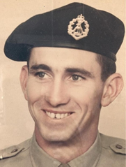
Geoff, a National Serviceman, served in South Vietnam with 1 Pl A Coy 2 RAR/NZ (ANZAC) Bn (19 May 1967 – 13 Jun 1968). Geoff, late of Vivian Street, Inverell and formerly of Moree, passed away at Inverell NSW with his family by his side on 4 Jan 2025, age 79. Geoff's funeral service took place at the Sapphire City Crematorium Chapel, Inverell NSW, followed by cremation.
Posted on Geoff’s Facebook page

3788649 Pte Neville John CRELLIN 08 Sep 1945 – 12 Jun 2025
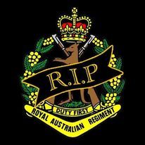
NS Neville served with 2RAR from 19 May 1967-26 Mar 1968.
A graveside funeral service was held at Koondrook Lawn Cemetery on Fri 20 Jun

14350 Maj Terrence (Terry) Edward DINNEEN 23 Jan 1940 – 4 Apr 2025
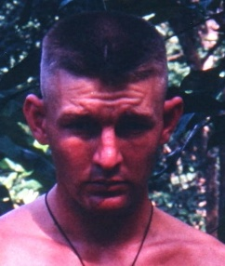
South Vietnam - 2IC D Coy 2 RAR 06 May - 18 Oct 1967
HQ 1st Australian Task Force 19 Oct 1967 - 02 Apr 1968
Terry’s memorial service was held at Leura Memorial Gardens, LEURA NSW. Terry's legacy to not just his dedication to preserving the military History of the Battalion but to all, will be long lasting and forever remembered. On the date/time of his funeral the RAR Association will lower the Australian ensign to half-mast at the National Memorial Walk in his honour as a noble warrior for Australia.

WO1 Mark FISHER Mar - 2015
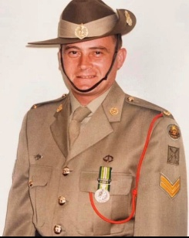
2RAR (1995-2001)
Gail Fisher has advised that her son Mark passed away after a long battle with cancer aged 59. Mark reached the rank of WO1 and served 25 years with service to East Timor and Somalia. Mark saw service with 2RAR and was Sect Comd, 4pl B Coy during INTERFET operations to East Timor. Marks funeral was held at St Georges Cathedral, Perth, WA.
RSL WA laid a wreath, and a Bugler played the Last post at his service.

43952 Cpl Peter HARAN 11 Feb 1948 – 10 Feb 2025

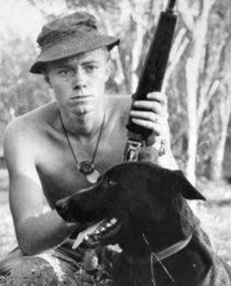
Peter, born in Birmingham UK, spent his childhood in Zimbabwe, South Africa, and came to Australia after leaving school and joined the Australian Army. He enlisted in Adelaide SA on 6 Jan 1966 and served in South Vietnam with 2 RAR/NZ (ANZAC) Bn, Tracker Pl (15 May – 13 Jun 1968), returning with 3 RAR Tracker Pl (25 Feb – 16 Oct 1971) and was discharged on 6 Jan 1972 and became a journalist and author, working on Adelaide newspapers for nearly 30 years. Peter late of Prospect SA passed away from complications from Leukaemia in Ashford Hospital, SA on 10 February 2025, aged 76 years.

2783994 Pte Leonard James (Jim) HOLMES 10 Dec 1945 – 26 Feb 2025
B Coy 6 RAR/NZ (ANZAC) Bn 14 Jan – 28 May 1967
B Coy CHQ 2 RAR/NZ (ANZAC) Bn 29 May – 12 Dec 1967
Jim, late of Central Mangrove NSW passed away on 26 Feb 2025, age 79. Jim’s Funeral Service was held at Pedigrew Family Funerals, Belmont NSW. Thankyou to Geoff Brewer

312826 Pte Ashley “Ash” William LINDSAY 28 Feb 2025
South Vietnam - 7 RAR (31 Dec 70 – 8 Feb 1971)
2 RAR/NZ (ANZAC) Bn 6 Pl B Coy (12 Mar – 6 May 1971)
Ash died on 28th February 2025 in a scuba diving accident. His funeral was held at St Kevin's Catholic Church, Avoca VIC. Ash was in 8 section 6 Platoon.
Thank you to Philip Burke

54587 Sgt Murray Graeme MARTIN 14 Dec 1941 - 13 Jan 2025
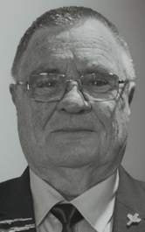
2 RAR (1963 – Jun 1965), 6 RAR A Coy (6 Jun 1965 – 1967 including active service in South Vietnam (Sect Comd A Coy - 31 May 1966 - 30 Jan 1967 - Battle of Long Tan). Corp transfer 1968 to Catering Corp as Sgt Mess supervisor in various postings including 2/4 RAR (20 Apr 1976 – 14 May 1978) for the rest of his career until 1986. Murray passed away on 13 Jan 2025, age 83. Murray’s funeral service and burial was held at the Allambie Park Cemetery in Albany WA.
Allan Whelan, Secretary 6 RAR Association INC

5714570 Pte George Kennington NICHOLS 25 Oct 1945 – 30 Apr 2025
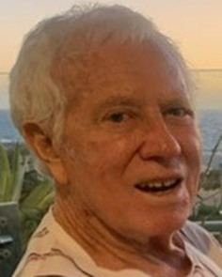
2 RAR/NZ (ANZAC) Bn, South Vietnam
10 Pl D Coy/4 Pl B Coy (09 May 1967 - 14 May 1968)
George passed away on 30 April 2025.
The Funeral Service was held at Brown Chapel, KARRAKATTA Cemetery WA

218905 Pte Kevin “Pol” Harry POLLEY 06 Jul 1949 – 10 Jan 2025

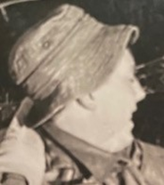
Kevin was a member of the Signals Platoon, 2 RAR/NZ (ANZAC) Bn in South Vietnam (12 May 1970- 1 Jun 1971). Kevin passed away on 10 January 2025, age 75, at the Aged Care Facility where he resided at Hammondville NSW. A private cremation was held and his ashes laid alongside those of his parents. Rest in Peace Kevin.
Thanks to Gary Thorpe, Kevin’s brother-in-law

2/4932 CPL Matthew David RENNIE OAM 11 Jun 1933-13 Feb 2025
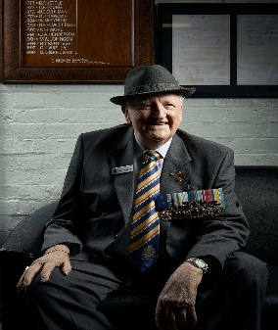
3rd Battalion RAR Korea 1952-1953, 1st Com Div Battle School Japan 53-54
2nd RAR Malay 55-57. 11th N. S Training BN Wacol58-61
Life Member of Ipswich RSL Subbranch and Meritorious Award Recipient. Life Member 2RAR Association.
Matt served in Korea with 3 RAR (4 Jul 1952 - 4 Jul 1953) (366 days), Japan with 1st Com Div Battle School (1953-54) in Malaya with 2 RAR (1955-57) and with 11th NS Training Bn Wacol Qld (1958-61). Matthew, late of Springfield Qld passed away on 13 Feb 2025, age 91.
Matt was a Life Member of the 2 RAR Association and served as Committee Member (2001-06), Vice President (2006-2010) and President (2009-11). In the 1993 Australia Day Honours List Matthew was award an OAM for “Service to Veterans and their families”.
It is with an extremely heavy heart that we share the passing of a living legend, Matthew Rennie OAM. A proud Korea Veteran, Matthew was a highly respected figure within RSL Queensland and a cherished member of both the Ipswich and Toowoomba communities.
Matthew’s unwavering dedication to veterans, his tireless efforts in research and advocacy, and his passion for ensuring those who served were never forgotten have left an indelible mark on all who had the privilege of knowing him.
His wisdom, kindness, and commitment to honouring our veterans will be deeply missed, but his legacy will live on in the countless lives he touched.
A memorial service was held at CSI Club Services Ipswich, North Ipswich QLD.

561489 Pte Graeme “Big Simmo” Vivian SIMPSON 01 May 1945 – 13 Jun 2025
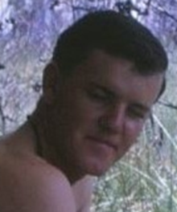
Tpt Pl, Admin Coy, 2 RAR/NZ (ANZAC) Bn, South Vietnam 19May 1967-13 Jun 1968.
Big Simmo passed away on 13 Jun 2025. A private cremation where his ashes will be scattered in Tasmania will be held.

5/1915 Cpl Ronald (Ron) George “Pappy” WALKER 04 Feb 1934 – 10 Jan 2025
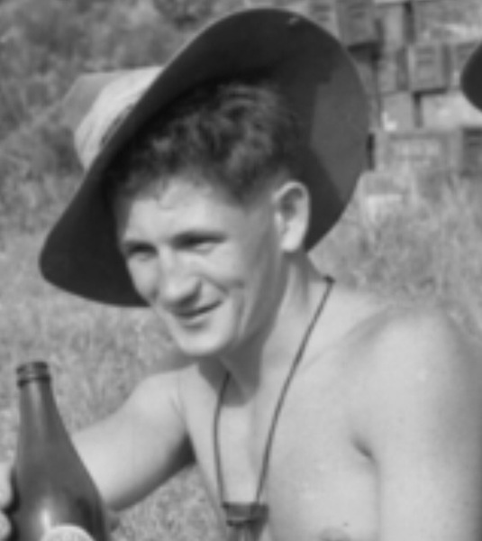
Ron enlisted in the Australian Regular Army on 1 July 1951 in Perth, WA, at the age of 17 and undertook Recruit training at Guilford, WA, and advanced infantry training at Puckapunyal, Victoria. He was then posted to the Machine-gun platoon, Support Company 2 RAR as a Corporal No. 1 gunner on a Vickers medium machine gun. He sailed with the battalion on the 'New Australia' and arrived in Korea on 17 March 1953. He joined Sergeant Brian Cooper's section at 'Vickers Village', a platoon position of four guns, and was positioned in the machine-gun bunker on Hill 111 during the battle of Hook on 24-26 July 1953, just prior to the war's end. Ron returned to Australia on 6 April 1954, having served 386 days in Korea. On his return to Australia, he served with 2 RAR at Enoggera and then Canungra, Queensland, and then with the 17th National Training Battalion at Wacol, Qld (Oct 1955 - Dec 1956). From January 1957 until June 1957, he was with the Bomb Search & Disposal Squad, Brisbane. He was discharged on 1 July 1957. Ron, late of Peeramon Qld passed away peacefully with his family by his side on 10 Jan 2025, aged 90. Ron’s Ashes were interred at the Tablelands Memorial Gardens, Nasser Road, Atherton FNQ. A Poppy Service will be conducted by the local Malanda RSL Sub Branch. Ron was a long-time member of the 2 RAR Association (No. 523). Thanks Honi-Joy Walker, Ron’s daughter

5714433 Pte Gerald Robert WATTS 03 Aug 1945 – 13 Jan 2025
South Vietnam: 1 ARU (25 Feb - 28 Mar 1967)
6 RAR (19 Mar – 28 May 1967)
2 Pl A Coy 2 RAR (29 May 1967 – 25 Feb 1968)
The Funeral Service for Gerald was conducted at Karrakatta Cemetery WA Thank you to Peter Heeney and RARA (WA)

1410932 Pte Allan “Lofty” Joseph WENT 15 Feb 1947 – 18 Jun 2025
A Coy 2 RAR/NZ (ANZAC) Bn, Signaller South Vietnam 19 May 1967-13 Jun 1968
Lofty passed away 18 Jun 2025

1735284 LCpl Boris ZOUBAKIN 21 Jul 1947 – 05 Feb 2025
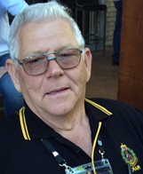
Boris a National Serviceman was born in China and served in A Coy HQ 2 RAR/NZ (ANZAC) Bn in South Vietnam (28 May - 26 Nov 1970). Boris passed away on 5 Feb 2025, aged 77 and his Funeral Service was held at Somerville Funerals Nerang Chapel, Nerang Qld. Boris was a member of the 2 RAR Assn (No. 602) regularly attending Reunions and the 2 RAR SE Qld Coffee Mornings. Rest in Peace Boris.

