Warriors Who Have Marched Out
2024

2783046 Pte Eric ASHBY 21 Dec 1945 – 27 Sep 2024
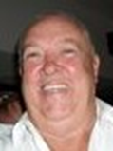
NS. Eric was a Driver with C Coy 2 RAR in South Vietnam (19 May – 6 Dec 1967). Eric passed away on 27 September 2024, aged 78 years. A Celebration of Eric’s Life was held at Mollymook Beach Bowling & Recreation Club, Ulladulla NSW

3786910 Pte Robert (Bob) Edward BOX 08 Apr 1945 - 23 Jul 2024
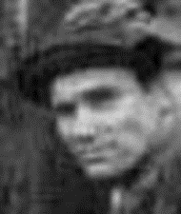
In 1962-63 Bob served in the CMF, he was conscripted in July 1965 and did his Recruit Training at 2 RTB. Bob was sent to 2 RAR for Corps Training and then in January 1965 joined 4 Sec, 8 Pl., C Coy, 5 RAR as a rifleman. He deployed to South Vietnam on 22 April 1966. When the company hit booby-traps on the Nui Thi Vai, Bob was badly wounded and medically returned to Australia (26 Oct 1966). Robert ‘Bob’ Box died peacefully in Swan Hill, VIC, on Tuesday 23 July. A private cremation was held for Bob. Thanks Shaun Hughes, Duty First

545985 WO1 Maxwell (Max) Richard BOYLE 1951 – 09 Jul 2024
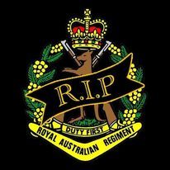
Max served in the Australian Army from about 1973 to 1995 with RA Inf, including service in 2/4 RAR (29 Jan – 15 Nov 1983), his last posting was RSM at the Pilbara Regiment. Max passed away in Geraldton WA, aged 73 years and his funeral was held at the Geraldton Crematorium followed by his burial in the Geraldton Lawn Cemetery.
Dennis Gilleland - ARMY MATES FB Page 17 Jul 2024
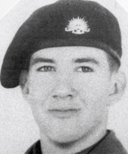
Pte Dean “Deano” BUNNETT 1956 - 02 Jul 2024
Dean grew up in Crystal Brook SA and enlisted in the Australian Army at the age of 17 in 1963; Recruit Training at 1 RTB (17 Pl C Coy) and served in RA Inf - 2 RAR, 6 RAR and the Demo Pl at JTC Canungra Qld before discharging in 1966. Dean was a bloody good mate and put a lot of time and thought into our War Memorial and will be sadly missed in our small community. Dean was a foundation member of the Gladstone South Australia Ex-Service Personnel Group.
Thanks to Richard Stott, Gladstone RSL (SA)

16341 Cpl Thomas Vincent BURTON 04 Feb 1937 – 22 Feb 2024
Tom passed away on 22d February this year. He served for nine years and five months in the Australian Regular Army. He first joined the army when called up for National Service on 18th August 1955, serving for five months in the 11th National Service Training Battalion.
Then, in 1961 Tom volunteered for service in the Regular Army. Following recruit training he was allocated to the Infantry Corps and served for three years in infantry battalions, first with 2 RAR, then with 3 RAR. It was here that he was promoted to corporal and his instructional skills were noted, leading to his posting as an instructor at the 2nd Recruit Training Battalion, which was raised to meet the needs of the Army as it expanded for its role in the Vietnam War. In December 1965 Tom returned to 2 RAR and in April 1969 he was posted to 8 RAR (Vietnam 17 Nov 1969 – 16 Jul 1970). Tom was a section commander in 9 Platoon, C Company and, as we all know, he was quietly spoken and a real gentleman, and as a leader he proved you didn’t have to be a fire-breathing dragon to lead men in battle. His quiet, but firm and reassuring manner ensured he was respected and got the best out of his men. RIP Tom – your duty done! “Behind the Eight Ball” April 2024

310083 SSgt William (Bill) Basil “Chips” CARPENTER 07 Nov 1925 – 22 Jun 2024
Bill was born in Redruth, Cornwall, England and embarked at the Port of London, England aboard RMS “ORMONDE” on 16 October 1950 as a 24-year-old Australian Army Recruit and served in Korea with 2 RAR (14 Mar 1953 – 6 Apr 1954). Bill passed away after a short illness, aged 98 years. After his funeral service, Bill was cremated and his ashes spread on the Clarence River, Yamba NSW. Bill was an early member of the 2 RAR Association (No. 74). Thanks to David Carpenter (Bill’s son)

164339 WO2 Edward (Ted) William CLARK 23 Aug 1958 – 26 Jul 2004
Ted enlisted in the Australian Regular Army on 1 Mar 1977 and was posted to the Royal Australian Infantry Corp, serving with 1 RAR, 6 RAR, C & SC, 11/28 RWAR, 16 RWAR, 2 RAR (as CQMS B Coy, including operational Deployment to East Timor from 20 Sep 1999 to 10 Jan 2000), 9 RQR and The Pilbara Regiment. Ted served a total of 26 years in the Australian Regular Army. Ted, late of Karratha WA, formerly of Brisbane and Townsville and Maryborough passed away on 26 Jul 2004 and is buried in Laidley Cemetery, Laidley Qld.

1202700 Pte Robert “Bob” COLE 1951 - 11 Nov 2024
Robert served in 4 RAR, 2 RAR & 2/4 RAR. Bob, late of Toowoomba, passed away on 11th November 2024, aged 73 years and his funeral was held at the Garden Chapel, Toowoomba Garden of Remembrance, Toowoomba. Thanks Wendy McLean, 4 RAR Assn

52053 WO1 Brian Charles COOPER MM 11 Aug 1933 – 15 May 2024
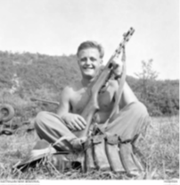
Brian Charles Cooper was born in East Perth, WA, in August 1933, and was a painter before enlisting in the Australian Army as an eighteen year old in 1951. Brian served in Korea with 2 RAR (17 Mar 1953 – 6 Apr 1954). In July 1953, holding the rank of temporary sergeant, he received an immediate award of the Military Medal for his gallantry and leadership at Hill 111, a position protecting the Australian lines at 'The Hook', near the Imjin River in North Korea. After service in Korea, Brian Cooper remained in the Army until 1968, reaching the rank of Warrant Officer Class I, and was later prominent in the Western Australian RSL. Brian passed away aged 90. His funeral was held at Pinnaroo Cemetery West Chapel,
HONOURS AND AWARDS – THE HOOK BATTLE –
5/2053 SGT BRIAN CHARLES COOPER MM
On the night of 24/25 Jul 1953 Sgt COOPER commanding the 2 Bn RAR MMG Section of ten men on Hill 111, a feature on the extreme right flank of the United States 1st Marine Division. The task of this section was to cover the western approaches to the HOOK feature, some thousand yards away. At about 2103 hrs a heavy enemy artillery concentration came down on Hill 111, causing three casulaties in the section, quickly followed by a fierce assault by an estimated enemy company, which penetrated the main defences on the immediate left of the section.
Sgt COOPER, leaving his MMGs manned and laid on their primary task, quickly organised the rest of his men into a defensive position facing his left flank and engaged the enemy so skilfully and with such a volume of grenades and small arms fire that they were unable, in spite of their numbers, to penetrate his position. During the next seven hours Sgt COOPER stubbornly fought off with his few remaining men repeated attempts by the enemy to overrun his position. He also on his own initiative called down friendly artillery fire, directing it so close to his own and the US Marines positions that it completely prevented the enemy from pressing home further organised attacks. The efficiency of his fire control was made more evident the next morning the the number of enemy dead who lay in front of the area.
In addition Sgt COOPER continued to pass back to his battalion, throught the action, a constant flow of the most valuable information concerning the situation in both his and the US Marines area, and also personally supervised the evacuation of his casualties to a safe area under heavy shell fire and through an area in which parties of the enemy were still moving. Throughout the whole night Sgt COOPER set an oustanding example of cool, cheerful and courageous leadership which was a splendid inspiration to not only to his own section but also the the men of the US Marines with whom he was fighting. There is no doubt the stubborn defence his section put up in the face of great odds, his skill in controlling his own artillery fire and the invaluable information he passed back were largely instrumental in breaking up a strong enemy attack on a feature vital to the defence of the whole HOOK area.
DROP SHORTS – RINGO Apr 2015 - 52053 Sgt Brian Charles Cooper, MM
At approximately 10am on or about 29/30th July '53, the Vickers Machine Gun Section was summoned to assemble outside the Support Coy. Orderly room, where it was addressed by the Coy. Comd. Major Thomas Wilson. He congratulated the assembled troops on their sterling efforts during the attacks by the enemy on Hill 111 (left of 2RAR position, The Hook) during the night of 24th/25th July, and that as a consequence of their efforts, a Military Medal had been awarded to the Section, and as per protocol, the senior N.C.O. of the Section would be assigned the Award. In deference to their memory, and the fact that they were recipients of the award, the names of ALL personnel should be recorded for posterity.
The members of this Section were:
Sgt Brian Cooper, Cpl Kevin Power, Cpl Ron Walker,Cpl Douglas Franklin (W.I.A.), Pte Arthur Tranter, Pte John Perring, Pte Kenneth Cranston,Pte Richard “Dick” Hill, Pte Allen Madgwick, Pte Allen Casey (Sect Sig.), Soo Kyo Soong (KATCOM), Pte Dan Mudford (Absent W.I.A.), H. Mathews (Sect Cook)
Thanks Ron Walker (Cpl Ron Walker MMG Pl 2RAR 17 March 1953 - 6 April 1954)

4720945 Pte William (Bill) George CORNISH 11 Apr 1949 – 11 Apr 2024
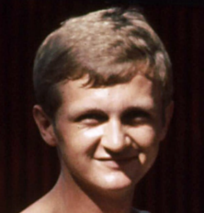
NS. Bill served in South Vietnam with 2 RAR/NZ (ANZAC) Bn Mortar Pl from 16 May 1970 – 1 Jun 1971. Bill passed away at Greenslopes Hospital, Brisbane QLD, it was his 75th Birthday. There was a gastro outbreak at the nursing home, and he contracted it resulting in internal bleeding. There was no funeral and his ashes will be taken to Adelaide SA for a memorial service. Thanks Helen Cornish

3162721 Pte Phillip “Coxy” John COX 01 Jul 1948 – 07 Oct 2024
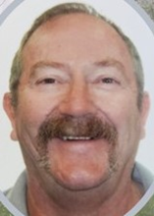
Phillip was a Signaller with C Coy HQ, 2 RAR/NZ (ANZAC) Bn in South Vietnam (16 May 1970 – 1 Jun 1971). Phillip passed away on 7 Oct 2024, aged 76 years; his funeral was held at Murrindindi Chapel, Alexandra, Vic followed by a private burial service. Phillip was a member of the 2 RAR Assn (No. 104).
Thanks to Ray Lunt and Peter Heeney

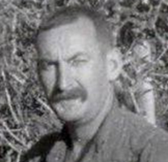
3411111 Sgt Austin “Mick” Michael CREDLIN 11 May 1936 – 5 Nov 2024
Mick was born in Sea Lake Vic and served in Malaya/Borneo with HQ Comms attached to 4 RAR; in South Vietnam with 2 RAR/NZ (ANZAC) Bn Section Comd 10 Pl D Coy (19 May 1967 – 13 Jun 1968), 1 ARU (16 Nov – 2 Dec 1968), 9 RAR (3 Dec 1968 – 27 Nov 1969), 1 ARU (28 Nov – 5 Dec 1969), HQ, 1 ALSG (21 Jan – 23 Jul 1970). Mick passed away peacefully on 5 November 2024, aged 88. Funeral Prayers for Mick were offered at Sacred Heart Catholic Church, Wodonga followed by a private cremation. Mick’s wake was held at the Wodonga RSL Club. Thanks Terry Dinneen, Tim Credlin

230745 Pte Ian Malcolm CUTHBERTSON 10 Feb 1963 – 07 Jun 2024
Ian served with C Coy 2/4 RAR (11 Jul 1984 – 14 Jan 1985). Ian lost his fight with cancer. A celebration of his life was held at Brighton Lake Golf Club, Moorebank NSW.
Thanks to James Thorpe

2793341 Pte Graham Thomas DORRINGTON 08 Feb 1949 – 14 Jul 2024

NS. Graham served in 5 Pl B Coy 2 RAR/NZ (ANZAC) Bn in South Vietnam (16 May 1970 – 1 Jun 1971. Graham Dorrington passed away suddenly at home in Coffs Harbour on 14 July 2024, aged 75 years. Graham’s funeral service was held in the chapel of the Coffs Harbour Crematorium, Coramba Road, Karangi, NSW.

43521 Cpl John (Johnny “Agro”) Graham GASSON 11 Jun 1945 – 26 Jan 2024
John served in Malaya (10 Pl D Coy 4 RAR) and Vietnam with 2 RAR CHQ B Coy (19 May 1967 - 05 Jun 1968) and 8 RAR Spt Coy (26 Nov 1969 - 10 Nov 1970). He also served with 6 RAR, 8 RAR and 8/9 RAR. Johnny passed away peacefully a long battle with cancer. A private family funeral was held with a get together for his many mates held later. 8 RAR Association

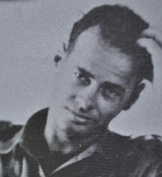
52396 Major Robert (Bob) Ian GEORGE 13 Jun 1934 – 08 May 2024
OCS Portsea Class of December 1952. 1 RTB (1953-55), 4 RAR (1955-58), 2 RAR (Holsworthy 1958-59), 1 RAR (Capt) 1959-1962 – Malaya 1959-61), AATTV (Original Team member 1962-64 – Vietnam 3 Aug 1962 - 30 Oct 1963 - Dong Da, National Training Centre, Phu Bai near Hue, Chief Weapons Committee. 2–6 Aug 63, observer 2nd ARVN Division operation), Inf Centre (1964-65), 3TB (1965-67), 8 RAR (1967-68), 1 RAR (Vietnam 31 May 1968 - 28 Feb 1969), 3 RAR (1969-70), Army Staff College, Queenscliff (1970), 3TB (1971-72), 2/4 RAR Bn 2IC (15 Aug 1973 - 15 Jun 1977). Bob had a great career in the Army and was a mentor and legend to the vast majority, he died peacefully in his sleep in Carlyle Gardens, Townsville Qld, aged 89 years, just five weeks short of his target (his 90th Birthday) declared to others on ANZAC Day 2024. Bob did not want a funeral and was privately cremated. Farewell George RI, until we all gather in Valhalla. Duty First. A well-respected officer and a gentleman. He will be missed by many. Rest In Peace. Thanks Dutchy Hemerik, Alan Braby, Merv Dicton, Terry Dinneen

4718504 Pte Michael (Mick) John HOLLOW 09 Jun 1946 – 18 Nov 2024
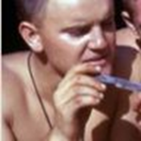
Mick served in 2 Sect 10 Pl D Coy 2 RAR/NZ (ANZAC) Bn in South Vietnam (10 May 1967 - 14 May 1968). Mick was from Balhannah South Australia and passed away peacefully surrounded by his family on 18 Nov 2024, aged 78. Mick’s funeral was held at Bowen Funeral, Darroch House, Felixstow SA. Mick had been a member of the 2 RAR Assn for many years.
Thanks Kevin Clarke

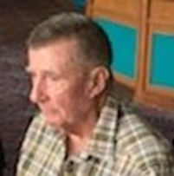
2783685 LCpl Ross James HORNE 14 May 1945 – 18 Apr 2024
NS. Vietnam: 2 Pl A Coy 2 RAR/NZ (ANZAC) Bn (19 May 1967 – 26 Mar 1968). Ross passed away on 18 April 2024 after a long battle with dementia, aged 78 years. His funeral was held at Eastern Suburbs Memorial Park, Matraville, NSW. Ross was a long term 2 RAR Association Member (No 235).
Thanks Gordon Hurford

29066 Major Karl Henry JACKSON 23 Jan 1937 – 18 Dec 2023
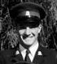
Karl graduated from OCS Portsea in June 1956 and posted as 2Lt to 1 RTB (19 Jun 1956 – 9 Feb 1958), 11 NS Trg Bn (10 Feb 1958 – 10 Mar 1959), 3 RAR (11 Nov 1959 - 7 Sep 1964 - included Visit to South Vietnam (3 – 12 Mar 1964), GSO3 (C Ops SD and Trg) HQ N Comd (8 Oct 1964 -26 Sep 1965), 2 RAR (26 Sep 1965 – 10 Nov 1966), South Vietnam OC 1 ARU (9 Nov 1966 - 07 Jun 1967), 5 RAR (21 Aug 1967 – 29 Jan 1968), 2 RTB (30 Jan 1968 – 19 Jan 1969), DAAG HQ Puckapunyal (20 Jan 1969 – Mar 1970), GSO2 HQ OTG E Comd (1971-72). I remember him as my Pl Comd 2 Lt in the 1st quarter of 1957 at 1 RTB. Thanks Terry Dinneen

3788990 Pte Stanley (Stan) JARUGA 24 Dec 1945 – 9 Jan 2024
Stan was born in Germany, as a National Serviceman served with 1 Section, 4 Platoon, B Company, 2 RAR in Vietnam from 19 May 1967 – 13 Jun 1968. During his tour Stan was one of 9 Machine Gunners unofficially seconded from B Company to the 135th Assault Helicopter Company. Stan served this role from 23 Jan 1968 to 14 Feb 1968. This unit, known as “The EMUs”, was the home of the RAN Helicopter Flight Vietnam. The members involved flew between 40 and 90 hours and were awarded the US Army’s combat flight decoration ‘The Air Medal’. They were also awarded a ‘one off’ set of ‘Air Gunner’ aircrew wings and the Republic of Vietnam Cross of Gallantry with Palm Unit Citation. Stan passed away in Geelong Hospital, Vic on 9 Jan 2024. A funeral service was held at West Geelong attended by many B Coy members. Thanks to Geoff Brewer

1735618 Pte Phillip “Leppy” LEP 24 Sep 1948 – 28 Jul 2024
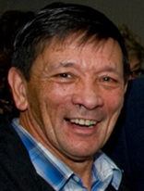
NS. Leppy served in 4 Pl B Coy and then Mortar Pl, 2 RAR/NZ (ANZAC) Bn in South Vietnam (16 May 1970 – 1 Jun 1971). Phil passed away surrounded by family on the night of 28 July 2024, aged 75+ years.
A Memorial Service for Phil was held at Mt Thompson Memorial Gardens, Holland Park attended by many of his mates from 2 RAR/NZ (ANZAC) Bn SVN 1970-71.

43484 Sgt Albert “Alby” John LUNDIE 07 Jul 1941 – 17 Dec 2024
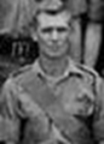
Pte Albert Lundie, served with 4 RAR in Borneo in 1966. He was Pl Sgt with 1 Pl A Coy and then Sp Coy in South Vietnam with 2 RAR/NZ (ANZAC) Bn (12 May 1970 – 1 Jun 1971). Albert, late of St Vincent's Aged Care Douglas, formerly Rasmussen Qld, passed away peacefully on 17 December 2024, aged 83, at the Townsville University Hospital, surrounded by family. In keeping with Albert's wishes a private service was held with the family. Townsville Bulletin 21 Dec 2024. Thanks Merv Dicton

3789311 Pte William (Jim) “Irish” James LYTTLE 03 Aug 1945 – 09 May 2024
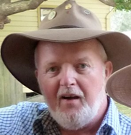
NS. Jim was born in Rathfriland Down, Northern Ireland. Served in 5 Pl B Coy 2 RAR/NZ (ANZAC) Bn South Vietnam (19 May 1967 – 11 Mar 1968). “Irish” passed away from Pulmonary Fibrosis, aged 78 years. Jim’s funeral was held at Bunurong Memorial Park, Dandenong Vic. He had been ill with that condition for over 10 years, so he virtually lived with an oxygen bottle beside him. As you know he was a 'one off' character.

34080 WO2 Rex Lawrence McCALL 05 Feb 1931 – 19 Sep 2024
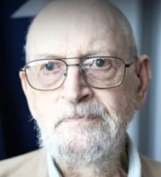
Rex served in Korea with 2 RAR (9 Jun 1953 - 7 Mar 1954 including the Battle of the Hook), with 2 RAR (Sgt) in Malaya (1961-63) and later in PNG; South Vietnam with 6 RAR (CSM B Coy – 4 Jun – 8 Nov 1966). Rex passed away on 19 September 2024, at the St Andrew's War Memorial Hospital, Brisbane, aged 93 years. Rex’s Funeral was held at Albany Creek Lawn Cemetery, Broidgeman Downs Qld.

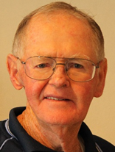
13879 Cpl Richard (Dick) Gordon “Gordon” McKEEN 20 Mar 1936 - 19 Sep 2023
Dick served with 2 RAR (Malaya 1956-57 and 1959-60) with BHQ, B Coy and C Coy. Dick served with Ray Simpson (later VC), Lt Col Ochiltree the CO, Lt Hands and Capt Chapman. Dick, late of Kingaroy and formerly of Warwick passed away on 19 Sep 2023, aged 87 years and his Funeral Service was held at Orana Lutheran Aged Care Chapel, Kingaroy and is buried in Taabinga Cemetery, Taabinga, Qld.

2791028 LCpl Donald (Don) “Noofa” William McINNESS 16 Apr 1948 – 28 Dec 2024
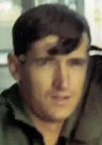
Don, a National Servicemen served in South Vietnam with 5 Pl B Coy 2 RAR/NZ (ANZAC) Bn South Vietnam (17 May 1970 – 3 Sep 1970). Don passed away on 28 Dec 2024, age 76. Don had an outstanding career in the Army, a great man that will be missed.
Thanks Peter Leembruggen, Merv Dicton


5714569 Pte Timothy (Tim “Smiley”) Smyley NELSON 20 Feb 1946 – 31 Mar 2024
NS. Jim served in Vietnam with 4 Sect 11 Pl D Coy 2 RAR/NZ (ANZAC) Bn (19 May 1967 – 13 June 1968) during the Battalions first tour of duty. Tim was an Association member (738). Tim, late of Darwin NT, passed away after a long illness on 31 March 2024 at the age of 78. Tim’s funeral was held at Darwin Funeral Services, Marrara, NT.
Thanks Pat King, Chaplain, NTPFES

218929 Pte Kevin “Ollie” Adrian OLIVER 09 Apr 1949 – 06 Aug 2024

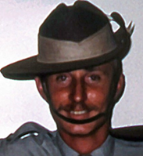
Ollie was a member of the Int Sect, 2 RAR/NZ (ANZAC) Bn serving in South Vietnam from 29 Apr – 13 Aug 1970. In 2002 Ollie underwent surgery for throat cancer, this did not stop him from enjoying life by playing golf and riding his motor bike. In recent years year Ollie was in a lot of pain, he Marched Out on his own terms on 6 Aug 2024, aged 75 years. No funeral was held as his body was donated to science.

Mrs Audrey Veronica (nee DUNIAM) SCATCHARD 27 Apr 1933 – 17 Mar 2024
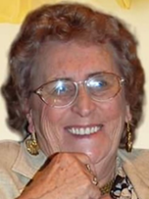
Audrey was the widow of the late Cpl Bernard Scatchard (Malaya 1955-57). Audrey passed away on 17 March 2024, aged 90 years and is buried in Burnie Lawn Cemetery, East Cam, Burnie City Tas.

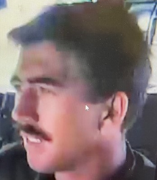
3795662 Cpl Jens “John/Schroeds” SCHROEDER 03 Oct 1948 – 10 Oct 2024
NS. John was a Section Commander in 6 Pl B Coy 2 RAR/NZ (ANZAC) Bn in South Vietnam (16 May – 24 Dec 1970). Schroeds passed away after suffering a stroke, aged 76 years, his funeral was held at Gregson and Weight, Caloundra Qld attended by many former members of the Battalion. John was the Administrator for the BCOY2RAR/NZ Facebook for many years and co-ordinated many B Coy 2nd Tour Reunions. Thank you for your service now Rest in Peace.

2786005 Pte James Lawrence (Jim) SHEPHERD 14 May 1946 – 26 Mar 2024
NS. Vietnam: 2 RAR/NZ (ANZAC) Bn 1 Pl A Coy (13 Nov 1967 – 13 Jun 1968. James, late of Callington SA passed away on 26 March, aged 77+ years, his funeral was held in the Carr Memorial Chapel, Mount Barker SA followed by a committal in the Callington Cemetery.
Ian “Patch” Campbell provided a Slouch Hat from Aldgate RSL and a 2 RAR Association flag was placed on the coffin. Thanks Mal Allen

2793195 Pte Phillip (Phil) Mervyn SHERD 07 Feb 1950 – 17 Jun 2024
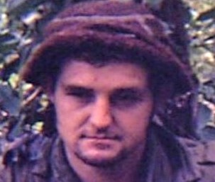
NS. Vietnam: 4 Pl B Coy 2 RAR/NZ (ANZAC) Bn (16 May 1970 – 1 Jun 1971). Phil passed away in hospital surrounded by family. R.I.P. No funeral details available.
Thanks Des Saunders, John Schroeder

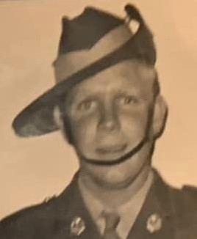
2785617 Pte Frederick William “Billy/Snow” Leonard SKINNER 30 Jun 1946 – 28 May 2024
NS. Vietnam: 8 Pl C Coy 2 RAR/NZ (ANZAC) Bn (14 Aug 1967 – 13 Jun 1968). Sad news, Billy had been fighting a very aggressive cancer, beat it twice before but suffered a heart attack and was rushed to hospital, where he passed away peacefully at 4.08am, aged 77 years. Bill’s funerl was conduced by Mackay Family Funerals, Ourimbah NSW. Bill was the Secretary / treasurer of the "NAMBUS" .He did an awesome job . Rest in Peace Bill, love you like the brother I never had. Thanks Bob Meehan ex 4 RAR

41769 WO2 Jack Richard STANNARD 09 May 1935 - 24 July 2024
Jack served in Malaya with 2 RAR; in South Vietnam with 6 RAR (22 May 1966 – 14 Jun 1967. In 1973 Jack was awarded a Medal for Long Service and Good Conduct (Military).
Jack passed away at Ipswich on 26 July 2024, aged 88+ years. A Funeral Service (Poppy Service) was held at the Rosewood RSL Soldiers Hall, Rosewood Qld.
Thanks 6 RAR Assn

3787036 Pte Donald (Don) “Tubby”Alexander TRELOAR 30 May 1945 – 05 Feb 2024
Don was a 1st intake National Service man, he did his recruit training at 2 RTB, Puckapunyal, then Corps Training with 2 RAR. In January 1966 he joined 2 Section, 7 Platoon, 5 RAR, as a rifleman. With 5 RAR he deployed to Vietnam aboard HMAS Sydney on 22 April 1966. Don continued with 7 Platoon and occasionally operated as the platoon’s signaller. He returned to Australia, with the Battalion, aboard HMAS Sydney on 12 May 1967. Don’s funeral Service was held at the Kyabram Community Church, VIC. Thanks to Gary Townsend, 5 RAR
12273 Pte Kevin TUPPER 06 Nov 1933 – 03 Mar 2024
Korea: 2 RAR (17 Mar 1953 - 06 Apr 1954). Kevin, late of Bridgeman Downs Qld passed away on 3 March 2024, aged 90+ years. Kevin was an Association Member for many years (Member No. 511).

3786964 Pte Trevor “Tiger” Allan WALSH 05 Mar 1945 – 22 Apr 2024
NS. Vietnam: 1 ARU (6 Feb -11 Mar 1967), 6 RAR (12 Mar – 28 May 1967), 2 RAR C Coy (29 May – 15 Aug 1967). Trevor passed away aged 79 years. A Graveside Service was held in his hometown of Koondrook (s on The Murray River) Vic. Trevor joined the 2 RAR Assn in 1991. Thanks Ed Whelan (Brother-in-law), Max Ingles

43504 Cpl Keith Richard WEBB 16 Feb 1947 – 14 Jun 2024
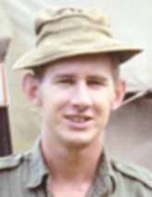
South Vietnam: Cpl Clerk, B Coy HQ 2 RAR/NZ (ANZAC) Bn (19 May 1967 – 13 Jun 1968). Keith was the B Coy Orderly Room Corporal throughout the entire 2 RAR First Tour. Not only did he keep the Orderly Room in good shape and he ran numerous patrols outside the wire. On his discharge he had his own rural magazine and book distribution company in Adelaide retiring to a rural property on the Fleurieu Peninsular in SA. Unfortunately, he had to manage dementia during the last few years of his life. Keith was 77 when he passed away and was privately buried prior to his Memorial Service at Mt Barker SA. Rest in Peace Keith. Thanks Geoff Brewer

1731889 Pte Ivan James WENDT 02 Oct 1945 – 16 Dec 2024
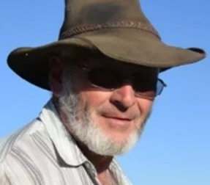
NS. Ivan Wendt served as a machine gunner with 2 Pl, A Coy, 2RAR/NZ (ANZAC) Bn in South Vietnam from 19 May 1967 until 26 Mar 1968, shortly before his discharge from National Service in April 1968. Ivan attended the Welcome Home Parade in 1987 and went to a couple of 2 RAR Assn Reunions, but generally kept to himself. In 2021 his family’s 4th Generation Dairy Farm was resumed by the local council and turned into a Sewage Treatment Works; this had a great effect on his well-being. Ivan finally succumbed to a prolonged battle with dementia at Logan Hospital, Qld on 16 Dec 2024, age 79 and his funeral was held at the historic, Bethania Lutheran Church, Bethania Qld. Ivan will be greatly missed by Dellas, his wife of over 50 years, his six daughters, his close extended family and his 2 RAR mates. May he now Rest in Peace. Thanks Paul King

54802 Pte William (Bill) “Circles” Harold WHITNEY 23 Nov 1944 – 20 Nov 2024
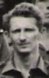
Bill was born in Farnborough, Kent, England and joined the Australian Army serving in Malayasia with 4 RAR (1965); later in South Vietnam as Forward Scout, 6 Sect, 5 Pl, B Coy 2 RAR/NZ (ANZAC) Bn (19 May 1967 - 25 Jun 1968), 1 ARU (23 Dec 1968 - 9 Feb 1969), 4 RAR/NZ (ANZAC) Bn (10 Feb - 13 May 1969), HQ 1 ATF (14 May - 8 Jun 1969), 9 RAR (9 Jun - 8 Oct 1969). Bill late of Beverly WA passed away on 20 Nov 2024, aged 79. No formal funeral was held; a Commemorative Moment was held at the Beverley RSL (WA). Bill was a member of 2 RAR Association for many years.

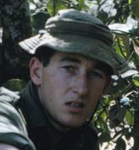
2785630 Pte Robert “Bobby” Thomas Frederick WICKES 15 Apr 1946 - 31 May 2024
NS. Vietnam: 4 Sect, 5 Pl, B Coy 2RAR/NZ (ANZAC) Bn, South Vietnam (14 Aug 1967 - 13 Jun 68). Bobby passed away around 11.30pm on 31 May, aged 78, he was struggling and agitated and having severe trouble so an Ambulance was called but they were unable to revive him. Bob’s funeral was held at Greenway Chapel and Memorial Gardens, Green Point, NSW. RIP Bobby, we shall miss your cheeky and smart wit. Thanks Bob Devers

5716688 Pte Allan James “Jimmy” WILLCOX 05 Sep 1948 – 13 Feb 2024
Allan was called up for National Service and posted to 2 RAR Transport Pl Admin Coy. He flew to Vietnam on 28 May 1970 with the Rear Party for the Battalions second tour. Allan RTA on 18 Feb 1971. He was diagnosed with pancreatic cancer and admitted to Palliative Care and sadly passed awy on 13 Feb 2024. Jimmys funeral was held in Merridin WA followed by a private burial with his family only in attendance.
Thanks “Rocket” Rod Hooper

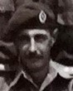
NZ 30743 Lt Col John Gilbert Hamish (Hamish) WILSON 22 Sep 1943 – 28 Jun 2024
Enlisted in the New Zealand Army as a Staff Cadet in January 1961 and graduated as a Lieutenant into RNZIR in December 1964. Served as Platoon Commander in A Coy 1 RNZIR 1965–1967. Completed tour in Borneo in 1966. Platoon Commander of 6 Platoon V2 Company 2 RAR/NZ (ANZAC) Bn in Vietnam, 1967–1968. Called time on 28 Jun 2024 at Christchurch Hospital, aged 80+ years. Funeral held at Lamb & Hayward Westpark Chapel & Memorial Garden, Christchurch. New Zealand. Thanks Ron Pritchard DCM

