2nd BATTALION,
THE ROYAL AUSTRALIAN REGIMENT ASSOCIATION, INC

“Second to None”

ANNUAL GENERAL MEETING


Cowboys Leagues Club

ON SATURDAY 26th OCTOBER 2024

2nd BATTALION, THE ROYAL AUSTRALIAN REGIMENT ASSOCIATION, INC

NOTICE OF ANNUAL GENERAL MEETING

SATURDAY 26th OCTOBER 2024

Notice is hereby given that the Annual General Meeting (AGM) of the 2RAR Association, Inc is to be held at 1100 hours Saturday 26th October 2024 at the Cowboys Leagues Club, 335 Flinders Street, Townsville QLD 4810.

Members attending are asked to arrive at 1030 hours and check their financial status. Only financial Ordinary and Life members are permitted to stand for election and to vote at the meeting.

Notice is also given that all Committee positions will be declared vacant. If you wish to nominate yourself or another person for a position on the Committee, complete the Nomination Form and submit your nomination in the prescribed manner.

The outline agenda for the meeting is as follows:
Attendance / Apologies Secretary
Confirmation of Previous Minutes Chairman
Business Arising Chairman
Reports Chairman
Financial / Auditors Report Chairman
Appointment of Auditor Chairman
Election of Office Bearers Chairman
Agenda Items……………………………….…. Chairman
Special Resolution 1
Special Resolution 2
General Business……………………………… Chairman
Next Meeting Secretary

Note: Any matters for discussion/notice of motion under General Business must be notified to the Secretary in writing no later than ten days (16th October 2024) before the date of the AGM.

Malcolm Gray
President
_______________________________________________________________________________

Methods of Voting
Voting is by the show of hands. The first past the post method of voting will be used. This means the nominee with the greatest number of votes for a position win. In the case of equality of votes; the Chairman shall have a second or casting vote. Listed below are the current Executive and Management Committee positions and incumbents filling those positions.

President Malcolm Gray
Vice President Justin Huggett, MG
Secretary Robert Althofer
Treasurer David White
Committee Troy McGill
Brendan Martin
Merv Dicton
Rick Avery

Auditor RWM Accountants

Note: Current serving Management Committee incumbents Justin Huggett MG, David White and Rick Avery have chosen NOT to stand for re-election.

2nd BATTALION,
THE ROYAL AUSTRALIAN REGIMENT ASSOCIATION, INC
ANNUAL GENERAL MEETING
AT COWBOYS LEAGUES CLUB TOWNSVILLE
COMMENCING AT 1100 AM
SATURDAY 26th OCTOBER 2024
AGENDA
- Attendance & Apologies
- Welcome
- Confirmation of the Minutes of the Previous Meeting
- Matters Arising from previous Minutes
- Management Committee Reports
  - President’s Report
  - Treasurer’s Report / Auditor’s Report
- Appointment of Auditor
- Election of Office Bearers for 2024 / 2025
- Agenda Items:
  - Nil
- General Business
- Closing Remarks
- Next Meeting: To be advised

Malcolm Gray

Malcolm Gray
President
01 Sep 2024

2ND BATTALION, THE ROYAL AUSTRALIAN REGIMENT ASSOCIATION INC.

MINUTES OF THE 2023 ANNUAL GENERAL MEETING
HELD AT
TOWNSVILLE RETURNED & SERVICES LEAGUE SUB-BRANCH
ON SATURDAY 28th OCTOBER 2023

The meeting commenced at 11.04 am.

The ODE

PRESENT: As per the attendance book (13 with 1 x being a non financial member), Online (5), SEQ (25). The Secretary advised there was a quorum.

APOLOGIES: Rod Hooper, Cameron Simpkins

WELCOME
The Chairperson (secretary) welcomed all those in attendance and confirmed that there were 6 proxies held with additional voting rights to vote on the members behalf (4 x given to chairman, 1 x given to Rick Avery and 1 x given to Terry Reid)

MINUTES OF THE 2022 ANNUAL GENERAL MEETING

Moved: Robert Althofer, Seconded: Brendan Martin, that the Minutes of the previous Annual General Meeting held on 29th October 2022 be taken as read.
CARRIED

MATTERS ARISING FROM PREVIOUS MINUTES
Financial Member, Jason Harrison attempted proposals that were not read out in full at the AGM 2022 due to the discussion and content not consistent with the rules of the Association. This has been discussed by the Committee during normal Management Committee meetings and has looked through the wording of his considerations diligently. Thus Special Resolutions have been drafted and will be tabled shortly due to some of Jason’s consideration items for the Association. We thank Jason for his input that was provided at the time of the 2022 AGM.

CHAIRPERSON REPORT

Welcome all to this the 2023 2RAR Association AGM. Throughout this year the Association has provided focus on the Association’s strategic goals with Being Relevant as the forefront to what we as an Association are striving to achieve. Our relevance comes through our four pillars of support to our members being:
- Transition Support
- Veteran Welfare
- Preserve the Units History
- Succession Plan
By acting on these four pillars the Association can provide meaningful support for our veterans both serving and ex-serving.

To be accountable to our members, I would like to explain how we have attempted to achieved these pillars?
Transition Support – This year we have once again been granted access to an Office on Samichon lines and we thank the CO & RSM for their continued support for allowing us access to their soldiers. On most Fri from 0900 we have a member of the committee be available to the soldiers to come in and discuss any matter they wish, this interaction is still a work in progress and we are continuing our focus in this area to engage current serving members. We have reached out to the RSL to look at attaining qualifications in Advocacy but this is long term goal in having a continued presence of an advocate available to our serving veterans. Our communication to the Btn and its members can be better and is a focus for us in 2024.

Veteran Welfare - Our Welfare & Social Programs provides unique support to both the current service members and our veterans. Home and Hospital welfare checks and Bereavement support are also key parts to our current Welfare Program. Regular veteran coffee catch ups continue on a weekly basis in NQLD and monthly in SQLD. SA weekly catch ups are available to all veterans not just 2 RAR and is continuing to be a well presented event thanks largely to our SA Rep. The ANZAC Day road trip to the NT that was supported by our NT State Rep Wayne Woodhouse was a much talked about event. Our engagement with other ex-service organisations/DVA has improved and we are working with the new Repatriation commissioner currently on helping to find one of our veterans NOK so that his remains can be returned to his family. We represented or had physical support for all of our Vietnam veterans at the Vietnam Veterans Vigil on the 03 Aug and we thank all those who conducted/attended these services to honour our Vietnam veterans. As this was a truly collaborative and much appreciated initiative.

Preserve the Units History – Much of this work has been done separately through Jason Harrison and his volunteer team at the 2 RAR Historical Collection. The Association is there to support the Historical collection in their efforts whilst also looking to our members to help provide their stories of service to us so that we may share these stories through Magazines such as Duty First and RINGO. We would love to read your story and encourage all our members to sit down with us and tell us their service story.

Succession Plan – We are always open to new ideas and new members in particular those who may have certain skill sets to help with the running of the association. At this stage no succession plan has been set in stone however we will continue to work with our current serving members with the focus of Being Relevant at the forefront in all actions that we do.

All though the Association probably hasn’t meet all our goals this year, we will continue to strive to do better and are happy for any feedback any of our members may have in approving our quality of output to our members.

Finally, I would like to acknowledge and thank the outstanding work of the committee members and importantly our State representatives as well. Their time and effort in volunteering to still serve 2 RAR is Second to None.

TREASURER’S REPORT

The Treasurer presented the Audited Statement of Accounts as at 30 September 2023.
Moved: David White, Seconded: Brendan Martin, that the Accounts be received.
CARRIED

Question from Jason Harrison: explain please why the Association isn’t doing more to gain higher interest as this was brought up last year and the Association should be doing more.
Reply: That is incorrect as last year was about Term deposits which we do have however the committee will look at further ways to see if our current accounts are the best and attaining a higher interest.

Question from Jock Cassidy: B Coy /D Coy funding has this been paid back.
Reply: This is still sitting in our accounts.

APPOINTMENT OF AUDITOR

RWM Accountants, the current Auditor, has indicated their willingness to continue in the position of Auditor for 2023 – 2024.
Moved: Robert Althofer, Seconded: Brendan Martin, that RWM Accountants be appointed Auditor.

ELECTION OF OFFICE BEARERS FOR 2023-24

Robert Althofer would not stand for re-election for the position of President and declared the seat vacant. Nomination for the position of President has been received for member Malcolm Gray. As there were no other nominations for the position, the Chairman declared Malcolm Gray elected.
CARRIED

Justin Huggett would stand for re-election for the position of Vice President. As there were no other nominations for the position, the Chairman declared Justin Huggett elected.
CARRIED

Malcolm Gray would not stand for re-election for the position of Secretary and declared the seat vacant. Nomination for the position of Secretary has been received for member Robert Althofer. As there were no other nominations for the position, the Acting Chairman declared Robert Althofer elected.
CARRIED

David White would stand for re-election as Treasurer. As there were no other nominations for the position, the Chairman declared David White elected.
CARRIED

The following members were nominating for the vacant positions in the Management Committee and were duly elected:
- Troy McGill
- Brendan Martin
- Roderick Avery
- Merv Dicton
CARRIED

THE COMMITTEE: President: Malcolm Gray, Vice President: Justin Huggett MG, Secretary: Robert Althofer, Treasurer: David White, Members: Troy McGill, Brendan Martin, Roderick Avery, Merv Dicton

AGENDA ITEMS

There are no Agenda items for this meeting, however there are 2 x Special Resolutions to be voted on. The Association is bound by rules of Association, which originated for the Association in 1991. Over time there have been several amendments to keep the rules, or constitution, modern and in tune with current practices. The Special Resolutions today reflects the need for the Rules to be further modernised particularly in the governance of the Association.

The Special Resolution has been circulated with the AGM notification papers which have given you ample time to peruse them. I will read and propose the Special Resolution, then ask for someone to Second the Motion and then we will vote on each in turn. To pass, the Special Resolution requires a 75% ‘yes’ vote.

Special Resolution 1:
Notice of Motion to amend Association Rules: “That Rule 4(2)(a) of the Association Rules be amended by deleting the existing Rule and substituting the following new Rule 4 (2)(a)

“4(2)(a) Any person who has served in 2 RAR after 16th October 1945 in peace and in war; and those who have been part of a 2 RAR Battalion Group on operations and past members of 66 Bn AMF; 2 AR, 2 RAR; 2/4RAR; 2 RAR/NZ (ANZAC), all ranks who have served, are currently serving, or will serve in 2RAR (Amphibious) in the future.”

That a motion to amend Rule 4(2)(a) of the Association Rules be considered, and if thought fit, passed by the Annual General Meeting on 28 October 2023.

All in favour – All All those opposed – Nil

Moved Robert Althofer Seconded Justin Huggett

Vote – Higher than 75% CARRIED

Special Resolution 2:
Notice of Motion to amend Association Rules: “That Rule 4(3) of the Association Rules be amended by deleting the existing Rule and substituting the following new Rule 4(3)

(3) Associate Membership. The following persons are eligible to be admitted as Associate members:
- Wives, partners, descendants and family members of ex serving members of 66 Bn, 2 AR, 2 RAR, 2 RAR/NZ (ANZAC) Bn, and 2 RAR (Amphibious), and

- members of other Battalions of The Royal Australian Regiment, and

- Supporters of 2 RAR.

- All associate members must be financial members of the Association

- All associate members are not eligible to vote but may enjoy all other privileges of an ordinary member.

That a motion to amend Rule 4(3) of the Association Rules be considered, and if thought fit, passed by the Annual General Meeting on 28 October 2023.

All in favour – Majority All those opposed – 1 vote

Moved Robert Althofer Seconded Troy McGill

Vote – Higher than 75% CARRIED

GENERAL BUSINESS

Comment from the Patron, Michael Slater, AO, DSC, CSC. Thank you to the outgoing President and to the committee for the ongoing work within the Association.

Discussion on whether current financial strategy would it be appropriate to increase /decrease fees and would a tier structure be something to consider. Should Associate members have reduced fees? Reply from Chairperson – hasn’t been discussed and is not in our current plans at this stage.

Question about RINGO and when next issue was to be sent. Reply from chairperson – Nov edition was the next issue to be released.

Closing Remarks –
Thanks to the Patron, Life Members and Honorary members and a big thank you goes out to all our families, without the support and appreciation from our families then a lot of this support could not be possible. I would also like to thank Wayne Woodhouse who has stood down from the Committee but will remain as our NT Representative. Thank you to the Btn without the Battalions support we will not be able to improve our bond with our current serving members. Thank you for your attendance today and for your continued support to the Association. We as an Association will continue to strive to work in the best interest of all our members and remain accountable for our actions.

DATE AND PLACE OF NEXT MEETING

The date, time and place for the next Annual General Meeting will be advised in due course

CONCLUSION

There being no further business, the meeting concluded at 1144 am.

Malcolm Gray Robert Althofer
President Secretary
2 RAR Association Inc 2 RAR Association Inc

2ND BATTALION,

THE ROYAL AUSTRALIAN REGIMENT ASSOCIATION, INC

FINANCIAL REPORT

FOR YEAR ENDED

30 SEPTEMBER 2024

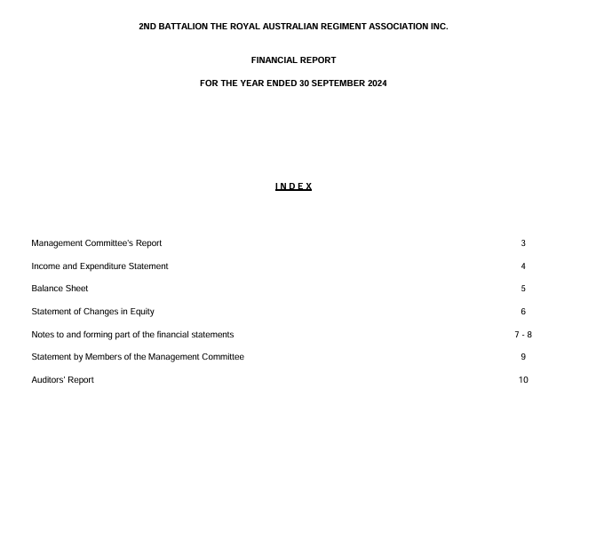

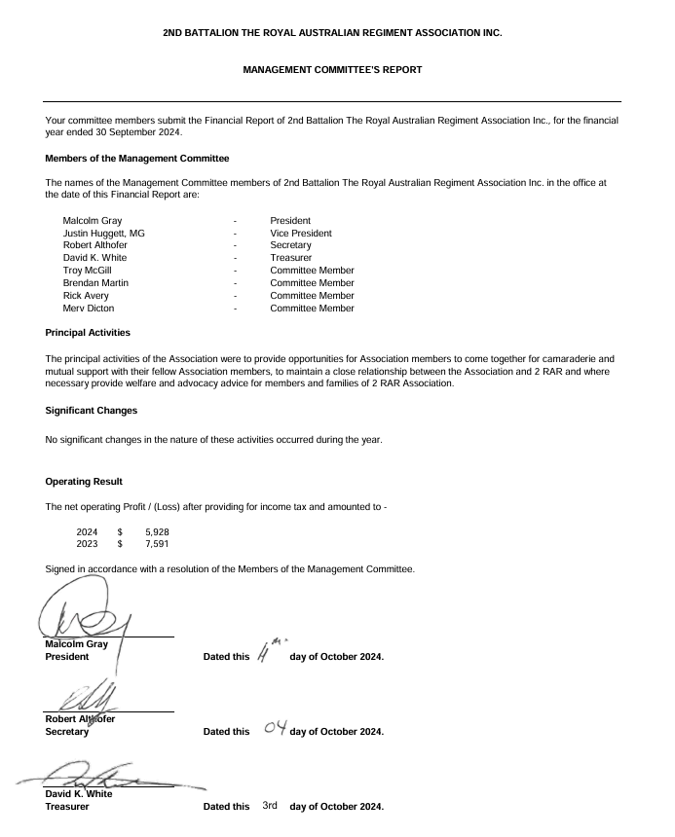

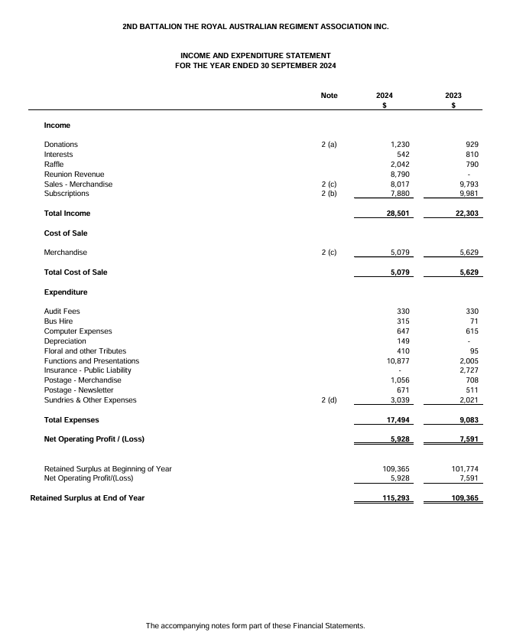

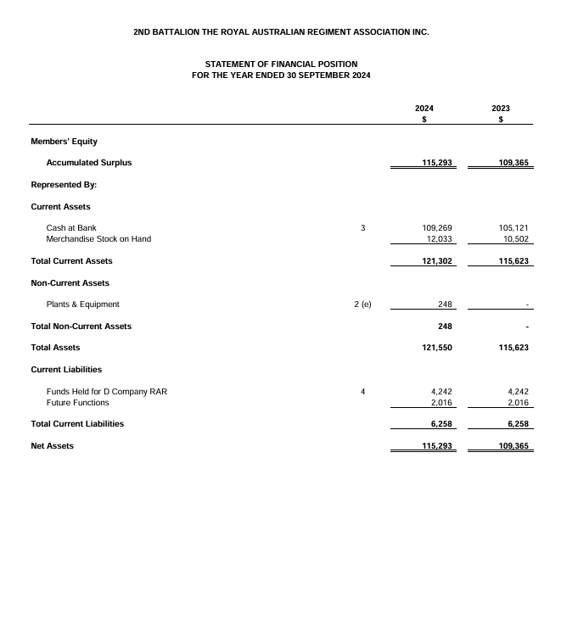
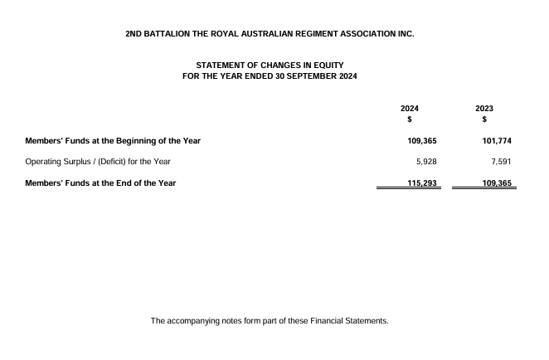

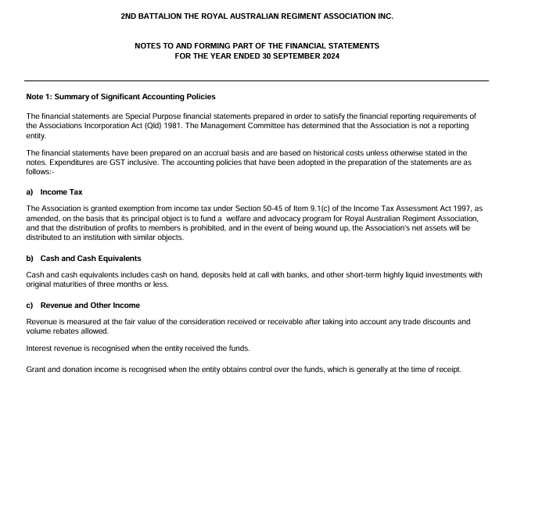

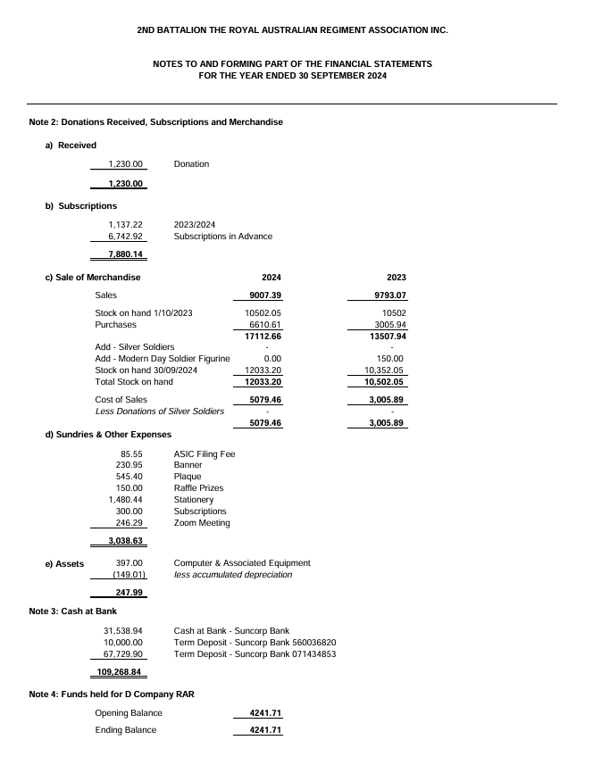

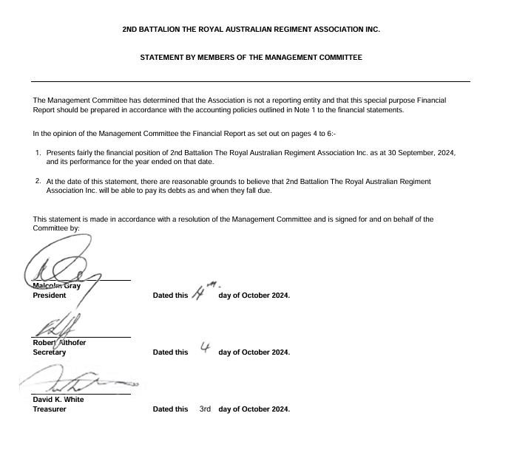

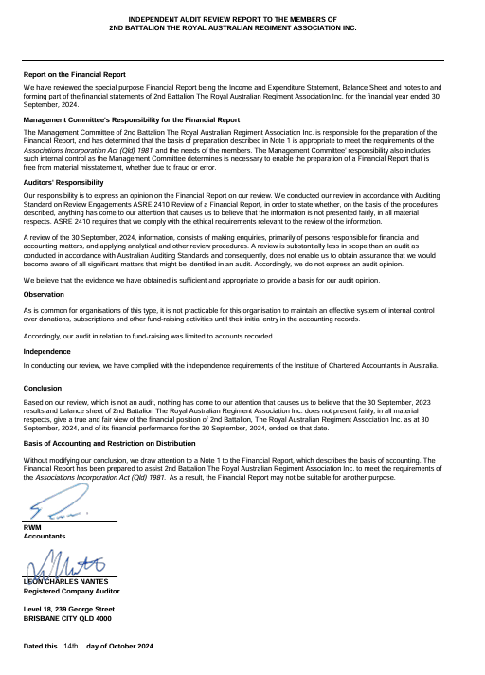

2nd BATTALION, THE ROYAL AUSTRALIAN REGIMENT ASSOCIATION, INC

PROXY FOR ANNUAL GENERAL MEETING

26th October 2024

Your Proxy is to be forwarded to the Secretary, 2nd Battalion, The Royal Australian Regiment Association, Inc, PO Box 2352, Idalia, QLD 4811 or 2rarsecretary@gmail.com to be received prior to the commencement of the meeting.

I………………………………………………….. of ………………………………………………………………………….

Being a Financial Member/Life Member of the above named Association and entitled to vote under its rules, hereby appoint:

*……………………………………………….... of …………….…………………………………………………………….

or, failing him *………………………………… of ………………………………………………………………………….
or the Chairman of the meeting

As my proxy to vote on my behalf at the Annual General Meeting of the Association to be held at 1100 hours Saturday 26th October 2024 at the Cowboys Leagues Club, Townsville, include voting on any Special Resolutions and at any resumption after the adjournment thereof.

Signed this ……………………………………. Day of …………………………….. 2024

Signature ……………………………………………………………………

*(Strike out whichever is not required)

_________________________________________________________________________________________

2nd BATTALION, THE ROYAL AUSTRALIAN REGIMENT ASSOCIATION, INC
NOMINATION FORM 2024

The nomination is to be received by the Secretary 2nd Battalion, The Royal Australian Regiment Association, Inc., PO Box 2352, Idalia QLD 4811 or, 2rarsecretary@gmail.com not less than 7 days prior to the commencement of the meeting.

I…………………………………………….……………………… being a financial member of 2nd Battalion, The Royal Australian Regiment Association, Inc., hereby nominate

………………………………….………………………………………………………………………….……………………..

for the position of ………………………………………………………………..… for the 2024 - 2025 Association year.

Nominator (Name) ……………………………………………………

Signed. …………………………………………………………………

Date …………………………

Seconded (Name)..…………..………………………………………..

Signed. …………………………………………………………………

Date …………………………………

I (Nominee name)…………………………………………………………………………….. being a financial member of 2nd Battalion, Royal Australian Regiment Association, Inc., accept the nomination for the above position.

Signed (Nominee)……………………………………………………

Date ……………………….

2nd BATTALION, THE ROYAL AUSTRALIAN REGIMENT ASSOCIATION, INC

ROLL OF HONOUR
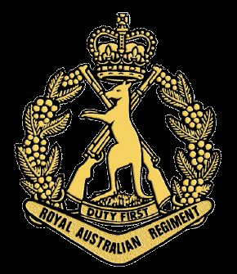

JAPAN 2 RAR  SX38810 PTE SE Evans  SX33581 CPL LR Lishmund  SX26369 PTE K Parken  QX55791 PTE NL Volling  WX23289 PTE HA Rowbottam  KOREA 2 RAR  3/3706 CPL JB Ashe  2/401173 LCPL EG Bourke  5/1482 CPL KJ Cooper  4/1172 PTE LJL Dawes  3/3601 SGT K Foran  2/401710 PTE P Green  2/5824 CPL GJ Hanley  1/2259 PTE BF Haworth  3/401092 CPL AW Haymes  2/401687 PTE TG Howarth  2/401510 PTE JR Jamieson  3/11228 PTE RJ Leigh  2/401213 PTE RJ McCoy  1/400592 PTE FC McDonnell  2/6184 LCPL HG Morgan  1/400292 PTE RC Rackley  2/5417 PTE JW Russell  2/401620 PTE D Sansom  2/11074 PTE AM Shaw  3/4540 PTE CB Sheah  3/10526 CPL AG Smith  3/3628 CPL AJ Wells  1/2684 PTE B Welsh  1/400702 PTE GW York  REBUBLIC OF KOREA  PTE SON JOONG Ok  PTE YOUN OK Dong  MALAYA 2 RAR  2/2836 CPL JN Allan  2/7271 SGT CC Anderson  2/8608 PTE JI Decent  1/2706 SGT KH Ewald  1/3693 PTE GC Fritz  2/9108 PTE TB Hallard  1/3207 PTE CC Ingra  2/8764 PTE CA Jay  3/2983 PTE HM Jephson  2/410190 PTE AW Keen  2/8234 CPL D MacVicar  1/3542 PTE JN Metcalf  2/7623 PTE JF Potts  3/410140 PTE J Wilson  REPUBLIC OF VIETNAM  SGT Nguyen Van Ha | VIETNAM 2 RAR  1201945 PTE LWH Adams  5714249 PTE RJ Bell  4410704 PTE RP Binning  18161 SGT T Birnie  2785150 PTE WJ Brett  4721369 PTE RS Chapman  2785238 PTE TJ Cutcliffe  311546 PTE WJ Davison  1411181 PTE FJ Fewquandie  61582 CPL TJ Grose  16141 PTE NS Harald  6708488 PTE FA Hyland  1735712 PTE PF Kowalski  2276245 PTE PJ Lyons  2782440 LCPL PE McDuff  2412362 PTE PS McGarry  1732186 PTE DW Morrison  1735386 PTE DW Neal  4718427 PTE DE Nelson  43058 CPL GL Norley  3790094 PTE NC Pettitt  43573 PTE SE Radomi  4410710 PTE JC Rivett  4718449 PTE J Rogers  1/4209 WOII RS Smith  1702729 PTE DL Thompson  2792375 PTE DJ Tully  1200750 SGT JW Twomey  1731955 PTE LJ Weston  3797671 PTE GI Willoughby  3411951 PTE KR Wilson  4718082 LCPL RM Woolford  NEW ZEALAND  699033 PTE WR Awatere  482859 PTE T Cooper  42752 GNR SW Ellwood  41301 LCPL CR Fisk  483256 PTE JL Gurnick  463211 PTE HD Hirini  211075 CPL GK Hoerara  629544 PTE LC Jones  346598 CPL M Manton  41081 LCPL ML Sutherland  41576 LT JR Winton  TIMOR LESTÉ 2 RAR  8514280 PTE AA Baker  AFGHANISTAN 2 RAR  8506296 PTE MC Lambert  8496923 LCPL LN Gavin  4Fd Regt RAA  8437949 CAPT BRA Duffy

