2nd Battalion – Roll of Honour

ROLL OF HONOUR – 3/3706 Cpl John Berkley ASHE
28th May 1953
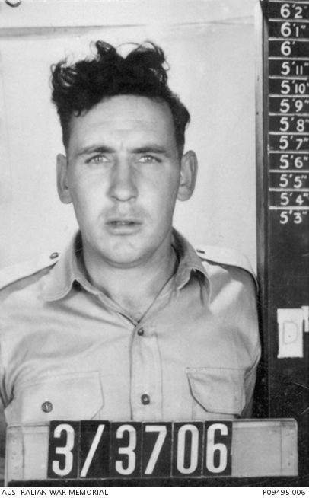

3/3706 CPL J.B ASHE
(29 Nov 1929 – 28 May 1953: Aged 23yrs)

Service Details
Cpl John Ashe was born on 29 November 1929 in the Melbourne suburb of Richmond, one of five children born to Guy and Mary Ellen Ashe. John grew up in Brighton, but after WWII began, his father, Guy, left the family and joined the AIF, leaving Mary nearly destitute. To keep her children fed and clothed, Mary Ellen had to work, so John and one of his brothers were put into an orphanage. Ashe hated the orphanage and escaped at his earliest opportunity and made his way home. He had been unable to take his brother with him, but did manage to return to the orphanage to visit.

When his mother moved to Benalla to work on various properties, Ashe went too. He enjoyed the farming life and was known as a good horseman and an excellent shot with a rifle. He attended school until the end of 8th grade, when he left to begin work. His pastimes included playing Australian Rules Football, and he was an avid Collingwood supporter. He also enjoyed swimming and judo.

By 1944, Ashe, now 14 years old, had returned to Melbourne. In September that year he attended the City Baths where he saved a young lady, Florence, from drowning. To ensure she was alright, Ashe escorted her home. From that day on, Ashe and Florence began a relationship.

Ashe was remembered as being a very restless person and every six months or so, he would “go bush” and work on various properties as a roustabout.

Each time he returned to Melbourne, he would meet with Florence’s parents and grandmother. He would take Florence, who was also a Collingwood supporter, to the football, and they both enjoyed time walking, attending dances, trips to the beach, and picnics.

After returning from one of his trips to the bush in 1949, he proposed to Florence in the middle of Collins Street. They married a month later at the St Mary’s Star of the Sea Church at West Melbourne. Their son John was born in May 1950. Sadly, Ashe and Florence separated not long after, but they remained the best of friends.

Ashe had difficulty in finding a job that appealed to him in the city. He was working as an electrical goods salesman Highett Radio Service, when he decided to join the army.

He enlisted for service in the Australian Regular Army on 15 November 1951 and in February the following year, after his initial training, he was posted to the 2nd Battalion, Royal Australian Regiment, where he joined 10 Platoon, D Company. Ashe found purpose in the army life and never once regretted his decision to enlist.

Soon after joining the battalion, Ashe was placed on courses for promotion. He successfully completed these on 14 August and was promoted to temporary corporal the following day.

By this time the battalion was preparing to deploy to Korea. On 5 March 1953, 2RAR embarked from Melbourne aboard the SS New Australia. The men disembarked at Pusan 12 days later replacing 1 RAR at Camp Casey near Tongduchon, South Korea. Ashe was promoted to corporal a week after arriving in Korea.

The battalion went into the front line on the night of 3-4 May, relieving the Royal Fusiliers. It would be a busy time for the men of 2RAR and patrols were sent out each night.

In the evening of 27 May, Ashe was in charge of a three-man lying up patrol that had been tasked to go into no-man’s land and observe Chinese movements.

In the pre-dawn hours of the next morning, the group was ambushed by Chinese troops near the Australians’ defensive minefield. In the initial exchange of fire, Ashe was wounded in the left thigh by a grenade fragment, but was able to continue. The two other members of the patrol were also wounded, and continued to engage the Chinese.

Another Australian patrol engaged the Chinese which allowed Ashe and his men to begin withdrawing. Due to the intensity of the firefight, the men were separated. Ashe inadvertently tripped a mine and was seriously wounded. One of his patrol mates made his way over to Ashe who said “stuff off” as he had “had it”. He then said “go, and that’s an order” leaving his mate no choice but to withdraw, leaving Ashe behind.

In the aftermath of the firefight a search was conducted to locate Ashe, but no trace of him could be found. Two more members of 2RAR were wounded after triggering a mine during the search. Ashe was listed as missing, presumed killed. He was 23 years old.

Back in Australia, Florence, who was working as a tram conductor, picked up a newspaper which had been left behind on a seat. As she started to read, she noticed the print “Corporal John Ashe – missing, presumed dead” and fainted in shock. It took much time and some persuasion by friends and family, but Florence eventually remarried and would have two more sons.

Ashe is commemorated on the memorial to the missing in the United Nations Memorial Cemetery at Busan in Korea.

Unit: 2nd Battalion, The Royal Australian Regiment -17 March 1953 to 28 May 1953 (73 days)
Fate: Place of Death Korea
Cause of Death: Presumed KIA
Memorial Details: United Nations Memorial Cemetery, Busan, Korea, the Australian War Memorial, Canberra ACT, 2nd Battalion Royal Australian Regiment Memorial, Lavarack Army Barracks Townsville Qld and RAR National Memorial Walk, Enoggera Qld.
Notes Corporal Ashe's body was never recovered and is therefore regarded as missing, presumed killed in action. Last seen at GR 143 183 Map: Majon Ni. and has No known grave - "Known Only Unto God".
THE LOST PATROL: THE FULL STORY - By John ‘Jack’ Barden – RINGO Jul 2019:
On the afternoon of the 27th July 1953 as I came off an eight-hour shift in the front operations, Corporal Jack Ashe asked me to go on a twenty-four-hour lay-up patrol [laying low in no-man’s-land or enemy territory to observe the Chinese movements]. The soldier who was picked as radio operator did not get along with Jack, so I said yes. Bob Hipworth was forward scout and myself radio operator. Just on dusk we were all up at the jump-off point and were wished good luck by our stand-by patrol as they made their way out to set up an ambush. It was these men who eventually saved our lives. As we checked our route with night glasses, we had a chat and a smoke, then they took away all our cigarettes. We were talking to Padre Joe Phillips when we saw a ‘chink’ patrol setting up an ambush about halfway to where we were going. I radioed headquarters for a new route but was told to follow orders. Joe Phillips got on the radio and told headquarters that it was suicide if we went that way but follow orders we did. As we continued, all seemed to be going well. We had passed where we had seen the ambush and radioed back that all was okay, when we heard a strange lingo telling us to “Halt”. We did not know the lingo, but we did know the sound of safety’s being taken off weapons. We were right in the centre of the enemy. They later told us that there could have been up to 60 or more Chinese. They started firing and we couldn’t just stand there, so all we could think of was to fire back at the gun flashes. We must have been doing okay, as we could hear a lot of screaming. Corporal Ashe was yelling to “bug out”, Hipworth was swearing that he was hit in the right side of his backside and as he slept on the right side, he would not be able to sleep. The Chinese must have thought we were mad standing there firing our guns and laughing our heads off. I dropped a full magazine and as I picked it up a Chinese grenade went off and blew some shrapnel into my right hand. As we turned away, ‘Cookie’s’ Bren opened up from the stand-by patrol and I could see the tracers and bullets hitting right into the Chinese. We started to run and kept running until we came to a minefield wire. Ashe and Bob went along the wire to the right and I went to the left. I came to another wire running at right angles, so I turned back. Jack and Bob had found the gap through the minefield, but the Chinese were already there.

We called headquarters on the radio but the Canadian operators would not give us airways as they were calling their own men and told us to get off the air. We eventually made contact but could hear the Chinese coming up the hill. Bob ran into the minefield, while Jack and I stopped and rolled a couple of grenades down hill to try and slow the Chinese advance. As I turned around, I got hit in the right shoulder and back of the head with shrapnel and could see Ashe up in the air with blue and green flames all around him – he had tripped a mine. I copped another hit in the hand and shrapnel also hit the radio receiver. I ran back up to Jack Ashe, but he said to “stuff off” as he had ‘had it’. I lay down alongside him, but he said, “Go and that’s an order”, as he didn’t want the Chinese to get the radio. I ran up to Bob and wanted him to come back but by then the Chinese were all around us. We made it to the gap where the standing patrol was supposed to be, but they had been called in and there were Chinese in their location. We turned left and ran until we hit a low spot. There were shells and bullets whistling all around us, so we stopped and lay there.

As it became a bit lighter, we found that the radio receiver had taken a bad hit and couldn’t be used. I crawled through the scrub, pulling myself along with my one good hand. When I reached Bob, we managed to get through to headquarters on his radio. We made our way out through the minefield, following the same footprints that we had made coming in. As we got up to the top, we ran into a patrol and I could see two blokes out to our left in a minefield. As I radioed to tell them that they were in the wrong area, they suddenly ‘went up’ and found out later, they were Maury and Ernie. After I got away, I wanted to lead the boys back to Jack but was ordered in. At that time, I would say they were within 70 to 80 yards of Jack, maybe less. I spent nearly two months in hospital at Kure and Hiro and later came back to ‘The Hook’ in Korea. After the peace treaty, I went with a patrol to where we had entered the minefield but by that time the summer growth was everywhere, and the place was like a jungle. They said they had already searched the minefield but could find no trace of Jack Ashe.

CAUGHT IN A MINEFIELD 27th/28th May 1953 by Ernie R. Holden
On the night of 27th/28th May 1953
......About 3 am. we were ordered out on a search and rescue patrol. A three-man (2/401399 Pte John Bernard Barden, Boggabilla, N.S.W.; 1/400258 Pte Robert James Hipworth, Cairns, Qld; 3/3706 Cpl John Berkeley Ashe, Chelsea, Victoria) reconnaissance patrol had been attacked by the enemy and was trapped out in "no man's land", somewhere near a mine field. .....

.......After searching for about one hour, looking behind clumps of bushes etc, (Chinese could be hidden behind these with "Burp" machine guns) and me with only my 303-rifle ready to fire one bullet at a time. We found no enemy, or the three men lost on patrol, and trudged back to the safety of our lines.

At about 5am. we were ordered out again. There must have been more radio contact with the "Lost" patrol. I remember the sounds that went tip amongst the men as it was getting close to 'first light', no one wanted to get trapped in "No man's land" in broad daylight. Once again, I had my trusty 303 rifle and no bullet proof vest.

At first light we came across two of the men (2/401399 Pte John Bernard Barden, Boggabilla, N.S.W.1/400258; Pte Robert James Hipworth, Cairns, Qld.). They both had light injuries, one had Russian "Burp" machine gun bullets through his hand and the other up his backside. They said Cpl Jack Ashe was still missing in the mine field, badly injured or killed. My mate, Maurie Sharp was upset because Jack Ashe wasn't found with these two men. He said he was going down to the mine field to look for him. I said to him, "can I come with you?" He agreed - I was always the adventurous type!!
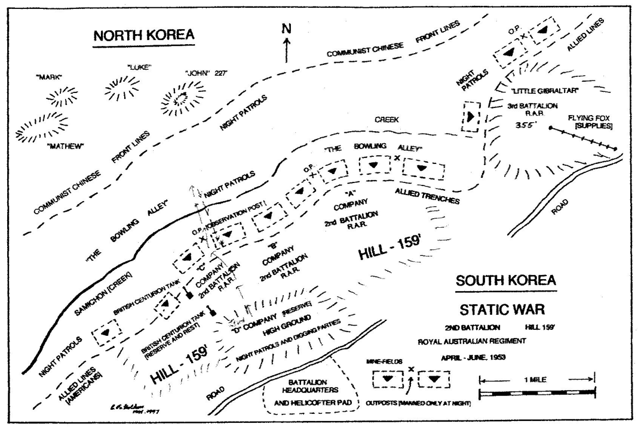

‘Lest we forget’

