**ROLL OF HONOUR – QX 55791 PTE Neville Leo VOLLING**

**01st May 1946**

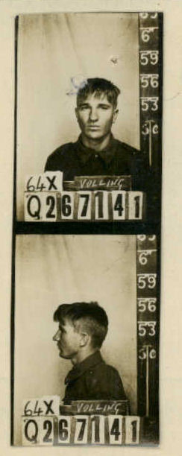

***QX55791 PTE N.L VOLLING***

(03 Mar 1924 – 01 May 1946: aged 22 yrs)

Private Neville Leo Volling was born in Longreach, QLD on 3 Mar 1924 to Alexander Volling and Julia Rose (Gillett) Volling and was a Station Hand prior to enlisting on 15 Oct 1942 at Selwyn, Qld (Q267141)

Neville was transferred to the AIF on 19 May 1943 and posted to 2/12 Fd Regt in Lae, New Guinea on 4 Feb 1944, he then transferred to 34th Inf Bde on 25 Oct 1945 and was posted to HQ Coy 66 Aust Inf Bn in Kure, Japan.

Neville died of injuries (rupture of liver) sustained in a road accident near Saka, Japan on 1 May 1946, age 22.

**Unit:** 66th Battalion, Australian Infantry, 2nd AIF.

**Fate:** Road Accident, Saka, Japan, 01 May 1946

**Cause of Death:** Sustained Injuries from vehicle accident

**Memorial Details:** Yokohama War Cemetery, Yokohama, Kanto, Japan – Plot Aust.Sec.E.C.4. Panel 71, Commemorative Area, Australian War Memorial, Canberra, ACT.

From 66 Bn War Dairy:



*‘****Lest we forget’***