**ROLL OF HONOUR – SX 26369 PTE Kenneth PARKEN**

**14th August 1946**

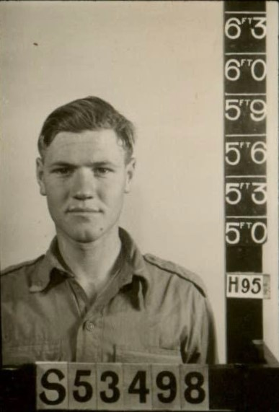

***SX26369 PTE K PARKEN***

(21 Sep 1923 – 14 Aug 1946: aged 22 yrs)

Private Kenneth Parken was born in South Australia on 21 Sep 1923 and grew up in Gawler, South Australia. Kenneth was Mechanics Asst prior to enlisting enlisted on 29 Dec 1941 (S53498) serving with the 108 A/Tank Regt and called up for full time duty on 10 Mar 1942 (SX26369) serving with 24 Aust Inf Bde (1944) and on 23 Feb 1946 marched in to 66th Aust Inf Bn in Kure, Japan.

Private Parken passed away on 14 Aug 1946 by accidental drowning near Nigata, Japan and his body was never recovered due to the swirling currents of the inland sea.

**Unit:** 66th Battalion, Australian Infantry, 2nd AIF.

**Fate:** Died Accidently (drowning) near Nigata, Japan 14 Aug 1946

**Cause of Death:** Drowned

**Memorial Details:** Panel 71, Commemorative Area, Australian War Memorial, Canberra, ACT, Australia. Adelaide WW2 Wall of Remembrance, Singapore Memorial Kranji War Cemetery column 133.

From 66 Bn War Dairy:



*‘****Lest we forget’***